IT Programming
Year 2025 - 2026
Panasiuk, Jesse
NSCC V0.0.10
Contents
Introduction to Class Notes 10
PROG1700 Logic and Programming 11
Python 11
Variables 11
If Statements 11
While Loops 12
NETW1027 Introduction to Networking and Security 13
Network Components 13
Host Rules 13
Peer-to-peer 14
End Devices 14
Intermediary Devices 15
Network Media 16
Network Representations and Topologies 17
Network Representations 17
Topology Diagrams 19
Common Types of Networks 20
Networks of Many Sizes 20
LANs and WANs 21
The Internet 24
Intranet and Extranets 25
Internet Connections 26
Internet Access Technologies 26
Home and Small Office Internet Connections 26
Business Internet Connections 28
The Converging Network 29
Reliable Networks 30
Network Architecture 30
Fault Tolerance 31
Scalability 31
Quality of Service 32
Network Security 33
Network Trends 34
Recent Trends 34
Bring Your Own Device (BYOD) 35
Online Collaboration 35
Video Communications 35
Cloud Computing 36
Technology Trends in the Home 37
Powerline Networking 37
Wireless Broadband 38
Network Security 39
Security Threats 39
Security Solutions 40
Networking Summary 1.0 41
Basic Switch and End Device Configuration 41
Cisco IOS Access 41
Operating Systems 41
GUI 42
Purpose of an OS 42
Access Methods 43
Terminal Emulation Program 44
IOS Navigation 44
Primary Command Modes 44
Configuration Mode and Subconfiguration Modes 45
Navigation Between IOS Modes 45
Note About Syntax Checker Activities 46
The Command Structure 46
Basic IOS Command Structure 46
IOS Command Syntax Check 47
IOS Help Features 48
Hot Keys and Shortcuts 49
Basic Device Configuration 50
Device Name 50
Password Guidelines 51
Configure Passwords 52
Encrypt Passwords 53
Banner Messages 54
Save Configurations 55
Configuration Files 55
Alter the Running Configuration 56
Capture Configuration to a Text File 56
Ports and Address 58
IP Addresses 58
Interfaces and Ports 60
Configure IP Addressing 62
Manual IP Address Configuration for End Devices 62
Automatic IP address Configuration for End Devices 63
Switch Virtual Interface Configuration 64
Networking Summary 2.0 65
Protocols and Models 65
The Rules 65
Communications Fundamentals 65
Communication Protocols 65
Rule Establishment 66
Network Protocol Requirements 66
Message Encoding 67
Message Formatting and Encapsulation 67
Message Size 68
Message Timing 68
Message Delivery Options 68
Protocols 69
Network Protocols Overview 69
Network Protocol Functions 70
Protocol Interaction 71
Protocol Suites 71
Network Protocol Suites 71
Evolution of Protocol Suites 72
TCP/IP Protocol Example 73
TCP/IP Protocol Suite 74
Standard Organizations 77
Open Standards 77
Internet Standards 78
Electronic And Communications Standards 79
Reference Model 79
The Benefits of Using a Layered Model 79
The OSI Reference Model 80
The TCP/IP Protocol Model 81
OSI and TCP/IP Comparison 82
Data Encapsulation 83
Segmenting Messages 83
Sequencing 83
Protocol Data Unites 84
Encapsulation Example 85
De-encapsulation Example 85
Data Access 85
Addresses 85
Layer 3 Logical Address 85
Devices on the Same Network 86
Role of the Data Link Layer Adress – Same IP Network 87
Role of the Network Layer Addresses 88
Role of the Data Link Layer Addresses – Different IP Networks 89
Data Link Addresses 90
Networking Summary 3.0 92
Purpose of the Physical Layer 93
The Physical Connection 93
The Physical Layer 95
Physical Layer Characteristics 95
Physical Layer Standards 95
Physical Components 96
Encoding 96
Signaling 97
Encoding 97
Bandwidth Terminology 98
Copper Cabling 99
Characteristics of Copper Cabling 99
Types of Copper Cabling 101
Unshielded Twisted-pair (UTP) 101
Shielded Twisted-pair (STP) 102
Coaxial Cable 103
UTP Cabling 104
Properties of UTP Cabling 104
UTP Cabling Standards and Connectors 105
Straight-through and Crossover UTP 108
Fiber-Optic Cabling 109
Properties of Fiber-Optic Cabling 109
Types of Fiber Media 109
Fiber-Optic Cabling Usage 110
Fiber-Optic Connectors 111
Fiber Patch Cords 113
Fiber versus Copper 113
Wireless Media 114
Properties of Wireless Media 114
Types of Wireless Media 115
Wireless LAN 116
Networking Summary 4.0 116
Binary Number Systems 117
Binary and IPv4 Addresses 117
Binary Positional Notation 118
Convert Binary to Decimal 120
Decimal to Binary Conversion 122
IPv4 Addresses 123
Hexadecimal Number Systems 125
Hexadecimal and IPv6 Addresses 125
Decimal to Hexadecimal Conversions 127
Hexadecimal to Decimal Conversions 127
Number System Summary 127
Data Link Layer 128
Purpose of the Data Link Layer 128
Topologies 129
Half-duplex Communications 130
Full-duplex Communications 131
Controlled access 131
Data Link Frame 131
Frame Field 132
Layer 2 Addresses 132
Data Link Layer Summary 133
Ethernet Switching 133
Ethernet Frames 133
Ethernet Encapsulation 133
Data Link Sublayers 134
MAC Sublayer 135
OSYS1200 Introduction to Windows Administration 136
The Evolving Role of System Administrators in the Future of Computing 136
Introduction 136
The Impact of Cloud Computing 137
Automation and DevOps 137
Security and Risk Management 137
Emerging Technologies and Skill Requirements 137
Conclusion 137
Windows: Using System and Utilities 138
Settings Overview 138
Administrative Tools 138
Microsoft Management Console 139
Services 140
Command-Line Administration Tools 141
Managing Disks and File System 142
Disk Technology 142
Disk Partition Styles 142
Disk Types 143
Disk Management Tools 143
Adding a New Drive 144
Configuring Storage Spaces Fault Tolerance 144
DBAS1007 Data Fundamentals 145
Databases 145
ACID Properties 146
Best Practices 146
Normalization 147
Normal Forms 147
Normalization Steps 147
ERDs and ERMs 150
Entity Relationship Modeling (ERM) 151
Entity Relationship Diagrams (ERD) 152
Key Differences 152
Components 152
Chen Notation 152
Three Types of Data Models 153
Conceptual Data Model 153
Logical Data Model 153
Physical Data Model 153
SQL 154
SQL Statements & Execution 154
SQL DDL 154
Logical Data Model 155
WEBD1000 Website Development 155
Web Development History 155
Introduction to Web Development 155
The Birth of the Web (1989 – 1991) 155
The Rise of Web Browsers (1993 – 1995) 155
The Browser Wars and Standards (1995 – 1998) 156
The Dot-Com Boom and Bust (1997 – 2001) 156
The Modern Web (2002 – Present) 156
Introduction to Usability 156
Principles of Good Usability 157
Principle of Contrast 157
Applying Contrast Effectively 157
Principle of Repetition 157
Applying Repetition Effectively 158
Principle of Alignment 158
Applying Alignment Effectively 158
Principle of Proximity 158
Applying Proximity Effectively 158
What is Web Accessibility? 159
Importance of Accessibility 159
Understanding WCAG (Web Content Accessibility Guidelines) 159
Accessible Design Components: Perceivable Content 160
Accessible Design Components: Operable Interface 160
Accessible Design Components: Understandable Content 160
Accessible Design Components: Robust Content 160
Tools and Resources for Testing Accessibility 161
Planning and Designing Websites 161
Understanding Project Requirements 161
Gathering Project Requirements 161
Analyzing Content Requirements 162
Designing Based on Criteria 162
Translating Requirements into Design 162
Designing for Content First 163
Balancing Aesthetics and Functionality 163
Importance of Wireframes in Web Design 163
Wireframing Process 164
Key Components of a Wireframe 164
Tools for Wireframing 164
Creating Web Structure Diagram 165
Steps to Create a Web Structure Diagram 165
Best Practices or Wireframing and Structure Diagrams 165
HTML 166
Understanding HTML Tags an Attributes 166
Understanding URLS 166
Creating Hyperlinks with HTML 167
Absolute Vs. Relative URLS 167
Adding Images to Web Pages 167
Using Special Characters in HTML 167
Introduction to CSS (Cascading Style Sheets) 168

Introduction to Class Notes

PROG1700 Logic and Programming

Python

Variables
Python, by convention uses snake_case when naming variables as opposed to camelCase.
Python does not require a “;” at the end of each line, unlike other languages (GML, C++, etc)
Variables are used to store information. When this variable is later called, whatever is stored within it, will be used in its place. Variables can take any name you give with (which the exception of some words used specifically for Python). Variables can be used to store Ints, floats, doubles, Booleans and even strings.
You can obtain the type of a variable by using “type(variable_name)” in a “print()” function.
You can also convert a variable by using “type(variable_name)”.


If Statements
If statements are used as a conditional branch to make programs more “interesting” and interactable by having different outcomes based on different variables.
The proper formatting for an if statement would be:
If variable_name (==, >, <, <= or >=) value:
Note: An if statement is checking to see “if something is true or false” and that the statements are always followed by “:”

If statements always check against a Boolean value (True or False) and can have different components to it. An elif (else if) statement may follow an if statement’s first condition, if another condition is to be checked. An else statement may follow an if statement’s first condition, or any subsequent elif statements if we want to have something happen, if the original condition, or any of the previous conditions, are not met.


If statements can also check multiple conditionals by using “and” and “or” in their conditonals.
Unlike C++, if statements in Python do not use “{ }” (curly braces) to contain their results. Instead, Python uses indentations.
i.e. if variable_name > 10 and variable_name < 25:
print(“See how it is indented? This means it is part of the if statement.”)

While Loops
While loops are similar to If statements, in that they perform a block of code based on a Boolean conditional. However, the difference is that while loops don’t have an elif or else component. Instead, when a while loop terminates, if the Boolean conditional is not met, the program will loop back to the beginning of the while loop.
In addition to satisfying the Boolean conditional, you can also use the “break” command. The “break” code will “break” you out of the loop, regardless of if the Boolean conditional of the while loop has been met.

Functions
Functions are like little mini blocks of code. They are good for separating chunks of code out of the “main body” of your script. They are also a great way to DRY (Don’t Repeat Yourself) your code, as anything that must be repeated, can be placed in its own function, so that you only need to call/invoke the function, rather than the entire block of code.
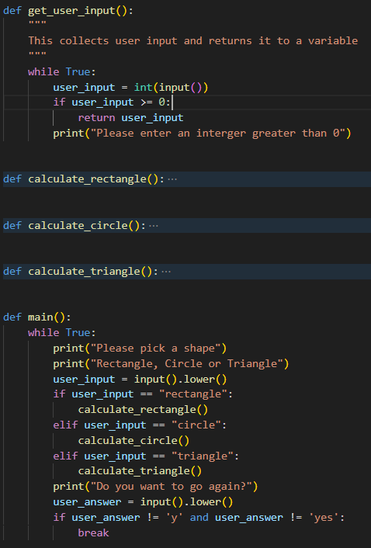

If you look at the above figure, the get_user_input() is responsible for getting our input from the user. Within it, it is asking the user to enter an integer and checking if it meets our requirements (being greater than 0). Now, if we need to ask the user for multiple integers, or if we need to ask for it, again, later down the road, we can simply invoke it by typing get_user_input() instead of re-typing out, everything that is within the function. What’s more, is if we later decide to modify the code to ask for the input an additional time, we just add that “get_user_input()” line.

When creating a function, we use the keyword “def” followed by <function name> an end it with “():”. The “()” is where we are going to pass in arguments, but we’ll discuss that later.
Just like If statements and while loops, everything indented below the “def <function name>()” is what will happen when we invoke the function.
Think of functions like elaborate variables:
If typing “x = 12” replaces x with 12 whenever you call x, then typing:
def call_this():
print(“This is a function”)
replaces “call_this()” with “print(“this is a function”) whenever you call, call_this().

Functions can be called by variables.
Consider the below:
def get_user_input():
print(“Please enter an integer”)
user_input = input()
return user_input

x = get_user_input()
See the “return user_input”? That is “returning” whatever value is in “user_input” when we exit the function. It is then being stored in the variable that invoked the function, which is x. So now, x = user_input.
Now, if you wanted to get another input, you could simply add “y = get_user_input()” beneath “x = get_user_input()

Functions can also be passed “arguments” or “parameters”.
Consider the below:
def add(x, y):
sum = x + y:
print(“The sum is “ + str(sum))

See how add has an “x” and a “y” value? Those are arguments that have been passed to it and will be used as part of it’s “function”. How do we pass them? By adding them to the “()” when we call it, like so:
add(4, 5)

This will call the function “add()” and pass it “4” and “5” as arguments. It will store 4 in x and 5 in y. When the function then goes through it’s code, it’s going to turn sum from “sum = x + y” into “sum = 4 + 5” and this, the print command will print “9”

So, how does this all come together?
Well, consider this:
def get_user_input():
print(“Please enter an integer:”)
user_input = input()
return user_input()

def add(a, b):
sum = a + b
return sum

x = get_user_input()
y = get_user_input()
z = add(x, y)
print(“The sum is “ + str(y))

Okay. So, lets break this down. First, we are defining “get_user_input()” and “add()”, just like we did previous examples. Then, in the main body of our code, we are declaring two variables, “x” and “y”. We are then using those variables to call “get_user_input” for each variable and storing the function’s return value into them. Imagine we entered 4 and 5. X will now equal 4 and Y will now equal 5.
Then we call add(a, b).
Now, this part is going to get confusing. The reason I used “a” and “b” when defining the function “add” is because I wanted to demonstrate that these can be anything. We can call them “Will” and “Gary”. Just because we are passing the values of “x” and “y” into add(a, b) doesn’t mean it has to use “x” and “y”. So, when we call add(), we call it with “add(x, y)” (“x” and “y” being the values we want to pass it) the function will then do “a = x” and “b = y” in the background.
So, when we call add(x, y) it will turn “x” and “y” into “a” and “b”, add the values together (4 and 5, respectively, in our imagination) and then return the value of “sum” and store it into “y”.
When we then get to “print(“The sum is “ +str(y))” it will print “The sum is 9”

NETW1027 Introduction to Networking and Security

Network Components

Host Rules
All computers that are connected to a network and participate, directly in network communication are classified as hosts. Hots can be called “end devices.” Some hosts are called “clients.” However, the term hosts specifically refer to devices on the network that are assigned a number for communication purposes. This number identifies the host within a particular network. This number is called the ”Internet Protocol (IP)” address. An IP address identifies the host and the network to which the host is attached.
Servers are computers with software that allow them to provide information, like email or web pages, to other end devices on the network. Each service requires separate server software. For example, a server requires web server software to provide web services to the network. A computer with server software can provide services simultaneously to many different clients.
As mentioned before, clients are a type of host. Clients have software for requesting and displaying the information obtained from the server, as shown in the figure.
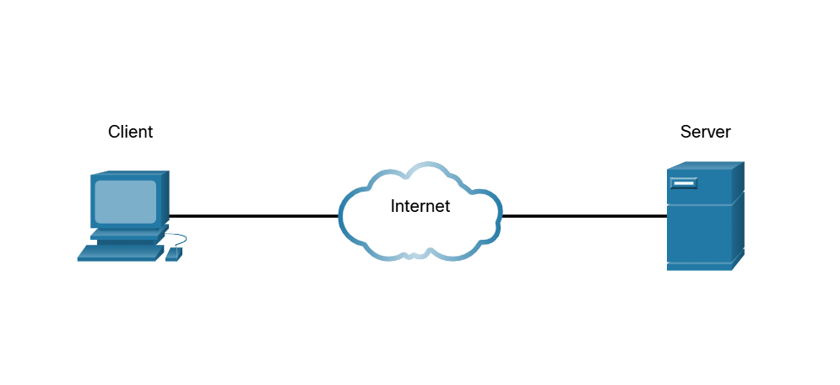
An example of client software is a web browser, like Chrome or Firefox. A single computer can also run multiple types of client software. For example, a user can check email and view a web page while instant messaging and listening to an audio stream. The table lists three common types of software.
Type | Description
Email | The email server runs email software. Clients use mail client software, such as Microsoft Outlook, to acces email on the server.
Web | The web server runs web server software. Clients use browser software, such as Windows Internet Explorer, to access web pages on the server.
File | The file server stores corporate and user files in a central locatin. The client devices access these files with client software such as the Windows File Explorer.

Peer-to-peer
Client and server software usually run on separate computers, but it is also possible for one computer to be used for both roles at the same time. In small businesses and homes, many computers function as the servers and clients on the network. This type of network is called a peer-to-peer network.
In the figure, the print sharing PC has a Universal Serial Bus (USB) connection to the printer and a network connection, using a network interface card (NIC), to the file share PC.
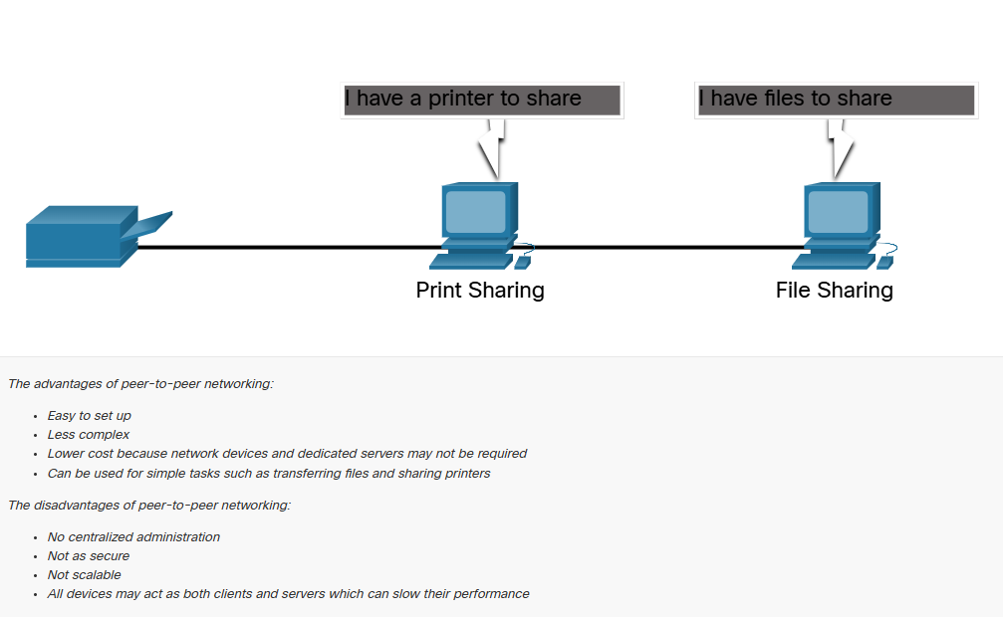

End Devices
The network devices that people are most familiar with are end devices. To distinguish one end device from another, each end device on a network has an address. When an end device initiates communication, it uses the address of the destination end device to specify where to deliver the message.
An end device is either the source or destination of a message transmitted over the network.
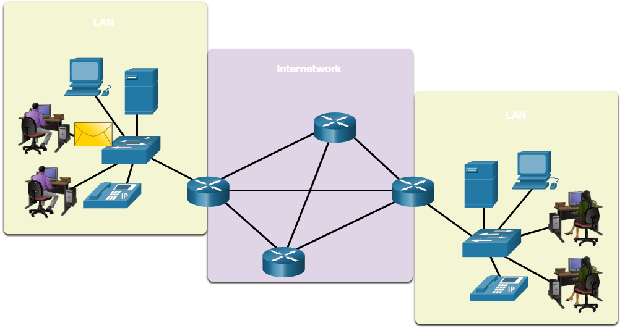

Intermediary Devices
Intermediary devices connect the individual end devices to the network. They can connect multiple individual networks to form an internetwork. These intermediary devices provide connectivity and ensure that data flow across the network.
Intermediary devices use the destination end device address, in conjunction with information about the network interconnections, to determine the path the messages should take through the network. Examples of the more common intermediary devices and a list of functions are shown in the figure.
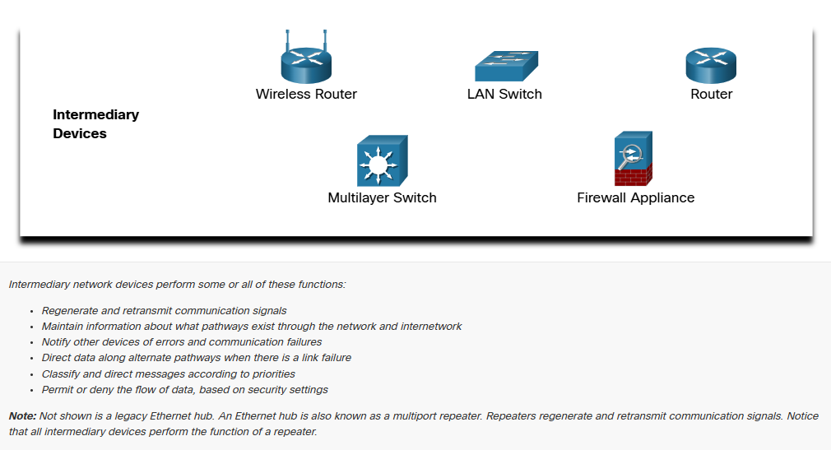
Intermediary network devices perform some or all of these functions:
- Regenerate and retransmit communication signals.
- Maintain information about what pathways exist through the network and internetwork
- Notify other devices of errors and communication failures.
- Direct data along alternate pathways when there is a link failure.
- Classify and direct messages according to priorities.
- Permit or deny the flow of data, based on security settings.
Note: Not shown above is a legacy ethernet hub. An ethernet hub is also known as a multiport repeater. Repeaters regenerate and retransmit communication signals. Notice that all intermediary devices perform the function of a repeater.

Network Media
Communication transmits across a network on media. The media provides the channel over which the message travels from source to destination.
Modern networks primarily use three types of media to interconnect devices, as shown in the figure:
- Metal wires within cables
  - Data is encoded into electrical impulses.
- Glass or plastic fibers within cables (fiber-optic cable)
  - Data is encoded into pulses of light.
- Wireless transmission
  - Bata is encoded via modulation of specific frequencies of electromagnetic waves.
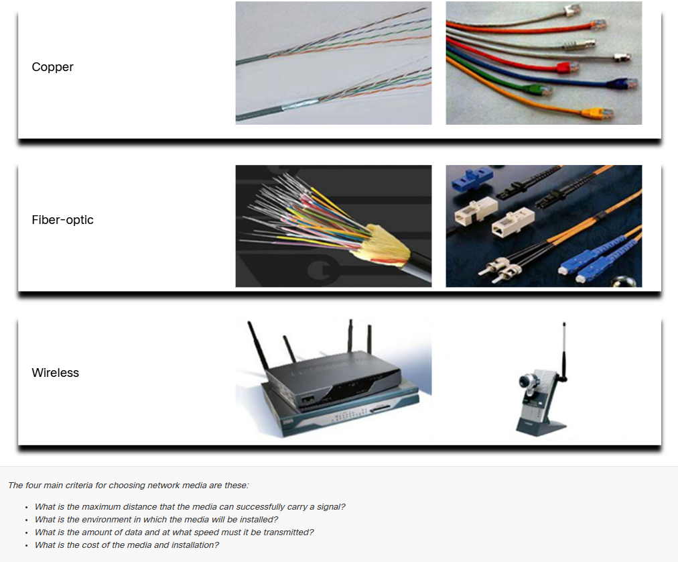
The four main criteria for choosing network media are these:
- What is the maximum distance that the media can successfully carry a signal?
- What is the environment in which the media will be installed?
- What is the amount of data and at what speed must it be transmitted?
- What is the cost of media and installation?

Network Representations and Topologies

Network Representations
Network architects an administrators must be able to show what their networks will look like They need to be able to easily see which components connect to other components, where they will be located, and how they will be connected. Diagrams of networks often use symbols, like those show in the figure, to represent the different devices and connections that make up a network.
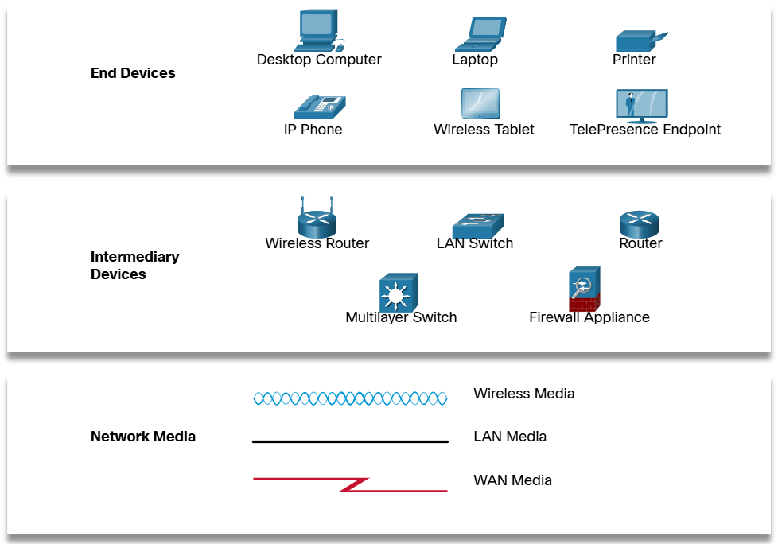

A diagram provides an easy way to understand how devices connect in a large network. This type of “picture” of a network is known as a topology diagram. The ability to recognize the logical representations of the physical networking components is critical to being able to visualize the organization and operation of a network.
In addition to these representations, specialized terminology is used to describe how each of these devices and media connect to each other:
- Network Interface Card (NIC)
  - A NIC physically connects the end device to the network.
- Physical Port
  - A connector or outlet on a networking device where the media connects to an end device on another networking device.
- Interface
  - Specialized ports on a networking device that connect to individual networks. Because routers connect networks, the ports on a router are referred to as network interfaces.
Note: The terms port ad interface are often used interchangeably.

Topology Diagrams
Topology diagrams are mandatory documentation for anyone working with a network. They provide a visual map of how the network is connected. There are two types of topology diagrams: physical and logical.
Physical Topology Diagrams
Physical topology diagrams illustrate the physical location of intermediary devices and cable installation, as shown in the figure. You can see that the rooms in which these devices are locate are labeled in this physical topology.
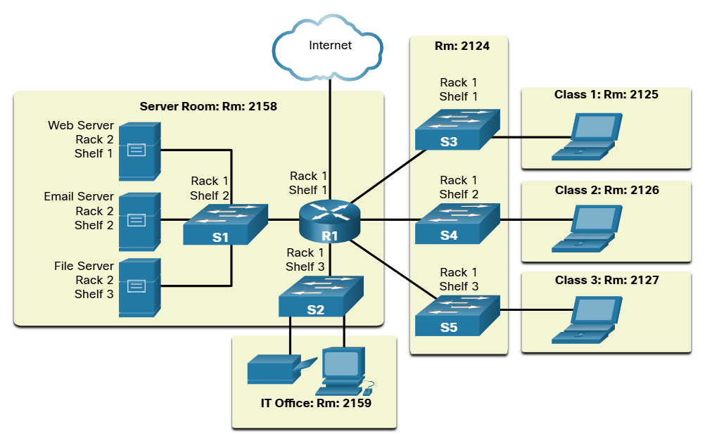
Logical Topology Diagrams
Logical topology diagrams illustrate devices, ports and the addressing scheme of the network, as shown in the figure. You can see which end devices are connected to which intermediary devices and what media is being used.
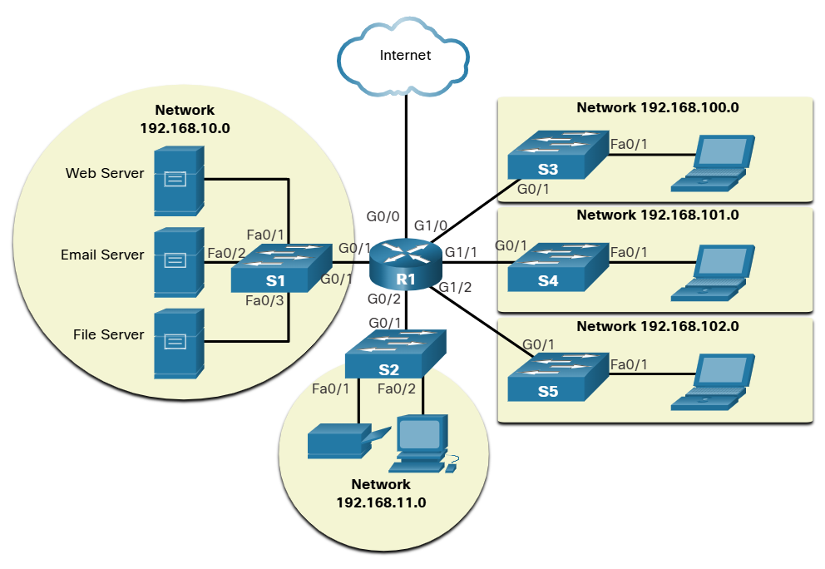

Common Types of Networks

Networks of Many Sizes
Now that you are familiar with the components that make up networks and their representations in physical and logical topologies, you are ready to learn about the many different types of networks.
Networks come in all sizes. They range from simple networks consisting of two computers, to networks connecting millions of devices.
Simple home networks let you share resources, such as printers, documents pictures, and music, among a few local end devices.
Small office and home office (SOHO) networks allow people to work from home, or a remote office. Many self-employed workers use these types of networks to advertise and sell products, order supplies, and communicate with customers.
Businesses and large organizations use networks to provide consolidation, storage, and access to information on network servers. Networks provide email, instant messaging, and collaboration among employees. Many organizations use their network’s connection to the internet to provide products and services to customers.
The internet is the largest network in existence. In fact, the term internet means a “network of networks”. It is a collection of interconnected private and public networks.
In small businesses and homes, many computers function as both servers and clients on the network. This type of network is called a peer-to-peer network.
Small Home Networks | Connect a few computers to each other and to the internet
Small Office and Home Office Networks | The SOHO network allows computers in a home office or a remote office to connect to a corporate network, or access centralized, shared resources.
Medium to Large Networks | Medium to large networks, such as those used by corporations and schools, can have many locations with hundreds or thousands of interconnected hosts.
World Wide Networks | The internet is a network of networks that connects hundreds of millions of computers world=wide.

LANs and WANs
Network infrastructures vary greatly in terms of:
  - Size of the area covered
  - Number of users connected
  - Number and types of service available
  - Area of responsibility

The two most common types of network infrastructures are Local Area Network (LANs) and Wide Area Networks(WANs).
A LAN is a network infrastructure the provides access to users and end devices in a small geographical area. A LAN is typically used in a department within an enterprise, a home or a small business network.
A WAN is a network infrastructure that provides access to other networks over a wide geographical area, which is typically owned and managed by a larger corporation or a telecommunications service provider. The figure shows LANs connected to WANs.
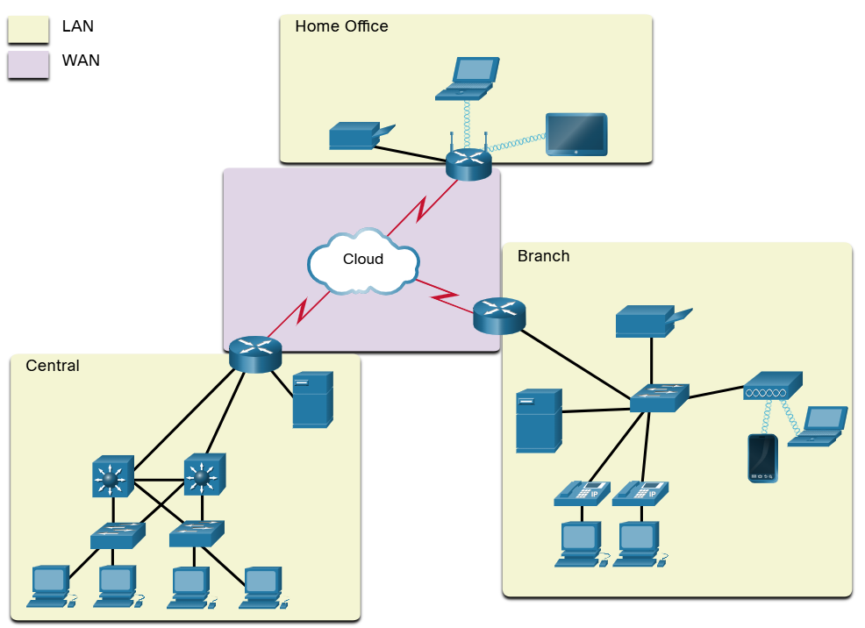

LANS
A LAN is a network infrastructure that spans a small geographical area. LANs have specific characteristics.
  - LANs interconnect end devices in a limited area such as a home, school, office building or campus.
  - A LAN is usually administered by a single organization or individual. Administrative control is enforced at the network level and governs the security and access control policies.
  - LANs provide high-speed bandwidth to internal end devices and intermediary devices, as shown in the figure.
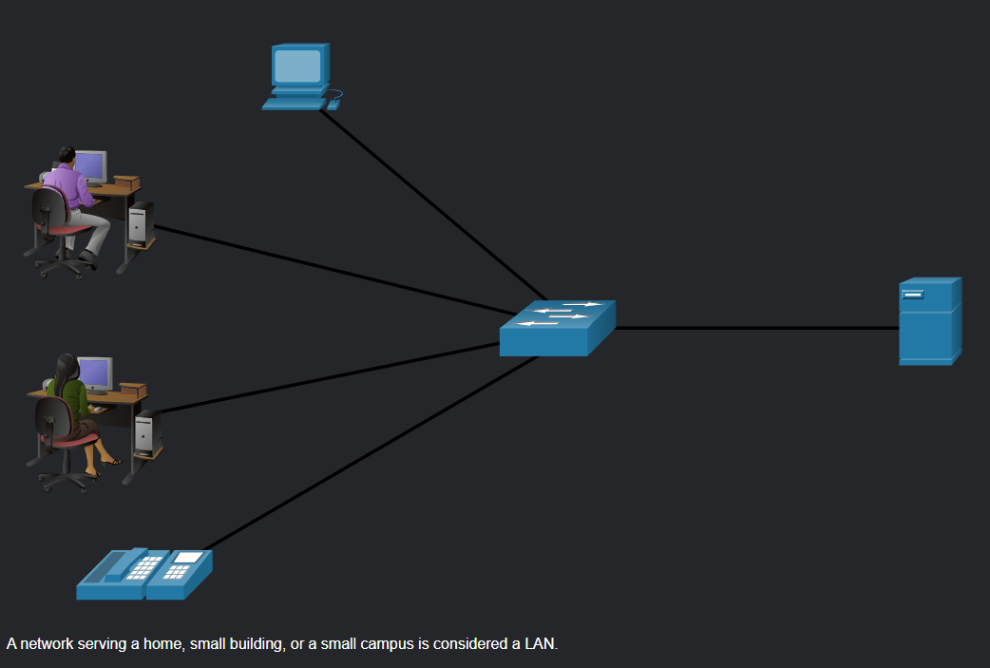
WANS
The figure shows a WAN which interconnects to LANs. A WAN is a network infrastructure that spans a wide geographical area. WANs are typically managed by a Service Provider (SPs) or Internet Service Provider (ISPs)

WANs have specific characteristics:
  - WANs interconnect LANs over wide geographical areas such as between cities, states, provinces, countries or continents.
  - WANs are usually administered by multiple service providers.
  - WANs typically provide lower speed links between LANs
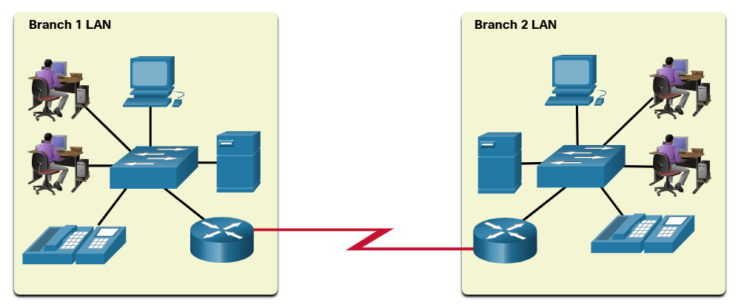

The Internet
The internet is a worldwide collection of interconnected networks (internetwork, or internet for short). The figure shows one way to view the internet as a collection of interconnected LANs and WANs.
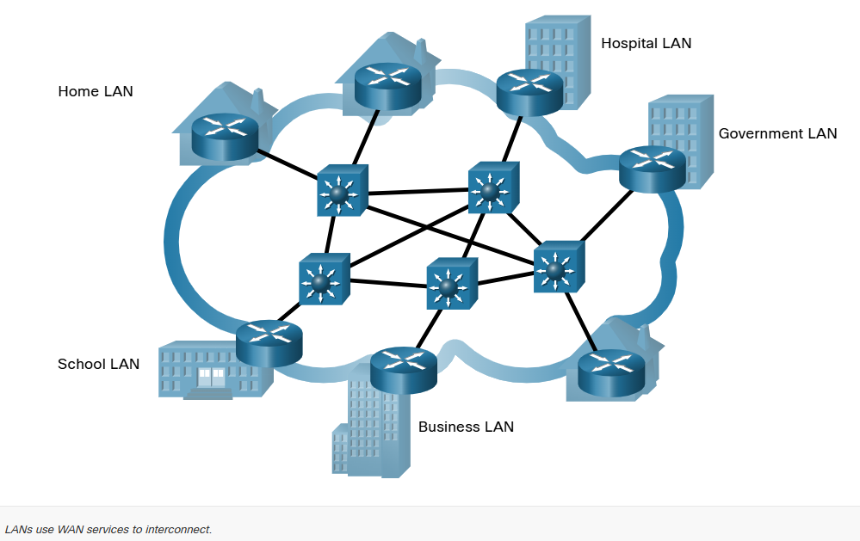
Some of the LAN examples are connected to each other through a WAN connection. WANs are then connected to each other. WANs can connect through copper wires, fiber-optic cables and wireless transmissions (not shown).
The internet is not owned by an individual or group. Ensuring effective communication across this diverse infrastructure requires the application of consistent and commonly recognized technologies and standards as well as the cooperation of many network administration agencies. There are organization that were developed to help maintain the structure and standardization of internet protocol and processes. These organizations include the Internet Engineering Task Force (ETF), Internet Corporation for Assigned Names and Numbers (ICANN), and the Internet Architecture Board (IAB) plus many others.

Intranet and Extranets
There are two other terms which are like the term internet: intranet and extranet.
Intranet is a term often use to refer to a private connection of LANs and WANs that belong to an organization. An intranet is designed to be accessible only to the organization’s members, employees, or others with authorization.
An organization may use an extranet to provide secure and safe access to individuals who work for a different organization but require access to the organization’s data. Here are some examples of extranets:
  - A company this is providing access to outside suppliers and contractors.
  - A hospital that is providing a booking system to doctors so they can make appointments for their patients.
  - A local office of education that is providing budget and personnel information to the schools in its district.
The figure illustrates the levels of access that different groups have to a company intranet, a company extranet, and the internet.
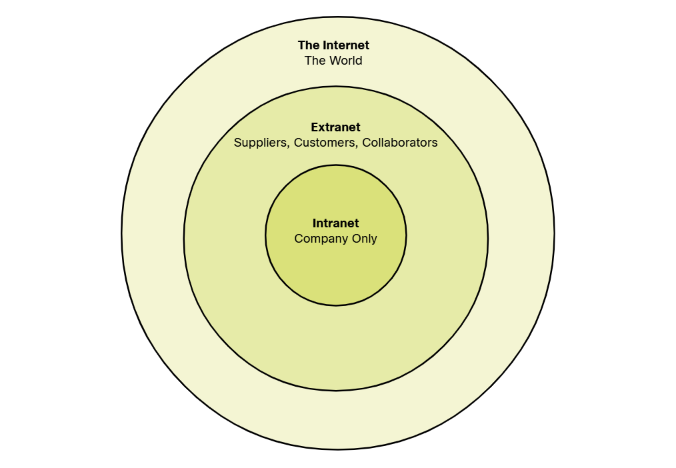

Internet Connections

Internet Access Technologies
So, now you have a basic understanding of what makes up a network and the different types of networks. But how do you actually connect users and organization to the internet? As you may have guessed, there are many different ways to do this.
Home users, remote workers and small offices typically require a connection to an ISP to access the internet. Connection options vary greatly between ISPs and geographical locations. However, popular choices include broadband cable, broadband digital subscriber line (DSL), wireless WANs, and mobile services.
Organizations usually need access to other corporate sites as well as the internet. Fast connections are required to support business services including IP phones, video conferencing and data center storage. SPs offer business-class connection. Popular business-class services include business DSL, leased lines, and Metro Ethernet.

Home and Small Office Internet Connections
The figure below illustrates common connection options for small office and home office user.
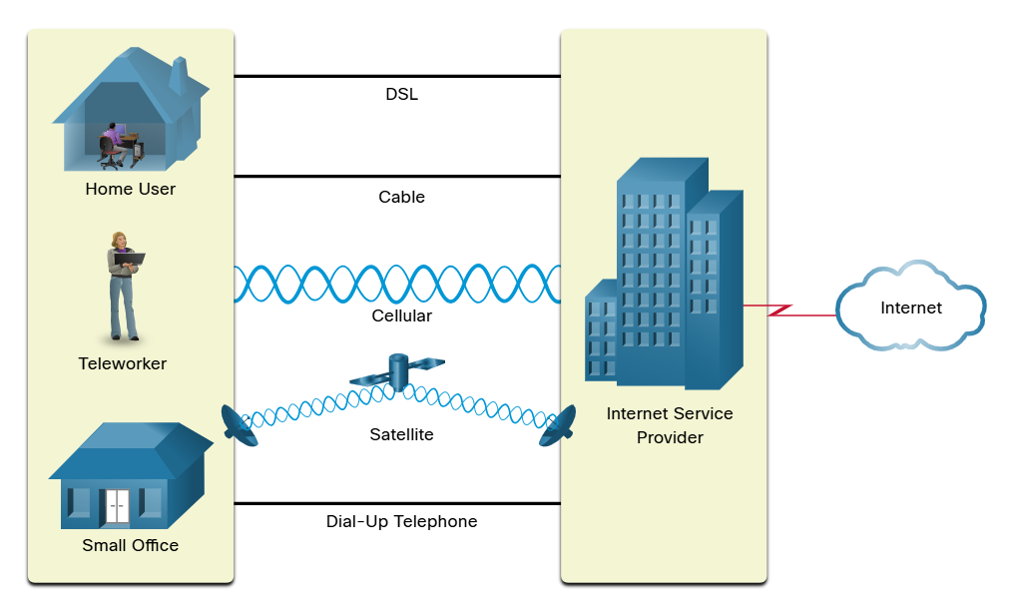
Cable – Typically offered by cable television service providers, the internet data signal transmits on the same cable that delivers cable television. It provides a high bandwidth, high availability and an always-o connection to the internet.
DSL – Digital Subscriber Lines also provide high bandwidth, high availability and an always-on connection to the internet. DSL runs over the telephone line. In general, small office and home office users connect using Asymmetrical DSL (ADSL) which means that the download speed is faster than the upload speed.
Cellular – Cellular internet access uses a cell phone network to connect. Wherever you can get a cellular signal, you can get cellular internet access. Performance is limited by the capabilities of the phone and the cell tower to which it is connected.
Satellite – The availability of satellite internet access is a benefit in those areas that would otherwise have no internet connectivity at all. Satellite dishes require a clear line of sight to the satellite.
Dial-up Telephone – An inexpensive option that uses any phone line and a modem. The low bandwidth provided by a dial-up modern connection is not sufficient for large data transfer, although it is useful for mobile access while traveling.

The choice of connection varies depending on geographical location and service provider availability.

Business Internet Connections
Corporate connection option differ from home user options. Businesses may require higher bandwidth, dedicated bandwidth and managed services. Connection options that are available differ depending on the type of service providers located nearby.
The figure below illustrates common connection options for businesses.
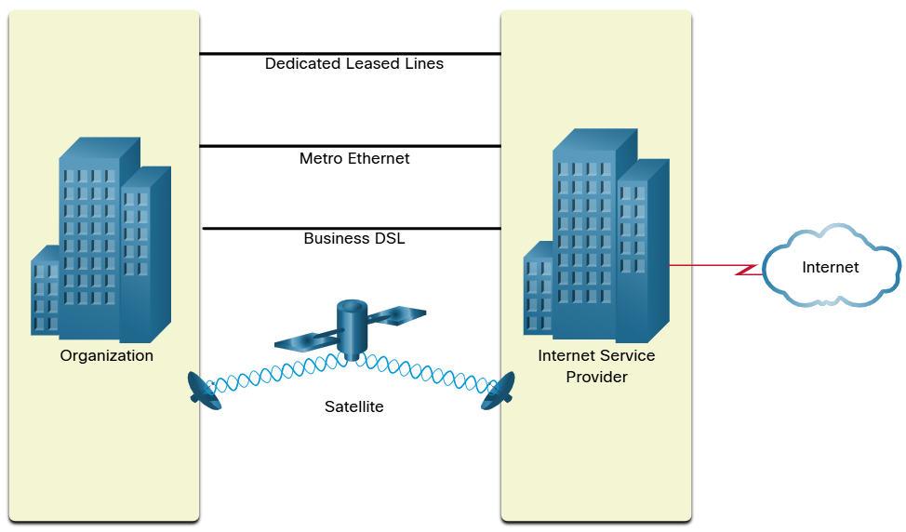

Dedicate Leased Line – Leased lines are reserved circuits within the service provider’s network that connect geographically separated offices for private voice and/or data networking. The circuits are rented at a monthly or yearly rate.
Metro Ethernet – This is sometimes known as Ethernet WAN. In this module, we will refer to it as Metro Ethernet. Metro ethernets extend LAN access technology into the WAN.
Business DSL – Business DSL is available in various formats. A popular choice is Symmetric Digital Subscriber Lines (SDSL) which is similar to the consumer version of DSL but provides uploads and downloads at the same high speeds.
Satellite – Satellite service can provide a connection when a wired solution is not available.

The choice of connection varies depending on geographical location and service provider availability.

The Converging Network

Traditional Separate Networks
Consider a school built thirty years ago Back then, some classrooms were cabled for the data network, telephone network and video network for televisions. These separate networks could not communicate with each other. Each network used different technologies to carry the communication signal. Each network had its own set of rules and standards to ensure successful communication. Multiple services ran on multiple networks.
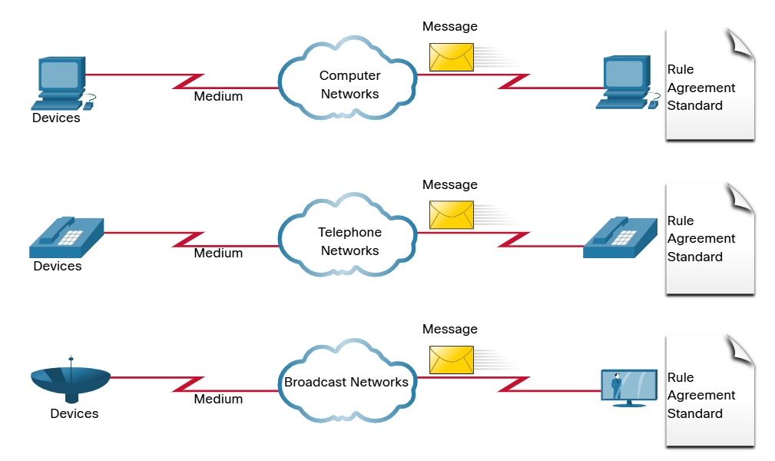
Converged Network
Toay, the separate data, telephone, and video networks converge. Unlike dedicated networks, converged networks are capable of delivering data, voice, and video between many different types of devices over the same network infrastructure. This network infrastructure uses the same set of rules, agreements and implementation standards. Converged data networks can carry multiple services on one network.
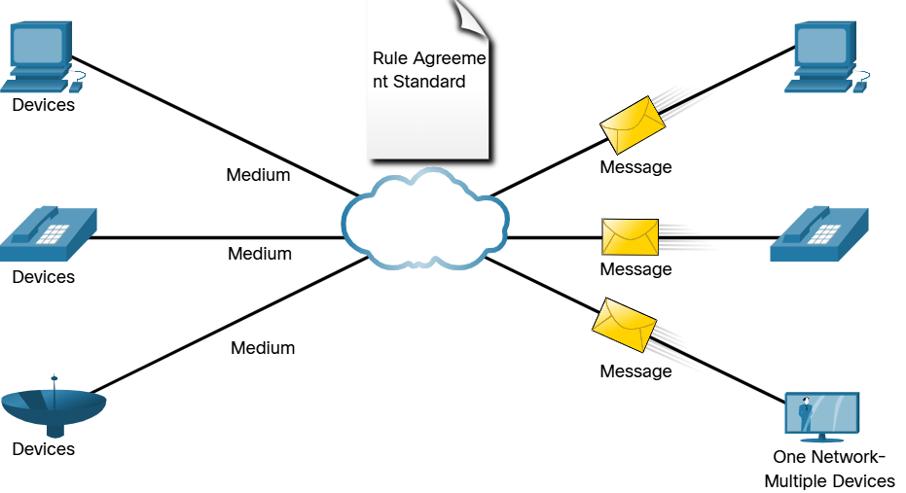

Reliable Networks

Network Architecture
Have you ever been busy working online, only to have “the internet go down”? as you know by now, the internet did not go down, you just lost your connection to it. It is very frustrating. With so many people in the world relying on network access to work and learn, it is imperative that networks are reliable. In this context, reliability means more than your connection to the internet. This topic focuses on the four aspects of network reliability.
The role of the network has changed from a data-only network to a system that enables the connections of people, devices, and information in a media-rich, converged network environment. For networks to function efficiently and grow in this type of environment, the network must be built upon a standard network architecture.
Networks also support a wide range of application and services. They must operate over many different types of cables and devices, which make up the physical infrastructure. The term network architecture, in this context, refers to the technologies that support the infrastructure and the programmed services an rules, or protocols, the move data across the network.
As networks evolve, we have learned that there are four basic characteristics that network architects must address to meet user expectations:
- Fault Tolerance
- Scalability
- Quality of Service (QoS)
- Security

Fault Tolerance
A fault tolerant network is one that limits the umber of affected devices during a failure. It is built to allow quick recovery when such a failure occurs. These networks depend on multiple paths between the source and destination of a message. If one path fails, the messages are instantly sent over a different link. Having multiple paths to a destination is known as redundancy.
Implementing a packet-switched network is one way that reliable networks provide redundancy. Packet switching splits traffic into packets that are routed over a shared network. A single message, such as an email or a video stream, is broken into multiple message blocks, called packets. Each packet has the necessary addressing information of the source and destination of the message. The routers within the network switch the packets based on the condition of the network at that moment. This means that all the packets in a single message could take very different paths to the same destination. In the figure, the user is unaware and unaffected by the router that is dynamically changing the route when a link fails.
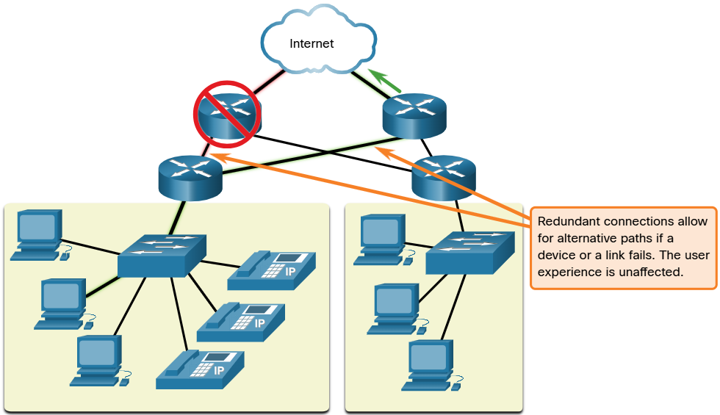

Scalability
A scalable network expands quickly to support new users and applications. It does this without degrading the performance of services that are being accessed by existing users. The figure shows how a new network is easily added to an existing network. These networks are scalable because the designers follow accepted standards and protocols. This let software and hardware vendor focus on improving products and services without having to design a new set of rules for operating within the network.
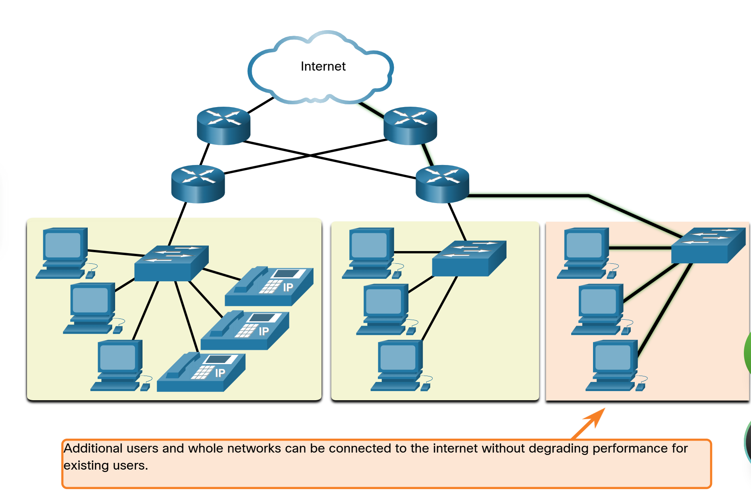

Quality of Service
Quality of Service (QoS) is an increasing requirement of networks today. New applications available to users over networks, such as voice and live video transmissions, create higher expectation for the quality of the delivered services. Have you ever tried to watch a video with constant breaks and pauses? As data, voice and video content continue to converge onto the same network, QoS becomes a primary mechanism for managing congestion and ensuring reliable delivery of content to all users.
Congestion occurs when the demand for bandwidth exceeds the amount available. Network bandwidth is measured in the umber of bits that can be transmitted in a single second, or bits per second (bps). When simultaneous communications are attempted across the network, the demand for network bandwidth can exceed its availability, creating network congestion
When the volume of traffic is greater than what can be transported across the network, devices will hold the packets in memory until resources become available to transmit them. In the figure, one user us requesting a web page, and another is on a phone call. With a QoS policy in place, the router can manage the flow of data and voice traffic, giving priority to voice communications if the network experiences congestion. The focus of QoS is to prioritize time-sensitive traffic. The type of traffic, not the content of traffic, is what is important.
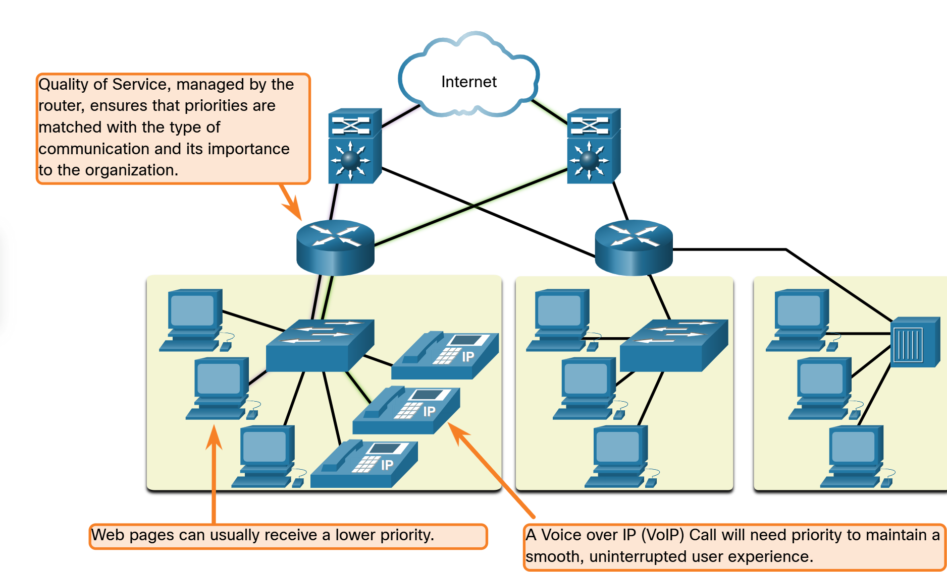

Network Security
The network infrastructure, service, and the data contained on network-attached devices are crucial personal and business assets. Network administrators must address two types of network security concerns: network infrastructure security and information security.
Securing the network infrastructure includes physically securing devices that provide network connectivity and preventing unauthorized access to the management software that resides on them, as shown in the figure.
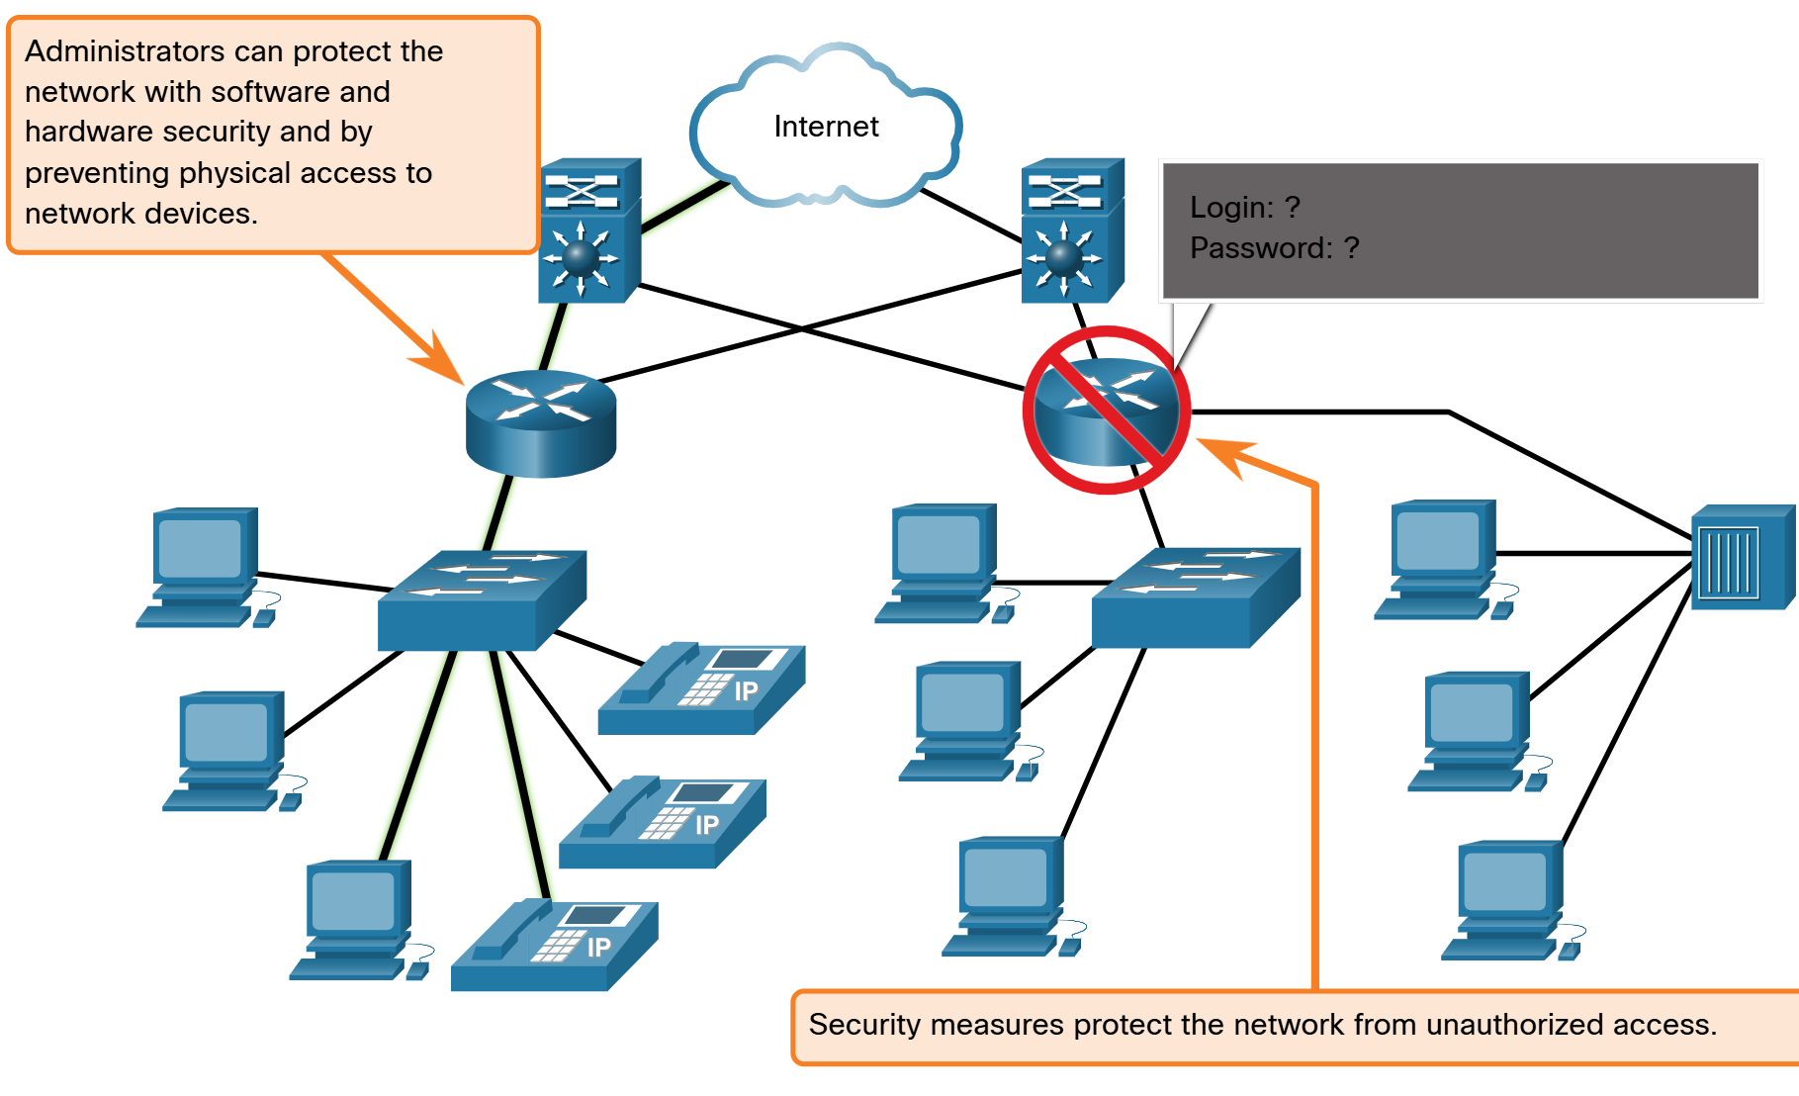

Network administrators must also protect the information contained within the packets being transmitted over the network, and the information stored on network attached devices. In order to achieve the goals of network security, here are three primary requirements.
  - Confidentiality – Data confidentiality means that only the intended and authorized recipients can access and read data
  - Integrity – Data integrity assures users that the information has not been altered in transmission, rom origin to destination.
  - Availability – Data availability assures users of timely and reliable access to data services for authorized users.

Network Trends

Recent Trends
You know a lot about networks now, what they are made of, how they connect us and what is needed to keep them reliable. But networks, like everything else, continue to change. There are a few trends in networking that you, as a NetAcad student, should know about.
As new technologies and end-user devices come to market, business and consumers must continue to adjust to this ever-changing environment. There are several networking trends that affect organizations and consumers:
- Bring Your Own Device (BYOD)
- Online collaboration
- Video Communications
- Cloud Computing

Bring Your Own Device (BYOD)
The concept of any device, for any content, in any manner, is a major global trend that requires significant changes to the way we use devices and safely connect them to networks. This is called Bring Your Own Device (BYOD).
BYOD enables end users with the freedom to use personal tools to access information and communicate across a business or campus network. With the growth of consumer devices, and the related drop in cost, employees and students may have advanced computing and networking devices for personal use. These include laptops, notebooks, tablets, smart phones and e-readers. These may be purchased by the company or school, purchased by the individual, or both.
BYOD mean any device, with any ownership, used anywhere.

Online Collaboration
Individuals want to connect to the network, not only for access to data applications, but also to collaborate with one another. Collaboration is defined as “the act of working with another or others on a join project.” Collaboration tools, like Cisco WebEx, give employees, students, teachers, customers and partners a way to instantly connect, interact and achieve their objectives.
Collaboration is a critical and strategic priority in education. Students need to collaborate to assist each other in learning, to develop the team skills used in the workforce, and to work together on team-based projects.
Cisco WebEx Teams is a multifunctional collaboration tool that lets you send instant messages to one or more people, post images, and post videos and links. Each team ‘space’ maintains a history of everything that is posted there.

Video Communications
Another facet of networking that is critical to the communication and collaboration effort is video. Video is used for communications, collaboration, and entertainment. Video calls are made to and from anyone with an internet connection, regardless of where they are located.
Video conferencing is a powerful tool for communicating with others, both locally and globally. Video is becoming a critical requirement for effective collaboration as organization extend across geographic and cultural boundaries.

Cloud Computing
Cloud computing is one of the ways that we access and store data. Cloud computing allows us to store personal files, even backup an entire drive on servers over the internet. Applications such as word processing and photo editing can be accessed using the cloud.
For businesses, Cloud computing extends the capabilities of IT without requiring investment in now infrastructure, training new personnel, or licensing new software. These services are available on-demand and delivered economically to any device that is anywhere in the world without compromising security or function.
Cloud computing is possible because of data centers. Data centers are facilities used to house computer systems and associated components. A data center can occupy one room of a building, one or more floors, or an entire warehouse-sized building. Data centers are typically very expensive to build and maintain. For this reason, only large organization use privately built data centers to house their data and provide services to users. Smaller organization that cannot afford to maintain their own private data center can reduce the overall cost of ownership by leasing server and storage services from a larger data center organization in the cloud.
For security, reliability, and fault tolerance, cloud providers often store data in distributed data centers. Instead of storing all the data of a person or organization in one data center, it is stored in multiple data enters in different locations.
There are four primary types of clouds: Public clouds, Private clouds, Hybrid clouds, and Community clouds.

Public clouds | Cloud-based applications and services offered in a public cloud are made available to the general population. Services may be free or are offered on a pay-per-use model, such as paying for online storage. The public cloud uses the internet to provide services.
Private clouds | Cloud-base application and services offered in a private cloud are intended for a specific organization or entity, such as a government. A private cloud can be set up using the organization’s private network, through this can be expensive to build and maintain. A private cloud can also be managed by an outside organization with strict access security.
Hybrid clouds | A hybrid cloud is made up of two or more clouds (example: part private, part public), where each part remains a distinct object, but both are connected using a single architecture. Individuals on a hybrid cloud would be able to have degrees of access to various services based on user access rights.
Community clouds | A community cloud is created for exclusive use by specific entities or organizations. The differences between public clouds and community clouds are the functional needs that have been customize for the community. Or example, healthcare organizations must remain compliant with policies and laws (e.g HIPAA) that require special authentication and confidentiality. Community clouds are use by multiple organizations that have similar needs and concerns. Community clouds are similar to a public cloud environment, but with set levels of security, privacy and even regulatory compliance of a private cloud.

Technology Trends in the Home
Networking trends are not only affecting the way we communicate at work and at school, but also changing many aspects of the home. The newest home trends include “smart home technology.”
Smart home technology integrates into every-day appliances, which can then connect with other devices to make the appliances more ‘smart’ or automated. For example, you could prepare food and place it in the over for cooking prior to leaving the house for the day. You program your smart over for the food you want it to cook. It would also be connected to your “calendar of events” so that it would determine what time you should be available to eat and adjust start times and length of cooking accordingly. It could even adjust cooking times and temperatures based on changes in schedule. Additionally, a smart phone or tablet connection lets you connect to the over directly, to make any desired adjustments. When the food is ready, the oven sends an alert message to you (or someone you specify) that the food is done and warming.
Smart home technology is currently being developed for all rooms with a house. Smart home technology will become more common as home networking and high-speed internet technology expands.

Powerline Networking
Powerline networking for home networks uses existing electrical wiring to connect devices, as shown in the figure.
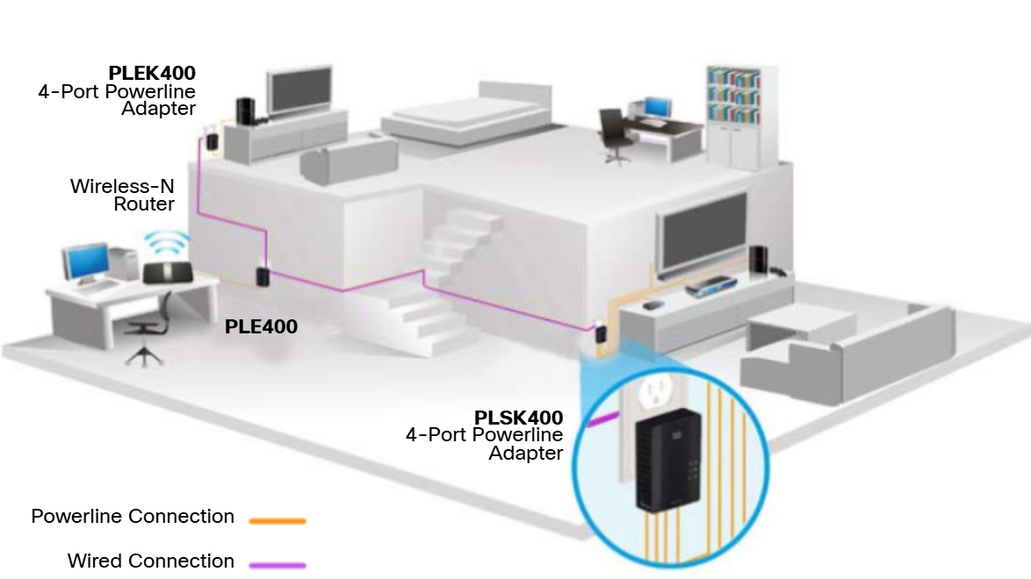
Using a standard powerline adaptor, devices can connect to the LAN wherever there is an electrical outlet. No data cables need to be installed, and there is little to no additional electricity used. Using the same wiring that delivers electricity, powerline networking sends information by sending data on certain frequencies.
Powerline networking is especially useful when wireless access points cannot reach all the devices in the home. Powerline networking is not a substitute for dedicate cabling in data networks. However, it is an alternative when data network cables or wireless communications are not possible or effective.

Wireless Broadband
In many areas where cable an DSL are not available, wireless may be used to connect to the internet.
Wireless Internet Service Provider
A Wireless Internet Service Provider (WISP) is an ISP that connects subscribers to a designated access point or hot spot using similar wireless technologies found in home wireless local area networks (WLANs). WISPs are more commonly found in rural environments where DSL or cable services are not available.
Although a separate transmission tower may be installed for the antenna, typically the antenna is attached to an existing elevated structure, such as a water tower or radio tower. A small dish or antenna is installed on the subscriber’s roof in range of the WISP transmitter. The subscriber’s access unit is connected to the wire network inside the home. From the perspective of the home user, the setup is not much different than DSL or cable service. The main difference is that the connection from the home to the ISP is wireless instead of a physical cable.
Wireless Broadband Service
This solution uses the same cellular technology as a smart phone. An antenna is installed outside the house providing either wireless or wired connectivity for devices in the home. In many areas, home wireless broadband is competing directly with DSL and cable services.

Network Security

Security Threats
You have, no doubt, heard or read news stories about a company network being breached, giving threat actors access to the personal information of thousands of customers. For this reason, network security is always going to be a top priority of administrators.
Network security is an integral part of computer networking, regardless of whether the network is in a home with a single connection to the internet or is a corporation with thousands of users. Network security must consider the environment, as well as the tools and requirements of the network. It must be able to secure data while allowing for the quality of service that users expect o the network.
Securing a network involves protocols, technologies, devices, tools and techniques in order to protect data and mitigate threats. Threat vectors may be external or internal. Many external network security threats today originate from the internet.
There are several common external threats to networks:
  - Viruses, worms, and Trojan horses – These contain malicious software or code running on a user device.
  - Spyware and adware – These are types of software which are installed on a user’s device. The software then secretly collects information about the user.
  - Zero-day attacks – Also called zero-hour attacks, these occur on the first day that a vulnerability become known.
  - Threat actor attacks – A malicious person attacks user devices or network resources.
  - Denial of server attacks – These attacks slow or crash applications and processes on a network device.
  - Data interception and theft – This attack captures private information from an organization’s network.
  - Identity theft – This attack steals the login credentials of a user in order to access private data.

It is equally important to consider internal threats. There have been many studies that show that the most common data breaches happen because of internal users of the network. This can be attributed to lost or stolen devices, accidental misuse by employees, and in the business environment, even malicious employees. With the evolving BYOD strategies, corporate data is much more vulnerable. Therefore, when developing a security policy, it is important to address both external and internal security threats.

Security Solutions
No single solution can protect the network from the variety of threats that exist. For this reason, security should be implemented in multiple layers, using more than one security solution. If one security component fails to identify and protect the network, other may succeed.
A home network security implementation is usually rather basic. Typically, you implement it on the end devices, as well as at the point of connection to the internet, and can even rly on contracted services from the ISP.
These are the basic security components for a home or small office network:
  - Antivirus and antispyware – Hese applications help to protect end devices from becoming infected with malicious software.
  - Firewall filtering - Firewall filtering blocks unauthorized access into and out of the network. This may include a host-based firewall system that prevents unauthorized access to the end device, or a basic filtering service on the home router to prevent unauthorized access from the outside world into the network.

In contrast, the network security implementation for a corporate network usually consists of many components built into the network to monitor and filter traffic. Ideally, al components work together, which minimized maintenance and improves security Larger networks and corporate networks use antivirus, antispyware, and firewall filtering, but they also have other security requirements:
  - Dedicated firewall systems – These provide more advanced firewall capabilities that can filter large amounts of traffic with more granularity.
  - Access control lists (ACL) - These further filter access and traffic forwarding based on IP addresses and application.
  - Intrusion prevention system (IPS) – These identify fast-spreading threats, such as zero-day or zero-hour attacks.
  - Virtual private networks (VPN) – These provide secure access into an organization for remote workers.
Network security requirements must consider the environment, as well as the various application and computing requirements. Both home and business environments must be able to secure their data while still allowing for the quality of service that users expect of each technology. Additionally, the security solution implemented must be adaptable to the growing and changing trends of the network.
The study of network security threats and mitigation techniques starts with a clear understanding of the underlying witching and routing infrastructure used to organize network services.

Networking Summary 1.0
- Through the use of networks, we are connected link never before.
- All computers that are connected to a network and participate directly in network communications are classified as hosts.
- Diagrams of networks often use symbols to represent the different devices and connections that make up a network.
- A diagram provides an easy way to understand how devices connect in a large network.
- The two types of network infrastructure are Local Area Network (LANs) and Wide Area Networks (WANs).
- SOHO (Small Office, Home Office) internet connections include cable, cellular, satellite, and dial-up telephone.
- Business internet connections include Dedicated Leased Line, Metro Ethernet, Business DSL and Satellite.
- Network architecture refers to the technologies that support the infrastructure and the programme services and rules, or protocols, that move data across the network.
- There are four basic characteristics of network architecture: Fault tolerance, Scalability, Quality of Service (QoS) and Security.
- Recent networking trends that affect organizations and consumers: Bring Your Own Device (BYOD), online collaboration, video communications and cloud computing.
- There are several common external and internal threats to networks.
- Larger networks and corporate networks use antivirus, antispyware and firewall filtering, but they also have other security requirements: Dedicated firewall systems, Access control lists (ACL), Intrusion Prevention System (IPS), and Virtual Private Network (VPN)
- The Cisco Certified Network Associate (CCNA) certification demonstrates your knowledge of foundational technologies.

Basic Switch and End Device Configuration

Cisco IOS Access

Operating Systems
All end devices and network devices require an operating system (OS). The portion of the OS that interacts directly with the computer hardware is known as the kernel. The portion that interfaces with applications and the user is known as the shell. The user can interact with the shell using a command-line interface (CLI) or a graphical user interface (GUI).

- Shell - The user interface that allows users to request specific tasks from the computer. These requests can be made either through CLI or GUI interfaces.
- Kernal – Communicates between the hardware and software of a computer and manages how hardware resources are used to meet software requirements.
- Hardware – The physical part of a computer including underlying electronics.

When using a CLI, the user interacts directly with the system in a text-based environment by entering commands on the keyboard at a command prompt. The system executes the command, often provided textual output. The CLI requires very little overhead to operate. However, it does require that the user have knowledge of the underlying command structure that controls the system.

GUI
A GUI such as Windows, macOS, Linux KDE, Apple iOS, or Android allows the user to interact with the systems using an environment of graphical icons, menus and windows. The GUI is ore user-friendly and requires less knowledge of the underlying command structure that controls the system. For this reason, most users rely on GUI environments.
However, GUIs may not always be able to provide all the features available with the CLI. GUIs can also fail, crash or simply not operate as specified. For these reasons, network devices are typically accessed through CLI. The CLI is less resource intensive and very stable when compared to a GUI.
The family of network operating systems used on many Cisco devices is called the Cisco Internetwork Operating System (IOS). Cisco IOS is used on many Cisco routers and switches regardless of the type or size of the device. Each device router or switch type uses a different version of Cisco IOS. Other Cisco operating systems include IOS XE, IOS XR, and NX-OS.
Note: The operating system on home routers is usually called firmware. The most common method for configuring a home router is by using a web browser-based GUI.

Purpose of an OS
Network operating systems are similar to PC operating systems. Through GUI, a PC operating system enable a user to do the following:
- Use a mouse to make selections and run programs
- Enter text and text-based commands
- View output on a monitor
A CLI-based network operating system (e.g. the Cisco IOS on a switch or router) enables a network technician to do the following:
- Use a keyboard to run CLI-based network programs.
- Use a keyboard to enter text and text-based commands.
- View output on a monitor.

Cisco networking devices run particular versions of the Cisco IOS. The IOS version is dependent on the type of device being used and the required features. While all devices come with a default IOS and feature set, it is possible to upgrade the IOS version or feature set to obtain additional capabilities.

Access Methods
A switch will forward traffic by default and does not need to be explicitly configured to operate. For example, two configured hosts connected to the same new witch would be able to communicate.
Regardless of the default behaviour of a new switch, all switches should be configured and secured.

Console | This is a physical management port that provides out-of-band access to a Cisco device. Out-of-band access refers to access via a dedicated management channel that is use for device maintenance purposes only. The advantage of using a console port is that the device is accessible even if no networking services are configured, such as performing the initial configuration. A computer running terminal emulation software and a special console cable to connect to the device are required for a console connection.
Secure Shell (SSH) | SSH is an in-band and recommended method for remotely establishing a secure CLI connection, through a virtual interface, over a network. Unlike a console connection, SSH connections require active networking services on the device, including an active interface configured with an address. Most versions of Cisco IOS include an SSH server and an SSH client that can be used to establish SSH sessions with other devices.
Telnet | Telnet is an insecure, in-band method of remotely establishing a CLI session, through a virtual interface, over a network. Unlike SSH, Telnet does not provide a secure, encrypted connection and should only be use in a lab environment. User authentication, passwords and the commands are sent over the network in plaintext. The best practice is to use the SSH instead of Telnet. Cisco IOS include both a Telnet server and a Telnet client

Note: Some devices, such as routers, may also support a legacy auxiliary port that was used to establish a CLI session remotely over a telephone connection using a modern. Similar to a console connection, the AUX port is out-of-band and does not require networking services to be configured or available.

Terminal Emulation Program
There are several terminal emulation programs you can use to connect to a networking device either by a serial connection over a console port, or by an SSH/Telnet connection. These program allow you to enhance your productivity by adjusting window sizes, changing font sizes and changing color schemes.

IOS Navigation

Primary Command Modes
In the previous topic, you learned that all network devices require an OS and that they can be configured using the CLI or a GUI. Using the CLI may provide the network administrator with more precise control and flexibility than using the GUI. This topic discuses using CLI to navigate the Cisco IOS
As a security feature, the Cisco IOS software separates management access into the follow two command modes:
- User EXEC Mode – This mode has limited capabilities but is useful for basic operations. It allows only a limited number of basic monitoring commands but does not allow the execution of any commands that might change the configuration of the device. The user EXEC mode is identified by the CLI prompt that ends with the > symbol
- Privileged EXEC Mode – To execute configuration commands, a network administrator must access privileged EXEC mode. Higher configuration modes, like global configuration mode, can only be reached from privilege EXEC mode. The privileged EXEC mode can be identified by the prompt ending with the # symbol.
User ExXEC Mode | - Mode allows access to only a limited umber of basic monitoring commands  - It is often referred to as “view-only” mode. | Switch>  Router>
Privilege EXEC Mode | - Mode allows access to all commands and features.  - The user can use any monitoring commands and execute configuration and management commands. | Switch#  Router#

Configuration Mode and Subconfiguration Modes
To configure the device, the user must enter global configuration mode, which is commonly called global config mode.
From global config mode, CLI configuration changes are made that affect the operation of the device. Global configuration mode is identified by a prompt that ends with (config)# after the device name, such as Switch(config)#.
Global configuration mode is accessed before other specific configuration modes. From global config mode, the user can enter different subconfiguration modes. Each of these modes allows the configuration of a particular part of function of the IOS device. Two common subconfiguration modes include:
- Line Configuration Mode – Used to configure console, SSH, Telnet or AUX access.
- Interface Configuration Mode – Used to configure a switch port or router network interface.

When the CLI is used, the mode is identified by the command-line prompt that is unique to that mode. By default, every prompt begins with the device name. Following the name, the remainder of the prompt indicates the mode. For example, the default prompt for line configuration mode is Switch(config-line)# and the default prompt for interface configuration mode is Switch(config-if)#.

Navigation Between IOS Modes
Various commands are used to move in and out of command prompts. To move from user EXEC mode to privileged EXEC mode, use the enable command. Use the disable privileged EXEC mode command to return to user EXEC mode.
Note: Privilege EXEC mode is sometimes called enable mode.
To move in and out of global configuration mode, use the configure terminal privilege EXEC mode command. To return to the privileged EXEC mode, enter the exit global config mode command.
There are many different subconfiguration modes. For example, to enter line subconfiguration mode, you use the line command followed by the management line type and number you wish to access. Use the exit command to exit the subconfiguration mode and return to global configuration mode.
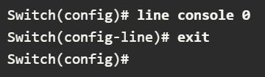
To move from any subconfiguration mode of the global configuration mode to the mode one step above it in the hierarchy of modes, enter the exit command.
To move from any subconfiguration mode to the privilege EXEC mode, enter the end command or enter the key combination Ctrl+Z.
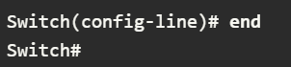
You can also move directly from one subconfiguration mode to another. Notice how after selecting an interface, the command prompt changes from (config-line)# to (config-if)#.
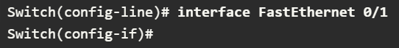

Note About Syntax Checker Activities
When you are learning how to modify device configurations, you might want to start in a safe, non-production environment before trying it on real equipment. NetAcad gives you different simulation tools to help build your configuration and troubleshooting skills. Because these are simulation tools, they typically do not have all the functionality of real equipment. One such tool is the Syntax Checker. In each Syntax Checker, you are given a set of instructions to enter a specific set of commands. You cannot progress in Syntax Checker unless the exact and full command is entered as specified. More advanced simulation tools, such as Packet Tracer, let you enter abbreviated commands, much as you would do on real equipment.

The Command Structure

Basic IOS Command Structure
This topic covers the basic structure of commands of the Cisco IOS. A network administrator must know the basic IOS command structure to be able to use the CLI for devices configuration.
A Cisco IOS device supports many commands. Each IOS command has a specific format, or syntax, and can only be executed in the appropriate mode. The general syntax for a command, shown in the figure, is the command followed by any appropriate keywords and arguments.
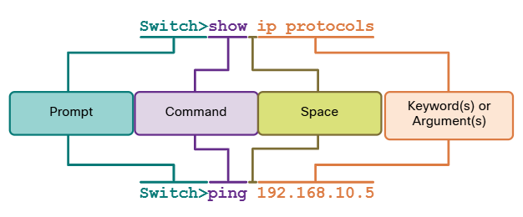
- Keyword – This is a specific parameter defined in the operating system (in the figure, ip protocols).
- Argument – This is not predefined; it is a value or variable defined by the user (in the figure, 192.168.10.5).
After entering each complete command, including any keywords and arguments, press the Enter key to submit the command to the command interpreter.

IOS Command Syntax Check
A command might require one or more arguments. To determine the keywords and arguments required for a command, refer to the command syntax. The syntax provides the pattern, or format, that must be used when entering a command.
As identified in the table, boldface text indicates commands and keywords that are entered as shown. Italic indicates an argument for which the user provides the value.
Boldface | Boldface text indicates commands and keywords that you enter literally as shown.
Italics | Italic text indicates arguments for which you supply values.
[square brackets] | [Square brackets] indicate an optional element (keyword or argument).
{braces} | {braces} indicate a required element (keyword or argument).
[braces { and | vertical } lines ] | Braces and vertical lines within square brackets indicate a required choice within a optional element. Spaces are used to clearly delineate parts of the command.

For instance, the syntax for using the description command is description string. The argument is a string value provided by the user. The description command is typically used to identify the purpose of an interface. For example, entering the command, description Connects to the main headquarters office switch, describes where the other device is at the end of the connection.
The following examples demonstrate conventions used to document and use IOS commands:
- Ping ip-address – The command is ping and the user-defined argument is the ip-address of the destination device. For example, ping 10.10.10.5
- Traceroute ip-adress – The command traceroute and the user-defined argument is the ip-address of the destination device. For example, traceroute 192.168.254.254.
If a command is complex with multiple arguments, you may see it represented like this:
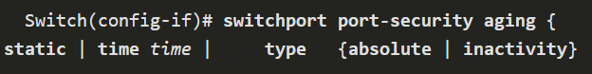
The command will typically be followed with a detailed description of the command and each argument.
The Cisco IOS Command Reference is the ultimate source of information for a particular IOS command.

IOS Help Features
The IOS has two forms of help available: context-sensitive help and command syntax check.
Context-sensitive help enables you to quickly find answers to these questions:
- Which commands are available in each command mode?
- Which command starts with specific characters or group of characters?
- Which arguments and keywords are available to particular commands?

To access context-sensitive help, simply enter a question mark at the CLI.
Command syntax check verifies that a valid command was entered by the user. When a command is entered, the command line interpreter evaluates the command from left to right. If the interpret understands the command, the requested action is executed, and the CLI returns to the appropriate prompt. However, if the interpreter cannot understand the command being entered, it will provide feedback describing what is wrong with the command.

Hot Keys and Shortcuts
The IOS CLI provides hot keys and shortcuts that make configuring, monitoring, and troubleshooting easier.
Commands and keywords can be shortened to the minimum number of characters that identify a unique selection. For example, the configure command can be shortened to conf because configure is the only command that begins with conf. An even shorter version, con, will not work because more than one command begins with con. Keywords can also be shortened.
The table lists keystrokes to enhance command line editing.
TAB | Completes a partial command name entry
BACKSPACE | Erases the character to the left of the cursor
CTRL + D | Erases the character at the cursor
CTRL + K | Erases all character from the cursor to the end of the command line
ESC D | Erases all characters from the cursor to the end of the word
CTRL + U or CTRL + X | Erases all characters from the cursor back to the beginning of the command line
CTRL + W | Erases the word to the left of the cursor
CTRL + A | Moves the cursor to the beginning of the line
LEFT ARROW or CTRL + B | Moves the cursor one character to the left
ESC B | Moves the cursor back one word to the left
ESC F | Moves the cursor forward one character to the right
UP ARROW or CTRL + P | Recalled the previous command in the history buffer, beginning with the most recent command
DOWN ARROW or CTRL + N | Goes to the next line in the history buffer
CTRL + R or CTRL + I or CTRL + L | Redisplays the system prompt and command line after a console message is received

Note: While the DELETE key typically deletes the character to the right of the prompt, the IOS command structure does not recognize the DELETE key.
When a command output produces more text than can be displayed in a terminal window, the IOS will display a “—More—” prompt. The following table describes the keystrokes that can be used when this prompt is displayed.
ENTER Key | Displays the next line
SPACE BAR | Displays the next screen
Any other key * | Ends the display string, returning to previous prompt.  *Except “y”, which answers “yes” to the –More—prompt, and acts like the SPACE BAR

This table lists commands used to exit out of an operation,

CTRL + C | When in any configuration mode, end the configuration mode and returns to privileged EXEC mode. When in setup mode, aborts ack to the command prompt.
CTRL + Z | When in any configuration mode, ends the configuration mode and returns to privileged EXEC mode.
CTRL + SHIFT + 6 | All-purpose break sequence used to abort DNS lookups, traceroutes, pings, etc.

Basic Device Configuration

Device Name
You have learned a great deal about the Cisco IOS, navigating the IOS, and the command structure. Now you’re ready to configure devices! The first configuration command on any device should be to give it a unique device name or hostname. By default, all devices are assigned a factory default name. For example, a Cisco IOS switch is “Switch.”
The problem is, if all switches in a network were let with their default names, it would be difficult to identify a specific device. For instance, how would you know that you are connected to the right device when accessing it remotely using SSH? The hostname provides confirmation that you are connected to the correct device.
The default name should be changed to something more descriptive. By choosing names wisely, it is easier to remember, document and identify network devices. Here are some important naming guidelines for hosts.
  - Start with a letter
  - Contain no spaces
  - End with a letter or digit
  - Use only letter, digits and dashes
  - Be less than 64 characters in length

An organization must choose a naming convention that makes it easy and intuitive to identify a specific device. The hostnames used in the device IOS preserve capitalization and lowercase characters. For example, the figure shows that three switches, spanning three different floors, are interconnected together in a network. The naming convention that was used incorporated the location and the purpose of each device. Network documentation should explain how these name were chosen so additional devices can be named accordingly.
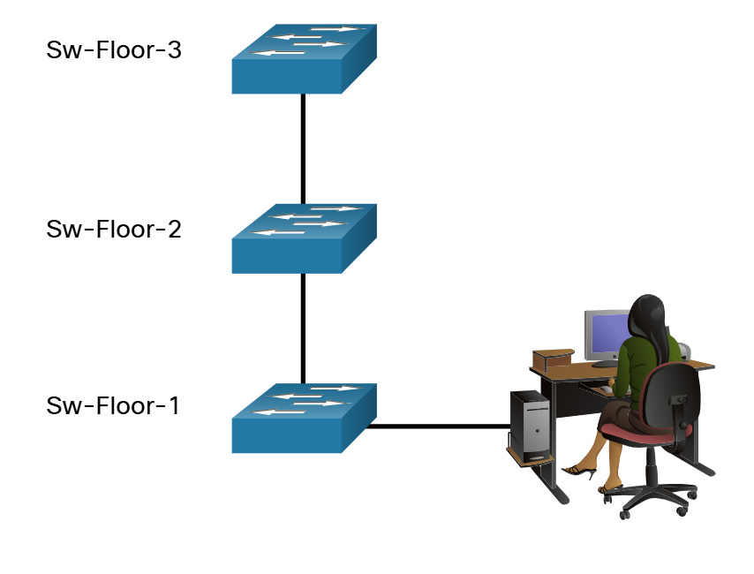
When the naming convention has been identified, the next step is to use the CLI to apply the names to the devices. As shown in the example, from the privileged EXEC mode, access the global configuration mode by entering the configure terminal command.
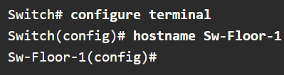

From global configuration mode, enter the command hostname followed by the name of the switch and press Enter.
Note: To return the switch to the default prompt, use the no hostname global config command.
Always make sure the documentation is updated each time a device is added or modified. Identify devices in the documentation by their location, purpose, and address.

Password Guidelines
The use of weak or easily guessed passwords continues to be the biggest security concern of organizations. Network devices, including home wireless routers, should always have passwords configured to limit administrative access.
Cisco IOS can be configured to use hierarchical mode passwords to allow different access privileges to a network device.
All networking devices should limit administrative access by securing privileged EXEC, user EXEC, and remote Telnet access with passwords. In addition, all passwords should be encrypted and legal notifications provided.
When choosing passwords, use strong passwords that are not easily guessed. There are some key points to consider when choosing passwords:
  - Use passwords that are more than eight characters in length
  - Use a combination of upper and lowercase letters, numbers, special characters and/or numeric sequences
  - Avoid using the same password for all devices
  - Do not use common words because they are easily guessed

Use an internet search to find a password generator. Many will allow you to set the length, character set and other parameters.
Note: Most of the labs in this course use simple passwords such as cisco or class. These passwords are considered weak and easily guessable and should be avoided in production environments. We only use these passwords for convenience in a classroom setting, or to illustrate configuration examples.

Configure Passwords
When you initially connect to a device, you are in user EXEC mode. This mode is secured using the console.
To secure user EXEC mode access, enter line console configuration mode using line console 0 global configuration command, as shown in the example. The zero is used to represent the first (and in most cases the only) console interface. Next, specify the user EXEC mode password using the password password command. Finally, enable user EXEC access using the login command.
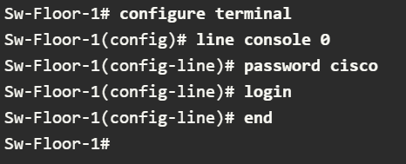
Console access will now require a password before allowing access to the user EXEC mode.
To have administrator access to all IOS commands including configuring a device, you must gain privileged EXEC mode access. It is the most important access method because it provides complete access to the device.
To secure privileged EXEC access, use the enable secret password global config command, as shown in the example.
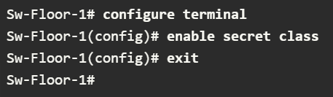
Virtual terminal (VTY) lines enable remote access using Telnet or SSH to the device. Many Cisco witches support up to 16 VTY lines that are numbered 0 to 15.
To secure VTY lines, enter the line VTY mode using the line vty 0 15 global config command. Next, specify the VTY password using the password password command. Lastly, enable VTY access using login command.
An example of securing the VTY lines on a switch is shown.
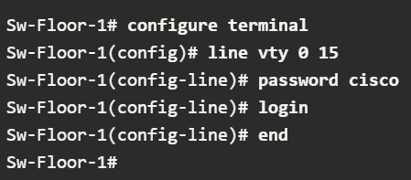

Encrypt Passwords
The startup-config and running-config files display most passwords in plaintext. This is a security threat because anyone can discover the passwords if they have access to these files.
To encrypt all plaintext passwords, use the service password-encryption global config command as shown in the example.
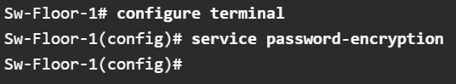

The command applies weak encryption to all unencrypted passwords. This encryption applies only to passwords in the configuration file, not to passwords as they are sent over the network. The purpose of this command is to keep unauthorized individuals from viewing passwords in the configuration file.
Use the show running-config command to verify that passwords are now encrypted.
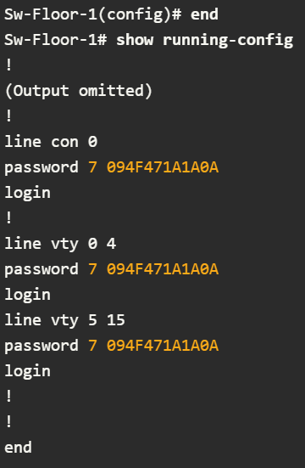

Banner Messages
Although requiring passwords is one way to keep unauthorized personnel out of the network, it is vital to provide a method for declaring that only authorized personnel should attempt to access the device. To do this, add a banner to the device output. Banners can be an important part of the legal process if someone is prosecuted for breaking into a device. Some legal systems do not allow prosecution, or even the monitoring of users, unless a notification is visible.
To create a banner message of the day on a network device, use the banner motd # the message of the day # global config command. The “#” in the command syntax is called the delimiting character. It is entered before and after the message. The delimiting character can be any character as long as it does not occur in the message. For this reason, symbols such as “#” are often used. After the command is executed, the banner will be displayed on all subsequent attempts to access the device until the banner is removed.
The following example shows the steps to configure the banner on Sw-Floor-1.


Save Configurations

Configuration Files
You know how to perform basic configuration on a switch, including passwords and banner messages. This topic will show you how to save your configurations.
There are two system files that store the device configuration:
  - Startup-config – This is the saved configuration file that is stored in NVRAM. It contains all the commands that will be use by the device upon start or reboot. Flash does not lose its contents hen the device is powered off.
  - running-config – This is stored in Random Access Memory (RAM). It reflects the current configuration. Modifying a running configuration affects the operation of a Cisco device immediately. RAM is volatile memory. It loses all of its content when the device is powered off or restarted.

The show running-config privileged EXEC mode command is used to view the running config. As shown in the example, the command will list the complete configuration currently stored in RAM.
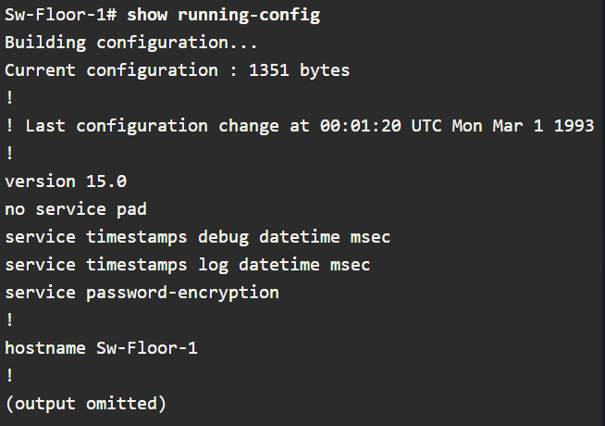
To view the startup configuration file, use the show startup-config privileged EXEC command.
If power to the device is lost, or if the device is restarted, all configuration changes will be lost unless they have been saved. To save changes made to the running configuration to the startup configuration file, use the copy running-config startup-config privileged EXEC mode command.

Alter the Running Configuration
If changes made to the running config do not have the desired effect and the running-config has not yet been saved, you can restore the device to its previous configuration. Remove the changed commands individually or reload the device using the reload privileged EXEC mode command to restore the startup-config.
The downside to using the reload command to remove an unsaved running config is the brief amount of time the device will be offline, causing network downtime.
When a reload is initiated, the IOS will detect that the running config has changed that were not saved to the startup configuration. A prompt will appear to ask whether to save the changes. To discard the changes, enter n or no.
Alternatively, if undesired changes were saved to the startup config, it may be necessary to clear all the configuration. This requires erasing the startup config and restarting the device. The startup config is removed by using the erase startup-config privilege EXEC mode command. After the command is issued, the switch will prompt you for confirmation. Press ENTER to accept.
After removing the startup config from NVRAM, reload the device to remove the current running config file from RAM. On reload, a switch will load the default startup config that originally shipped with the device.

Capture Configuration to a Text File
Configuration files can also be saved and archived to a text document. This sequence of steps ensures that a working copy of the configuration file is available for editing or reuse later
For example, assume that a switch has been configured, and the running config has been saved on the device.
Step 1. Open terminal emulation software, such as PuTTY or Tera Term, that is already connect to a switch.
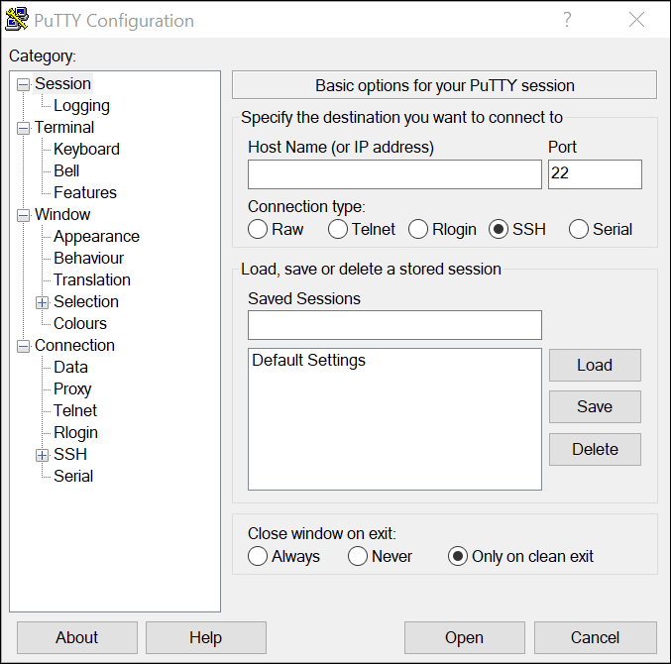
Step 2. Enable logging in the terminal software and assign a name and file location to save the log file. The figure displays that All session output will be captured to the file specified (i.e., MySwitchLogs.)
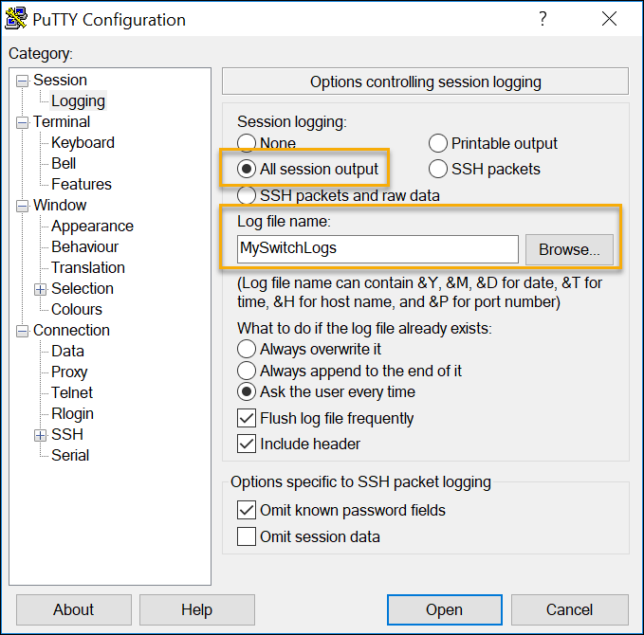

Step 3. Execute the show running-config or show startup-config command at the privileged EXEC prompt. Text displayed in the terminal window will be placed into the chosen file.
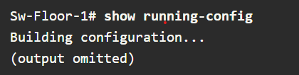
Step 4. Disable logging in the terminal software. The figure shows how to disable logging by choosing None session logging option.
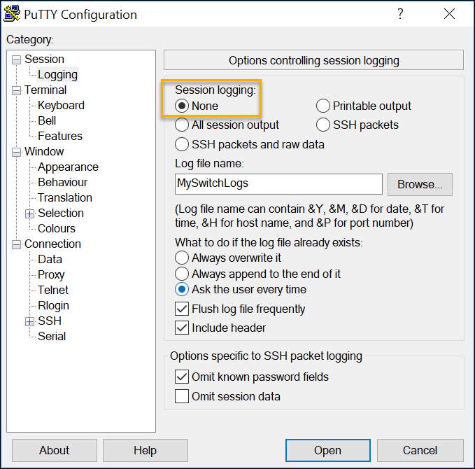

The text file created can be used as a record of how the device is currently implemented. The file could require editing before being used to restore as saved configuration to a device.
To restore a configuration file to a device:
Step 1. Enter global configuration mode on the device.
Step 2. Copy and paste the text file into the terminal window connected to the switch.
The text in the file will be applied as commands in the CLI and become the running configuration on the device. This is a convenient method of manually configurating a device.

Ports and Address

IP Addresses
If you want your end devices to communicate with each other, you must ensure that each of them has an appropriate IP address and is correctly connected. You will learn about IP addresses, device ports and the media used to connect devices in this topic.
The use of IP addresses is the primary means of enabling devices to locate one another and establish end-to-end communication on the internet. Each end device on a network must be configured with an IP address. Examples of end devices include the following:
  - Computers (work stations, laptops, file servers, web servers)
  - Network printers
  - VoIP phones
  - Security cameras
  - Smart phones
  - Mobile handheld devices (such as wireless barcode scanners_

The structure of an IPv4 address is called dotted decimal notation and is represented by four decimal numbers between 0 and 255. IPv4 addresses are assigned to individual devices connected to a network.
Note: IP in this course refers to both IPv4 and IPv6 protocols. IPv6 is the most recent version of IP and is replacing the more common IPv4.
With the IPv4 address, a subnet mask is also necessary. An IPv4 subnet mask is a 32-bit value that differentiates the network portion of the address from the host portion. Coupled with the IPv4 address, the subnet mask determines which subnet the device is a member
The example in the figure displays the IPv4 address (192.168.1.10), subnet mask (255.255.255.0), and default gateway (192.168.1.1) assigned to a host. The default gateway address is the IP address of the router that the host will use to access remote networks, including the internet.
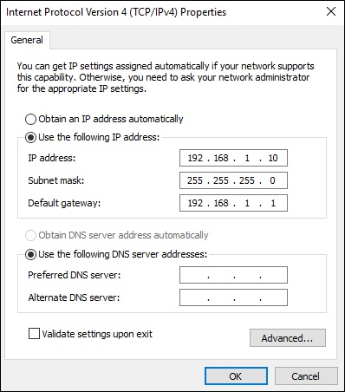
IPv6 addresses are 128 bits in length and written as a string of hexadecimal values. Every four bits is represented by a hexadecimal digit; for a total of 32 hexadecimal values Groups of four hexadecimal digits are separated by a colon. IPv6 addresses are not case-sensitive and can be written in either lowercase or uppercase.

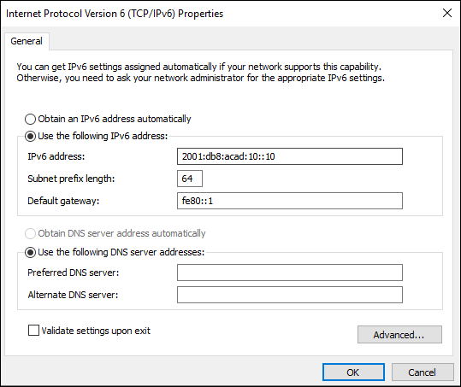

Interfaces and Ports
Network communications depend on end user device interfaces, networking device interfaces, and the cables that connect them. Each physical interface has specifications, or standards, the define it. A cable connecting to the interface must be designed to match the physical standards of the interface. Types of network media include twisted-pair copper, fiber-optic cables, coaxial cables, or wireless.
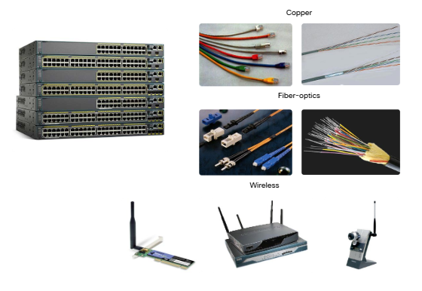
Different types of network media have different features and benefits. Not all network media have the same characteristics. Not all media are appropriate for the same purpose. These are some of the differences between various types of media:
  - Distance the media can successfully carry a signal
  - Environment in which the media is to be installed
  - Amount of data and the speed at which it must be transmitted
  - Cost of the media and installation

Not only does each link on the internet require a specific network media type, but each link also requires a particular network technology. For example, Ethernet is the most common local-area network (LAN) technology used today. Ethernet ports are found on end-user devices, switch devices and other networking devices that can physically connect to the network using a cable.
Cisco IOS Layer 2 switches have physical ports for devices to connect. These ports do not support Layer 3 IP addresses. Therefore, switches have one or more switch virtual interfaces (SVIs). These are virtual interfaces because there is no physical hardware on the device associated with it. An SVI is created in software.
The virtual interface lets you remotely manage a switch over a network using IPv4 and IPv6. Each switch comes with one SVI appearing in the default configuration “out of the box”. The default SVI is interface VLAN1.
Note: A Layer 2 switch does not need an IP address. The IP address assigned to the SVI is use to remotely access the switch. An IP address is not necessary for the switch to perform its operation.

Configure IP Addressing

Manual IP Address Configuration for End Devices
Much like you need your friends’ telephone numbers to text or call them, end devices in your network need an IP address so that they can communicate with other devices on your network. In this topic, you ill implement basic connectivity by configuring IP addressing on switches and PCs.
IPv4 address information can be entered into end devices manually, r automatically using Dynamic Host Configuration Protocol (DHCP).
To manually configure an IPv4 address on a Windows host, open the Control Panel > Network Sharing Center > Change adaptor setting and choose the adaptor. Next, right-click and select Properties to display the Local Area Connection Properties, as shown in the figure.
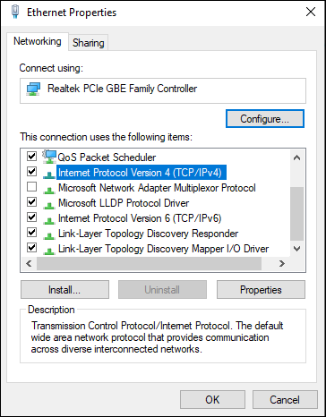
Highlight Internet Protocol Version 4 (TCP/IPv4) and click Properties to open the Internet Protocol Version 4 (TCP/IPv4) Properties window, shown in the figure. Configure the IPv4 address and subnet mask information and default gateway.
Note: IPv6 addressing and configuration are similar to IPv4.
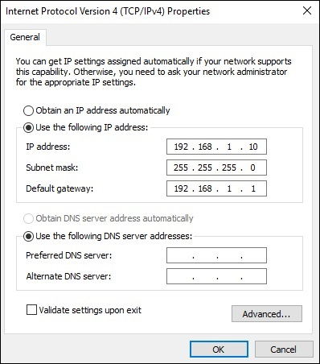
Note: The DNS server addresses are the IPv4 and IPv6 addresses of the Domain Name System (DNS) server, which are use to translate IP addresses to domain names.

Automatic IP address Configuration for End Devices
End devices typically default to using DHCP for automatic IPv4 address configuration. DHCP is a technology that is used in almost every network. The best way to understand why DHCP is so popular is by considering all the extra work that would have to take place without.
In a network, DHCP enable automatic IPv4 address configuration for every end device that is DHCP-enabled. Imagine the amount of time it would take I every time you connected to the network, you had to annually enter the IPv4 address, the subnet mask, the default gateway, and the DNS serv er. Multiple that by every user and every device in an organization and you see the problem. Manual configuration also increases the chance of misconfiguration by duplication another device’s IPv4 address.
As shown in the figure, to configure DHCP on a Windows PC, you only need to select Obtain an IP address automatically and Obtain DNS server address automatically. You PC will search out a DHCP server and be assigned the address settings necessary to communicate on the network.
Note: IPv6 uses DHCPv6 and SLAAC (Stateless Address Autoconfiguraton) for dynamic address allocation.
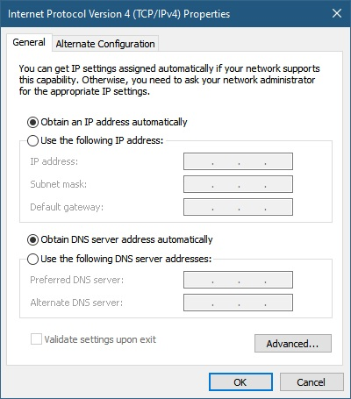

Switch Virtual Interface Configuration
To access the switch remotely, an IP address and a subnet mask must be configured on the SVI. To configure an SVI on a witch, use the interface vlan 1 global configuration command. VLAN 1 is not an actual physical interface but a virtual one. Next assign an IPv4 address using the ip address ip-address subnet mask interface configuration command. Finally, enable the virtual interface using the no shutdown interface configuration command.
After these commands are configured, the switch has all the IPv4 elements ready for communication over the network.
Note: Similar to a Window host, switch configured with IPv4 address will typically also need to have default gateway assigned. This can be done using the ip default-gateway ip-address parameter would be the IPv4 address of the local router on the network, as shown in the example. However, in this module you will only be configuring a network with switches and hosts. Routers will be introduced later.
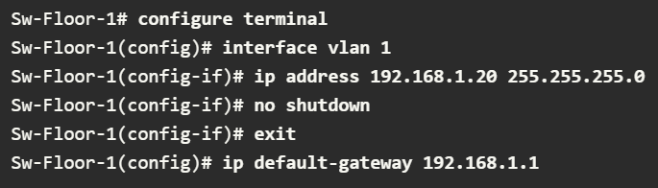

Networking Summary 2.0
- All end devices and network device require an operating system (OS)
- Cisco IOS software separates management access into the following two command modes: User EXEC Mode and Privilege EXEC Mode.
- Global configurations mode is access before other specific configuration modes. Rom global config mode, the user can enter different sub-configuration modes.
- Each IOS command has a specific format or syntax and can only be executed in the appropriate mode.
- Basic device configurations: hostname, password, encrypt passwords and banner.
- There are two system files that store the device configurations: startup-config and running-config
- IP addresses enable devices to locate one another and establish end-to-end communication on the internet. Each end device on a network must be configured with an IP address.

Protocols and Models

The Rules

Communications Fundamentals
Networks vary in size, shape and function. They can be as complex as devices connected across the internet, or as simple as two computers directly connected to one another with a single cable an anything in-between. However, simply having a wired or wireless physical connection between end devices is not enough to enable communication. For communication to occur, devices must know “how” to communicate.
People exchange ideas using many different communication methods. However, all communication methods have the following three elements in common:
  - Message source (sender) – Message sources are people, or electronic devices, that need to send a message to other individuals or devices.
  - Message Destination (receiver) – The destination receives the message interprets it.
  - Channel – This consists of the media that provides the pathway over which the message travels from source to destination.

Communication Protocols
Sending a message, whether by face-to-face communication or over a network, is governed by rules called protocols. These protocols are specific to the type of communication method being used. In our day-to-day personal communing, the rules we use to communicate over one medium, like a telephone call, are not necessarily the same as the rules for using another medium, such as sending a letter.
The process of sending a letter is a like communication that occurs in computer networks.
Imagine two people attempting to communicate, face-to-face.
They must agree on how to communicate. If the communication is to be voice, they must first agree on the language. Next, they will have to format the message they want to communicate in a way that is understandable. If the language is English, but poor sentence structure is used, then the message may be misunderstood.

Rule Establishment
Before communicating with another, individuals must use established rules or agreements to govern the conversation. Consider this message for example
“humans communication between govern rules. It is verydifficult tounderstand messages that are not correctly formatted and donot follow the established rules and protocols. A estrutura da gramatica, da lingua, da pontuacao e do sentence faz a configuracao humana compreensivel por muitos individuos diferentes.”
It is difficult to read the message because it is not formatted properly. It should be written using rules (i.e., protocols) that are necessary for effective communication. The example below shows the message, following proper protocols:

“Rules govern communication between humans. It is very difficult to understand messages that are not correctly formatted and do not follow the established rules and protocols. The structure of the grammar, the language, the punctuation and the sentence make the configuration humanly understandable for many different individuals.”
Protocols must account for the following requirements to successfully deliver a message that is understood by the receiver:
  - An identified sender and receiver
  - Common language and grammar
  - Speed and timing of delivery
  - Confirmation or acknowledgement of requirements.

Network Protocol Requirements
The protocols that are used in network communications share many of these fundamental traits. In addition to identifying the source and destination, computer and network protocols define the details of how a message s transmitted across a network. Common computer protocols include the following requirements:
  - Message encoding
  - Message formatting and encapsulation
  - Message size
  - Message timing
  - Message delivery options

Message Encoding
One of the first steps to sending a message is encoding. Encoding Is the process of converting information into another acceptable form, for transmission. Decoding reverses this process to interpret the information.

Imagine a person calls a friend to discuss the details of a beautiful sunset. To communicate the message, she converts her thoughts into an agreed upon language. She then speeds the words using the sounds and inflections of the spoken language that convey the message. Her friend then listens to the description and decodes the sounds to understand the message he received.

Encoding between hosts must be in an appropriate format for the medium. Messages sent across the network are first converted into bits by the sending host. Each bit is encoded into a pattern of voltages on copper wires, infrared light in optical fibers, or microwaves for wireless systems. The destination host receives an decodes the signals to interpret the message

Message Formatting and Encapsulation
When a message is sent from the source to the destination, it must use a specific format or structure. Message formats depend on the type of message and the channel that is used to deliver the message.
A common example of requiring the correct format in human communication is when sending a letter. An envelope has the address of the sender and receiver; each located at the proper place on the envelope. If it’s destination address and formatting are not correct, the letter is not delivered.
The process of placing one message format (the letter) inside another message format (the envelope) is called encapsulation. De-encapsulation occurs when the process is reversed by the recipient, and the letter is removed from the envelope.
Similar to sending a letter, a message that is sent over a computer network follows specific format rules for it to be delivered and processed.
Internet Protocol (IP) is a protocol with a similar function to the envelope example. In the figure, the fields of the Internet Protocol version 6 (IPv6) packet identify the source of the packet and its destination. IP is responsible for sending a message from the message source to destination over one or more networks.

Message Size
When people communicate with each other, the messages that they send are usually broken into smaller parts or sentences. These sentences are limited in size to what the receiving person can process at one time.
Likewise, when a long message is sent from one host to another over a network, it is necessary to break the message into smaller pieces. The rules that govern the size of the pieces or frames, communicated across the network are very strict. They can also be different, depending on the channel used. Frames that are too long or too short are not delivered.
The size restrictions of frames require the source host to break a long message into individual pieces that meet both the minimum and maximum size requirements. The long message will be sent in separate frames, with each frame containing a piece of the original message. Each frame will also have its own addressing information at the receiving host, the individual pieces of the message are reconstructed into the original message.

Message Timing
Message timing is also very important in network communications. Message timing includes the following:
  - Flow Control – This is the process of managing the rate of data transmission. Flow control defines how much information can be sent and the speed at which it can be delivered. For example, if one person speaks too quickly, it may be difficult for the receiver to hear and understand the message. In network communication, there are network protocols used by the source and destination devices to negotiate and manage the flow of information.
  - Response Timeout – If a person asks a question and does not hear a response within an acceptable amount of time, the person assumes that no answer is coming and reacts accordingly. The person may repeat the question or instead may go on with the conversation. Hosts on the network use network protocols that specify how long to wait for responses and what action to take if a response timeout occurs.
  - Access method – This determines when someone can send a message. When a device wants to transmit on a wireless LAN, it is necessary for the WLAN network interface card (NIC) to determine whether the wireless medium is available.

Message Delivery Options
A message can be delivered in different ways
Sometimes, a person wants to communicate information to a single individual. At other times, the person may need to send information to a group of people at the same time, or even to all people in the same area.
Network communications has similar delivery options to communicate. There are three types of data communication:
  - Unicast – Information is being transmitted to a single end device
  - Multicast – Information is being transmitted to one or more end devices
  - Broadcast – Inormation is being transmitted to all end devices

Note: The multicast animation is indicating the destination devices. By default, a switch will end multicast packets out all ports except the incoming port. However, only the hosts that are part of the multicast group will process the packet.

Protocols

Network Protocols Overview
You know that for end devices to be able to communicate over a network, each device must abide by the same set of rules. These rules are called protocols, and they have many functions in a network. This topic gives you an overview of network protocol.
Network protocols define a common format and set of rules for exchanging messages between devices. Protocols are implemented by end devices and intermediary devices. Protocols are implemented by end devices and intermediary devices in software, hardware or both. Each network protocol has its own function, format, and rules for communications.
The table lists the various types of protocols that are needed to enable communications across one or more networks.
Network Communications Protocols | Protocols enable two or more devices to communicate over one or more networks. The Ethernet family of technologies involves a variety of protocols such as IP, Transmission Control Protocol (TCP), HyperText Transfer Protocol(HTTP) and many more
Network security Protocols | Protocols secure data to provide authentication, data integrity, and data encryptions. Examples of secure protocols include Secure Shell (SSH), Secure Sockets Layers (SSL) and Transport Layer Security (TLS)
Routing Protocols | Protocols enable routers to exchange route information, compare path information and then to select the best ath to the destination network. Examples of routing protocols include Open Shortest Path First (OSPF) and Border Gateway Protocol (BGP)
Service Discovery Protocols | Protocols are use for the automatic detection of devices for services. Examples of service discovery protocols include Dynamic Host Configuration Protocol (DHCP) which discovers services for IP address allocation and Domain Name System (DNS) which is used to perform name-to-IP address translation.

Network Protocol Functions
Network communication protocols are responsible for a variety of functions necessary for network communications between end devices.
Computers and network devices used agreed-upon protocols to communicate. The table lists the functions of these protocols.
Addressing | This identifies the sender and the intended receiver of the message using a defined addressing scheme. Examples of protocols that provide addressing include Ethernet IPv4 and IPv6
Reliability | This function provides guaranteed delivery mechanisms in case messages are lost or corrupted in transit. TCP provides guaranteed delivery.
Flow control | This function provides guaranteed delivery mechanisms in case messages are lost or corrupted in transit TCP provides guarantees delivery
Sequencing | This function uniquely labels each transmitted segment of data/ The receiving device uses the sequencing information to reassemble the information correctly. This is useful if the data segments are lost, delayed or received out-of-order. TCP provides sequencing services.
Error Detection | This function is used to determine if data became corrupted during transmission. Various protocols that provide error detection include Ethernet, IPv4, IPv6 and TCP
Application Interface | This function contains information used for process-to-process communications between network applications. For example, when accessing a web page, HTTP or HTTPS protocols are use to communicate between the client and server web processes.

Protocol Interaction
A message sent over a computer network typically requires the use of several protocols, each one with its own functions and format. The figure shows some common network protocols that are used when a device sends a request to a web server for its web page.
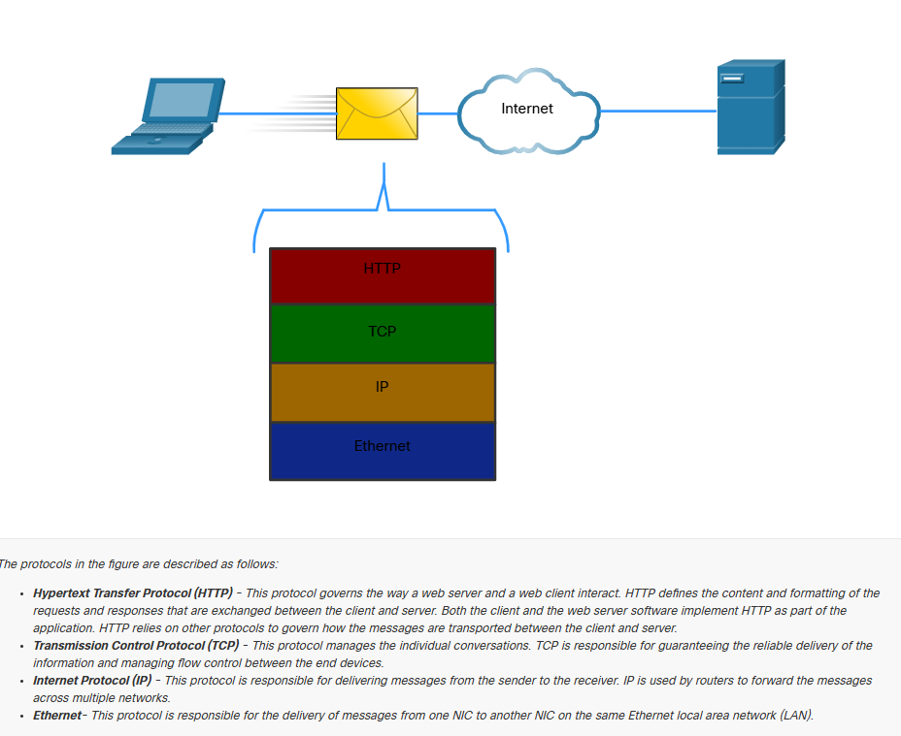

Protocol Suites

Network Protocol Suites
In many cases, protocols must be able to work with other protocols so that your online experience gives you everything you need for network communication. Protocols suites are designed to work with each other seamlessly.
A protocol suite is a group of inter-related protocols necessary to perform a communication function.
One of the best ways to visualize the protocols within a suite interact is to view the interaction as a stack. A protocol stack shows how the individual protocols within a suite are implemented. The protocols are viewed in terms of layers, with each higher-level service depending on the functionality defined by the protocol shown in the lower levels. The lower layer of the stack are concerned with moving data over the network and providing services to the upper layers, which are focused on the content of the message being sent.
As illustrated in the figure, we can use layers to describe the activity occurring in face-to-face communication. At the bottom is the physical layer where we have two people with voices saying words out loud. In the middle is the rules layer that stipulates the requirements of communication including that a common language must be chosen. At the top is the content layer and this is where the content of the communication is spoken.
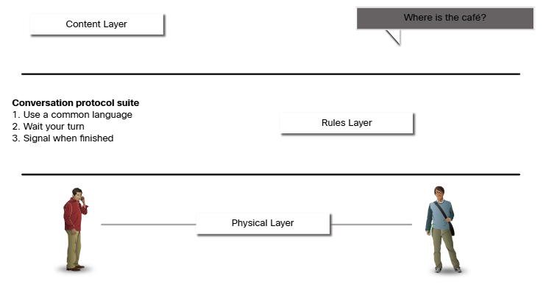

Evolution of Protocol Suites
A protocol suite is a set of protocols that work together to provide comprehensive network communication services. Since the 1970s there have been several different protocol suites, some developed by a standards organization and other developed by various venders.
During the evolution of network communications and the internet there were several competing protocol suites, as shown in the figure.
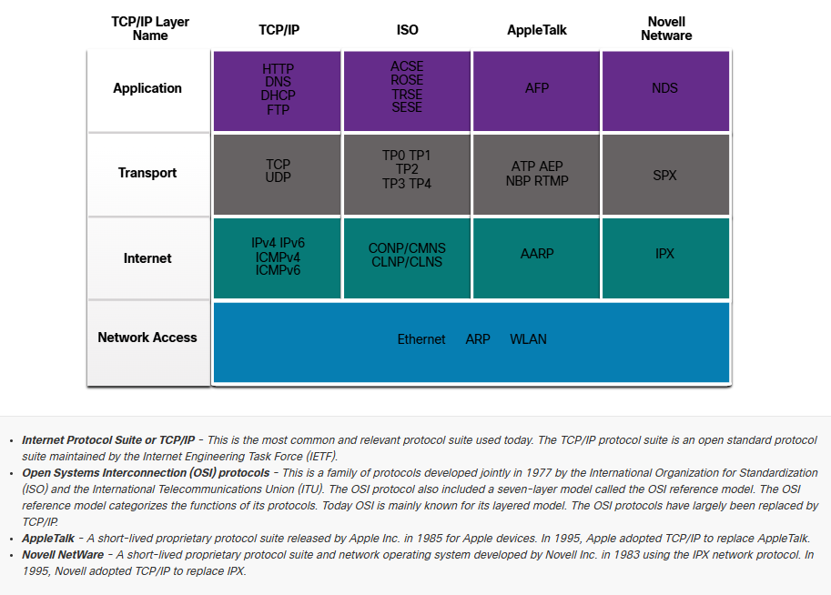

TCP/IP Protocol Example
TCP/IP Protocols are available for the application, transport and internet layers. There are no TCP/IP protocols in the network access layer. The most common network access layer LAN protocols are Ethernet and WLAN (wireless LAN) protocols. Network access layer protocols are responsible for delivering the IP packet over the physical medium.
The figure shows an example of the three TCP/IP protocols used to send packets between the web browser of a host and the web server. HTTP, TCP and IP are the TCP/IP protocols used. At the network access layer, Ethernet is used in the example. However, this could also be a wireless standard such as a WLAN or cellular service.
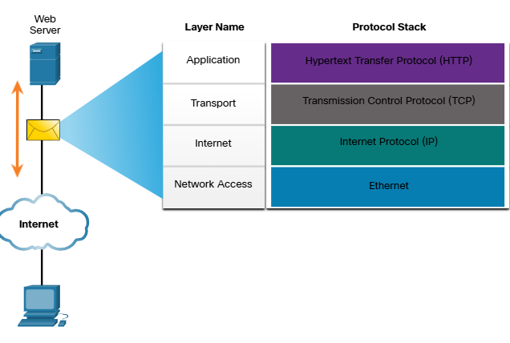

TCP/IP Protocol Suite
Today, the TCP/IP protocol suite includes many protocols and continues to evolve to support new service. Some of the more popular ones are shown in the figure.
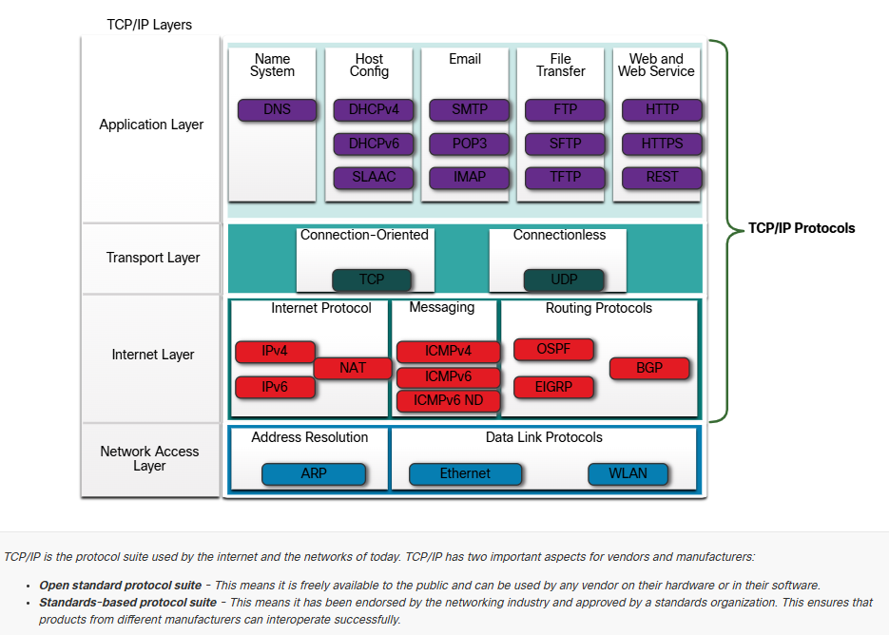
The following is a brief description of protocols at each layer.
Application Layer
Name System
    - DNS – Domain Name System. Translates domain names such as cisco.com, into IP addresses
Host Configuration
    - DHCPv4 – Dynamic Host Configuration Protocol for IPv4. A DHCPv4 server dynamically assigns IP4 addressing information to DHCP4 clients at start-up and allows the addresses to be re-use when no longer needed
    - DHCPv6 – Dynamic Host Configuration Protocol for IPv6. DHCPv6 is similar to DHCPv4. A DHCPv6 server dynamically assigns IPv6 address information to DHCPv6 clients at start-up.
    - SLAAC – Stateles Adress Autoconfiguration. A method that allows a device to obtain its IPv6 addressing information without using a DHCPv6 server
Email
    - SMTP – Simple Mail Transfer Protocol. Enables clients to send email to a mail server and enables servers to send emails to other servers.
    - POP3 – Post Office Protocol version 3. Enables clients to retrieve email from a mail server and download the email to the client’s local mail application
    - IMAP – Internet Message Access Protocol. Enables clients to access email stored on a mail server as well as maintaining email on the server.
File Transfer
    - FTP – File Transfer Protocol. Sets the rules that enable as user on one host to access and transfer files to and from another host over a network. FTP is a reliable, connection-oriented, and acknowledged file delivery protocol.
    - SFTP – SSH File Transfer Protocol. As an extension to Secure Shell (SSH) protocol, SFTP can be used to establish a secure file transfer session in which the file transfer is encrypted. SSH is a method for secure remote login that is typically used for accessing the command line of a device.
    - TFTP – Trivial File Transfer Protocol. A simple, connectionless file transfer protocol with best-effort, unacknowledged file delivery. IT uses less overhead than FTP.
Web and Web Service
    - HTTP – Hypertext transfer Protocol. A set of rules for exchanging text, graphic images, sound, video and other multimedia files on the World Wide Web.
    - HTTPS – HTTP Secure. A secure form of HTTP that encrypts the data that is exchanged over the World Wide Web.
    - REST – Representational State Transfer. A web service that uses application programming interfaces (APIs) and HTTP requests to create web applications.
Transport Layer
Connection-Oriented
    - TCP – Transmission Control Protocol. Enables reliable communication between processes running on separate hosts and provides reliable, acknowledged transmissions that confirm successful delivery

Connectionless
    - UDP – User Datagram Protocol. Enables a process running on one host to send packets to a process running on another host. However, UDP does not confirm successful datagram transmission.
Internet Layer
Internet Protocol
    - IPv4 – Internet Protocol version 4. Receives message segments from the transport layer, packages messages into packets, and addresses packets for end-to-end delivery over a network. IPv4 uses a 32-bit address
    - IPv6 – Internet Protocol version 6. Similar to IPv4 but uses a 128-bit address
    - NAT – Network Address Translation. Translate IPv4 addresses from a private network into globally unique public IPv4 addresses
Messaging
    - ICMPv4 – Internet Control Message Protocol for IPv4. Provide feedback from a destination host to a source host about errors in packet delivery.
    - ICMPv6 – ICMP for Pv6. Similar functionality to ICMPv4 but is use for IPv6 packets.
    - ICMPv6 ND – ICMPv6 Neighbour Discovery. Includes four protocol messages that are used for address resolution and duplicate address detection.
Routing Protocol
    - OSPF – Open Shortest Path First. Link-state routing protocol that uses a hierarchical design based on areas. OSPF is an open standard interior routing protocol.
    - EIGRP – Enhanced Interior Gateway Routing Protocol. An open standard routing protocol developed by cisco that uses a composite metric based on bandwidth, delay, load and reliability.
    - BGP – Border Gateway Protocol. An open standard exterior gateway routing protocol used between Internet Service Providers (ISPs). BGP is also commonly used between ISPs and their large private clients to exchange routing information.

Network Access Layer
Address Resolution
    - ARP – Address Resolution Protocol. Provides dynamic address mapping between an IPv4 address and a hardware address
Note: You may see other documentation state that ARP operates at the Internet Layer (OSI Layer 3). However, in this course we state that ARP operates at the Network Access Layer (OSI Layer 2) because it’s primary purpose is to discover the MAC address of the destination. A MAC address is a Layer 2 operation.
Data Link Protocols
    - Ethernet – Defines the rules for wiring nd signaling standards of the network access layer.
    - WLAN – Wireless Local Are Network. Defines the rules for wireless signaling across the 2.4 GHz and 5 GHz radio frequencies.

Standard Organizations

Open Standards
When buying new tires for a car, there are many manufacturers you might choose. Each of them will have at least one type of tire that fits your car. This is because the automotive industry uses standards when they make cars. It is the same with protocols. Because there are many different manufacturers of network components, they must all use the same standards. In networking, standards are developed by international standard organizations.
Open standards encourage interoperability, competition and innovation. They also guarantee that the product of no single company can monopolize the market or have an unfair advantage over its competition.
A good example of this is when purchasing a wireless router for the home. There are many different choices available from a variety of vendor, all of which incorporate standard protocols such as IPv4, IPv6, DHCP, SLAAC Ethernet and 801.11 Wireless LAN. These open standards also allow a client running the Apple OS X operating system to download a web page from a web server running the Linux operating system. This is because both operating systems implement the open standard protocols, such as those in the TCP/IP protocol suite.
Standards organizations are usually vendor-neutral, non-profit organizations established to develop and promote the concept of open standards. These organization are important in maintaining an open internet with freely accessible specifications and protocols that can be implemented by any vendor
A standards organization may draft a set of rules entirely on its own or, in other cases, may select a proprietary protocol as the basis for the standard. If a proprietary protocol is used, it usually involves the vendor ho created the protocol.

Internet Standards
Various organizations have different responsibilities for promoting and creating standards for the internet and TCP/IP protocol

- Internet Society (ISOC) – Responsible for promoting the open development and evolution of internet use throughout the world.
- Internet Architecture Board (IAB) - Responsible for the overall management and development of internet standards
- Internet Engineering Task Force (IETF) – Develops, updates and maintains internet and TCP/IP technologies. This includes the process and documents for developing new protocols and updating existing protocols, which are know as Request for Comments (RfC) documents.
- Internet Research Task Force (IRTF) – Focused on long-term research related to internet and TCP/IP protocols such as Anti-Spam Research Group (ASRG), Cypto Forum Research Group (CFRG) and Peer-to-peer Research Group (P2PRG).

The following are standard organizations involved with the development and support of TCP/IP and include IANA and ICANN.

- Internet Corporation for Assigned Names and Numbers (CANN) – Based in the United States, ICANN coordinates IP address allocation, the management of domain names and assignment of the other information used in TCP/IP protocols
- Internet Assigned Numbers Authority (IANA) – Responsible for overseeing and managing IP address allocation, domain name management, and protocol identifiers for ICANN

Electronic And Communications Standards
Other standards organizations have responsibilities for promoting and creating the electronic and communication standards used to deliver the IP packets as electronic signals over a wired or wireless medium
These standard organizations include the following:
  - Institute of Electrical and Electronics Engineers (IEEE, pronounced “I-triple-E”) – Organization of electrical engineering and electronic dedicated to advancing technological innovation and creating standards in a wide area of industries including power and energy, healthcare, telecommunication, and networking. Important IEEE networking standards included 802.3 Ethernet and 802.11 WLAN standard. Search the internet for other IEEE network standards.
  - Electronic Industries Alliance (EIA) – Organization is best known for its standard relating to electrical wiring, connectors and the 19-inch racks used to mount networking equipment.
  - Telecommunications Industry Association (TIA) – Organization responsible for developing communication standards in a variety of areas including radio equipment, cellular towers, Voice over IP (VoIP) devices, satellite communication and more
  - International Telecommunications Union-Telecommunication Standard Sector (ITU-T) – One of the largest and oldest communication standards organization. The ITU-T defines standards for video compression, Internet Protocols Television (IPTV), and broadband communications, such as a digital subscriber line (DSL)

Reference Model

The Benefits of Using a Layered Model
You cannot actually watch real packets travel across a real network, the way you can watch the components of a car being put together on an assembly line. So, it helps to have a way of thinking about a network so that you can imagine what is happening. A model is useful in these situations.
Complex concepts such as how a network operates can be difficult to explain and understand. For this reason, a layered model is used to modularize the operations of a network into manageable layers
These are the benefits of using a layered model to describe network protocols and operations:
  - Assisting in protocol design because protocols that operate at a specific layer have defined information that they act upon and a defined interface to the layers above and below
  - Fostering competition because products from different vendors can work together
  - Preventing technology or capability changes in one layer from affecting other layers above and below
  - Providing a common language to describe networking functions and capabilities.

As shown I the figure, there are to layered models that are used to describe network operations:
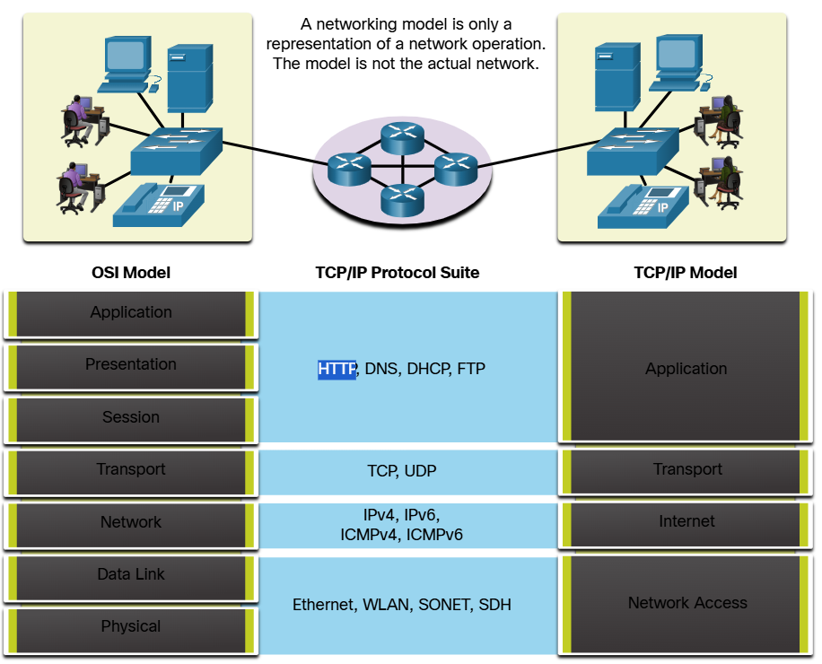

The OSI Reference Model
The OSI Reference Model provides an extensive list of functions and services that can occur at each layer. This type of model provides consistency within all types of network protocols and services by describing what must be done at a particular layer, but not prescribing how it should be accomplished.
It also describes the interaction of each layer with the layers directly above and below. The TCP/IP protocols discussed in this course are structured around both the OSI and TCP/IP models. The table shows details about each layer of the OSI model. The functionality of each layer and the relationship between layers will become more evident throughout this course as the protocols are discussed in more detail:
7 – Application | The application layer contains protocols used for process-to-process communications
6 – Presentation | The presentation layer provides for common representation of the data transferred between application layer services
5 – Session | The session layer provides services to the presentation layer to organize its dialogue and to manage data exchange
4 – Transport | The transport layer defines services to segment, transfer and reassemble the data for individual communications between the end devices.
3 – Network | The network layer provides services to exchange the individual pieces of data over the network between identified end devices
2 – Data Link | The data link layer protocol describe methods for exchanging data frames between devices over a common media
1 – Physical | The physical layer protocols describe the mechanical, electrical, functional and procedural means to activate, maintain and de-activate physical connections for a bit transmission to and from a network device
Note: Whereas the TCP/IP model layers are referred to only by name, the seven OSI model layers are more often referred to by number rather than by name. For instance, the physical layer is referred to as Layer 1 of the OSI model, data link layer is Layer 2 and so on.

The TCP/IP Protocol Model
The TCP/IP protocol model for internetwork communications was created in the early 1970s and is sometimes referred to as the internet model. This type of model closely matches this structure of particular protocol suite. The TCP/IP model is a protocol model because it describes the functions that occur at each layer of protocol within the TCP/IP suite.
4 – Application | Represents data to the user, plus encoding and dialog control
3 – Transport | Supports communication between various devices across diverse networks
2 – Internet | Determines the best path through the network
1 – Network Access | Controls the hardware devices and media that make up the network

The definitions of the standard and the TCP/IP protocols are discussed in a public forum and defined in a publicly available set if IETF RFCs. An RFC is authored by networking engineers and sent to other IETF members for comments.

OSI and TCP/IP Comparison
The protocols that made up the TCP/IP protocol suite can also be described in terms of the OSI reference model. In the OSI model, the network access layer and the application layer of the TCP/IP model are further divided to describe discrete functions that must occur at these layers.
At the network access layer, the TCP/IP protocol suite does not specify which protocols to use when transmitting over a physical medium; it only describes the handoff from the internet layer to the physical network protocols. OSI layers 1 and 2 discuss the necessary procedures to access the media and the physical means to send data over a network.
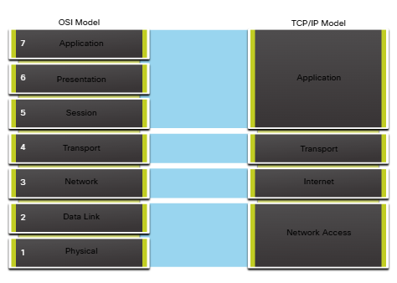
The key similarities are in the transport and network layers; however, the two models differ in how they relate to the layers above and below each layer
  - OSI Layer 3, the network layer, maps directly to the TCP/IP internet layer. This layer is used to describe protocols that address and route messages through an internetwork.
  - OSI Layer 4, the transport layer, maps directly to the TCP/IP transport layer. This layer describes general services and functions that provide ordered and reliable delivery of data between source and destination hosts.
  - The TCP/IP application layer includes several protocols that provide specific functionality to a variety of end user applications. The OSI model Layers 5, 6 and 7 are used as references for application software developers and vendor to produce applications that operate on networks.
  - Both the TCP/IP and OSI models are commonly used when referring to protocols at various layers. Because the OSI model separates the data link layer from the physical layer, it is commonly use when referring to these lower layers.

Data Encapsulation

Segmenting Messages
Knowing the OSI reference model and the TCP/IP protocol model will come in handy when you learn about how data is encapsulated as it moves across a network. It is not as simple as physical letter being sent through the mail system.
In theory, a single communication, such as a video or an email message with many large attachments, could be sent across a network from a source to a destination as one massive, uninterrupted stream of bits. However, this would create problems for other devices needing to use the same communication channels or links. These large streams of data would result in significant delays. Further, if any link in the interconnected network infrastructure failed during the transmission, the complete message would be lost and would have to be retransmitted in full.
A better approach is to divide the data into smaller, more manageable pieces to send over the network. Segmentation is a process of dividing a stream of data into smaller units for transmissions over the network. Segmentation is necessary because data networks use the TCP/IP protocol suite send data in individual IP packets. Each packet is sent separately, similar to sending a long letter as a series of individual postcards. Packets containing segments for the same destination can be sent over different paths.
This leads to segmenting messages having two primary benefits:
  - Increases speed – Because a large data stream is segmented into packets, large amounts of data can be sent over the network without typing up a communications link. This allows many different conversations to be interleaved on the network called multiplexing.
  - Increase efficiency - If a single segment fails to reach its destination due to failure in the network or network congestion, only that segment needs to be retransmitted instead of resending the entire data stream.

Sequencing
The challenge to using segmentation and multiplexing to transmit messages across a network is the level of complexity that is added to the process. Imagine if you had to send a 100-page letter, but each envelope could only hold one page. Therefore, 100 envelopes would be required and each envelope would need to be addressed individually. It is possible that the 100-page letter in 100 different envelopes arrives out-of-order. Consequently, the information in the envelope would need to include a sequence number to ensure that the receiver could reassemble the pages in the proper order.
In network communications, each segment of the message must go through a similar process to ensure that it gets to the correct destination and can be reassembled into the content of the original message.

Protocol Data Unites
As application data is passed down the protocol stack on its way to be transmitted across the network media, various protocol information is added at each level. This is known as the encapsulation process.
Note: Although the UDP PDU is called datagram, IP packets are sometimes also referred to as IP datagrams.
The form that a piece of data takes at a layer is called a protocol data unit (PDU). During encapsulation, each succeeding layer encapsulates the PDU that it receives from the layer above in accordance with the protocol being used. At each stage of the process, a PDU has a different name to reflect its new functions. Although there is no universal naming convention for PDUs, in this course, the PDUs are named according to the protocols of the TCP/IP suite. The PDUs for each form of data are shown in the figure.
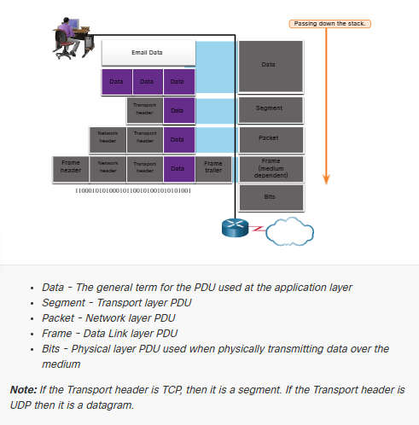

Encapsulation Example
When messages are being sent on a network, the encapsulation process works for top to bottom. At each layer, the upper layer information is considered data within the encapsulated protocol. For example, the TCP segment is considered data within the IP packet.

De-encapsulation Example
This process is reversed at the receiving host ad is known as de-encapsulation. De-encapsulation is the processed used by receiving device to remove one or more of the protocol headers. The data is de-encapsulated as it moves up the stack toward the end-user application.

Data Access

Addresses
As you just learned, it is necessary to segment messages in a network. But those segmented messages will not go anywhere if they are not addressed properly. This topic gives an overview of network addresses. You will also get the chance to use the Wireshark Tool, which ill help you to “view” network traffic.
The network and data link layers are responsible for delivering the data from the source device to the destination device. As shown in the figure, protocols at both layers contain a source and destination address, but their addresses have different purposes:
- Network layer source and destination addresses – Responsible for delivering the IP packet from the original source to the final destination, which may be on the same network or a remote network.
- Data link layer source and the destination addresses - Responsible for delivering the data link frame from one Network Interface Card (NIC) to another NIC on the same network.
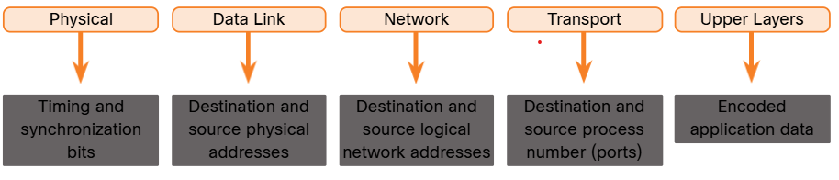

Layer 3 Logical Address
An IP address is the network layer, or Layer 3, logical address used to deliver the IP packet from the original source to the final destination, as shown in the figure.
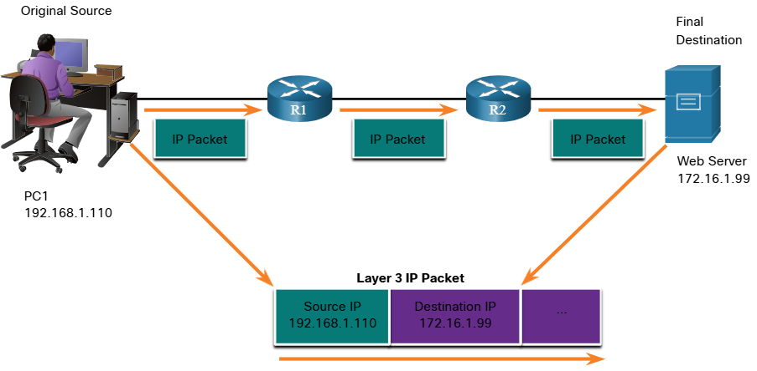
The IP packet contains to IP addresses:
  - Source IP Address – The IP address of the sending device, which is the original source of the packet.
  - Destination IP Address – The IP address of the receiving device, which is the final destination of the packet.
The IP addresses indicate the original source IP address and final destination IP address. This is true whether the source and destination are on the same IP networks or different IP networks.
An IP address contains two parts:
  - Network Porton (IPv4) or Prefix (IPv6) – The left-most part of the address that indicates the network in which the IP address is a member. All devices on the same network will have the same network portion of the address.
  - Host Portion (IPv4) or Interface ID (IPv6) – The remaining part of the address that identifies a specific device on the network. This portion is unique for each device or interface on the network.
Note: The subnet mask (IPv4) or prefix-length (IPv6) is used to identify the network portion of an IP address from the host portion.

Devices on the Same Network
In this example, we have a client computer, PC1, communicating with an FTP server on the same IP network.
  - Source IPv4 Address – The IPv4 address of the sending device, the client computer PC1: 192.168.1.110
  - Destination IPv4 Address – The IPv4 address of the receiving device, FTP server. 192.168.1.9
Notice in the figure that the network portion of the source IPv4 address and the network portion of the destination IPv4 address are the same and therefore; the source and destination are on the same network.
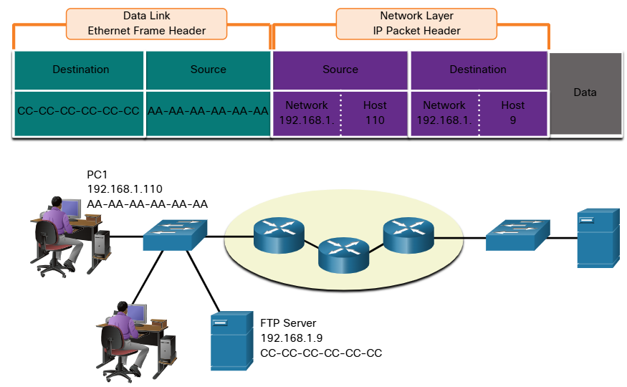

Role of the Data Link Layer Adress – Same IP Network
When the sender and receiver of the IP packet are on the same network, the data link frame is sent directly to the receiving device. On an Ethernet network, the data link addresses are known as Ethernet Media Access Control (MAC) addresses, as highlight in the figure.
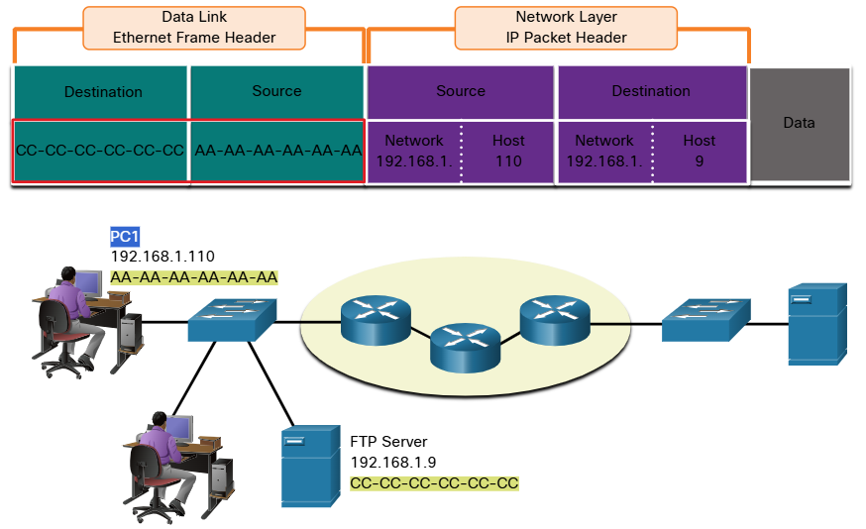

MAC addresses are physically embedded on the Ethernet NIC
  - Source MAC address – This is the data link address, or the Ethernet MAC address, of the device that sends the data link frame with the encapsulated IP packet. The MAC address of the Ethernet NIC of PC1 is AA:AA:AA:AA:AA:AA, written in hexadecimal notation.
  - Destination MAC address - When the receiving device is on the same network as the sending device, this is the data link address of the receiving device. In this example, the destination MAC address is the MAC address of the TP server. CC:CC:CC:CC:CC:CC, written in hexadecimal notation.
The frame with the encapsulated IP packet can now be transmitted from PC1 directly to the FTP server

Role of the Network Layer Addresses
When the sender of the packet is on a different network from the receiver, the source and destination IP addresses will represent hosts on different networks. This will be indicated by the network portion of the IP address of the destination host.
  - Source IPv4 address – The IPv4 address of the sending device, the client computer PC1: 192.1.110
  - Destination IPv4 address – The IPv4 address of the receiving device, the server, Web Server. 172.16.1.99.
Notice in the figure that the network portion of the source IPv4 address and destination IPv4 address are on different networks.
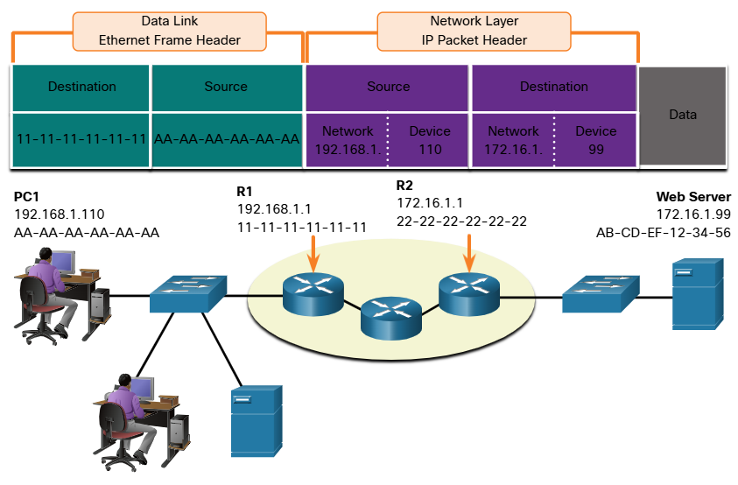

Role of the Data Link Layer Addresses – Different IP Networks
When the sender and receiver of the IP address are on different networks, the Ethernet data ink frame cannot be sent directly to the destination host because the hose is not directly reachable in the network of the sender The Ethernet frame must be sent to another device known as the router or default gateway. In our example, the default gateway is R1. R1 has an Ethernet data link address that is on the same network a PC1. Tis allows PC1 to reach the router directly.
  - Source MAC address – The Ethernet MAC address of the sending device, PC1. The MAC address of the Ethernet interface of PC1 is AA-AA-AA-AA-AA-AA
  - Destination MAC address – When the receiving device, the destination IP address, is on a different network from the sending device uses the Ether MAC address of the default gateway or router. In this example, the destination MAC address is the MAC address of the R1 Ethernet interface, 11-11-11-11-11-11. This is the interface that is attached to the same network as PC1, as shown in the figure.
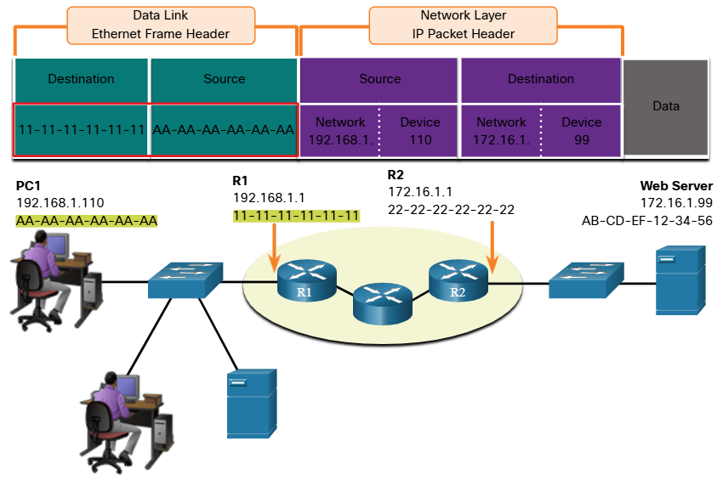
The Ethernet frame with the encapsulated IP packet can now be transmitted to R1. R1 forwards the packet to the destination, Web Server. This may mean that R1 forwards the packet to another router or directly to Web Server if the destination is on a network connected to R1.
It is important that the IP address of the default gateway be configured on each host on the local network. All packets to a destination on remote networks are sent to the default gateway. Ethernet MAC addresses and the default gateway are discussed in more detail in ore modules.

Data Link Addresses
The data link Layer 2 physical address has a different role. The purpose of the data link address is to deliver the data link frame from one network interface to another network interface on the same network.
Before an IP packet can be sent over a wired or wireless network, it must be encapsulated in a data link frame, so it can be transmitted over the physical medium.
Host to Router
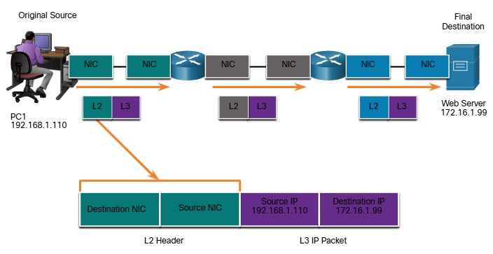
Router to Router
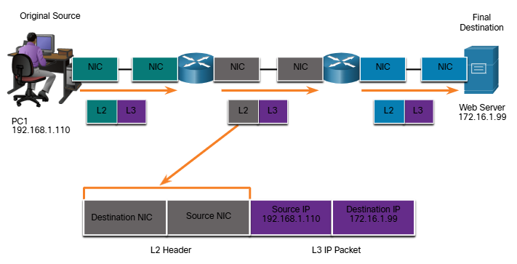

Router to Server
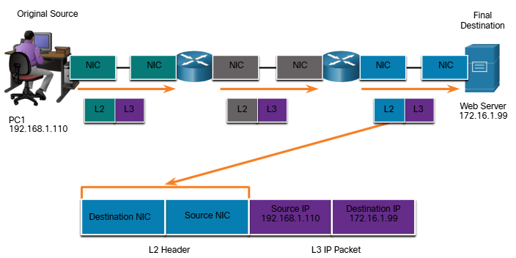
As the IP packet travels from host-to-router, router-to-router and finally router-to-host, at each point along the way, the IP packet is encapsulated in a new data link frame. Each data link frame contains the source data link address of the NIC card sending the frame, and the destination data link address of the NIC card receiving the frame.
The Layer 2, data link protocol is only used to deliver the packet from NIC-to-NIC on the same network. The router removes the Layer 2 information as it is received on one NIC and adds new data link information before forwarding out the exit NIC on its ways towards the final destination.
The IP packet is encapsulated in a data link frame that contains the following data link information:
  - Source data link address – The physical address of the NIC that is sending the data link frame
  - Destination data link address – The physical address of the NIC that is receiving the data link frame The address s either the next hop router of the address of the final destination device.

Networking Summary 3.0
- Rules
  - Protocols must have a sender and a receiver
  - Common computer protocol include these requirements: message encoding, formatting and encapsulation, size, timing, and delivery options.
- Protocols
  - To send a message across the network requires the use o several protocols
  - Each network protocol has its own functions, format and rules for communications.
- Protocol Suites
  - A protocol suite is a group of inter-related protocols.
  - TCP/IP protocol suites are protocols use today.
- Standards Organizations
  - Open standards encourage interoperability, competition and innovation.
- Reference models
  - The two models used in networking are the TCP/IP and the OSI model.
  - The TCP/IP model has 4 Layers and the OSI model has 7 Layers
    - TCP/IP
      - Application
      - Transport
      - Internet
      - Network Access
    - OSI
      - Application
      - Presentation
      - Session
      - Transport
      - Network
      - Data Link
      - Physical
- Data Encapsulation
  - The form that a piece of data takes at any layer is called a protocol data unit (PDU).
  - There are five different PDUs used in the data encapsulation process: data, segment, packet, frame, and bits.
- Data Access
  - The Network and Data Link Layers are going to provide addressing to move data through the network
  - Layer 3 will provide IP addressing and Layer 2 will provide MAC addressing
  - The way these layers handle addressing will depend on whether the source and the destination are on the same network or if the destination is on a different network from the source.

Purpose of the Physical Layer

The Physical Connection
Whether connecting to a local printer in the home or a website in another country, before any network communication can occur, a physical connection to a local network must be established. A physical connection can be a wired connection using a cable or wireless communication using radio waves.
The type of physical connection used depends upon the setup of the network. For example, in many corporate offices, employees have desktop or laptop computers that are physically connect, via cable, to a shared switch. This type of setup is wired network. Dat is transmitted through a physical cable.
In addition to wired connections, many businesses also offer wireless connections for laptops, tablets and smartphones. With wireless devices, data is transmitted using radio waves. Wireless connectivity is common as individuals and businesses alike discover its advantages. Devices on a wireless network must be connected to a wireless access point (AP) or wireless router like the one shown in the figure.
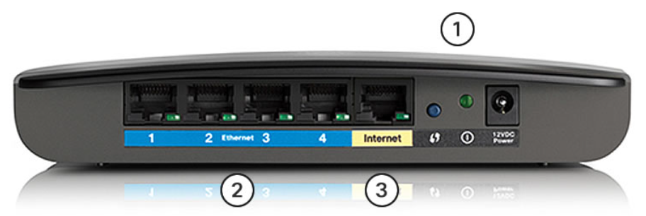
These are the components of an access point:
- The wireless antennas (These are embedded inside the router version shown in the figure)
- Several ethernet switchports
- An internet port
Similar to a corporate office, most homes offer both wired and wireless connectivity to the network. This figure shows a home router and a laptop connecting to the local area network (LAN)
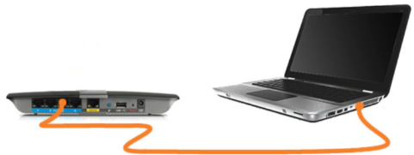
Network Interface Cards
Network Interface Cards (NICs) connect a device to a network. Ethernet NICs are used for a wired connection, as shown in the figure, whereas wireless local area network (WLAN) NICs are used for wireless. An end-user may include one or both types of NICs. A network printer, for example, may only have an Ethernet NIC and therefore, must connect to a network using an Ethernet cable. Other devices, such as tablets and smartphones, might only contain a WLAN NIC and must use a wireless connection.

The Physical Layer
The OSI physical layer provides the means to transport the bits that make up a data link layer frame across the network media. This layer accepts a complete frame from the data link layer and encodes it as a series of signals that are transmitted to the local media. The encoded bits that comprise a frame are received by either an end device or an intermediate device.
The physical layer encodes the frames and creates the electrical, optical or radio wave signals that represent the bits in each frame These signals are then sent over the media, one at a time.
The destination node physical layer retrieves these individual signals from the media, restores them to their bit representation and passes the bits up to the data link layer as complete frame.

Physical Layer Characteristics

Physical Layer Standards
In the previous topic, you gained a high-level overview of the physical layer and its place in a network. This topic dives a bit deeper into the specifics of the physical layer. This includes the components ad the media used to build a network, as well as the standards that are required so that everything works together.
The protocols and operations of the upper OSI layers are performed using software designed by software engineers and computer scientists. The services and protocols in the TCP/IP suite are defined by the Internet Engineering Task Forces (IETF).
The physical layer consists of electronic circuitry, media and connectors developed by engineers. Therefore, it is appropriate that the standards governing this hardware are defined b the relevant electrical and communications engineering organizations.
There are many different international and national organization, regulatory government organization, and private companies involved in establishing and maintaining physical layer standards. For instance, the physical layer hardware, media, encoding an signaling standards are defined and government by these standard organizations:
- International Organization for Standardization (ISO)
- Telecommunications Industry Association/Electronic Industries Association (TIA/EIA)
- International Telecommunications Union (ITU)
- American National Standards Institute (ANSI)
- Institute of Electrical And Electronics Engineers (IEEE)
- National Telecommunication Regulatory Authorities including the Federal Communication Commission (FOC) in the USA and the European Telecommunication Standards Institute (ETSI)
In addition to these, there are often regional cabling standard groups such as CSA (Canadian Standards Association), CENELEC (European Committee for Electronical Standardization), and JSA/JIS (Japanese Standards Association), which develop local specifications.
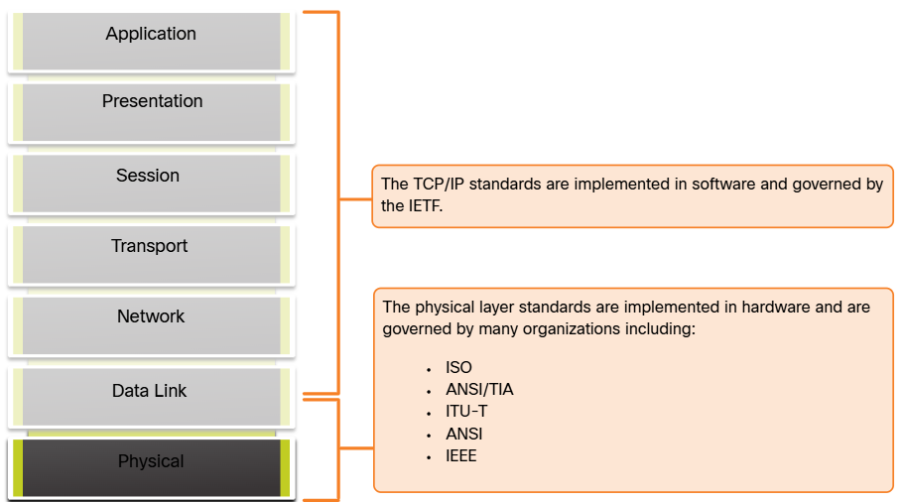

Physical Components
The physical layer standards address three functional areas:
  - Physical Components
  - Encoding
  - Signaling

The physical components are the electronic hardware devices, media and other connectors that transmit the signals that represent the bits. Hardware components such as NICs, interface and connectors, cable designs are all specified in standards associate with the physical layer. The various ports and interfaces on a Cisco 1941 router are also examples of physical components with specific connectors and pinouts resulting from standard

Encoding
Encoding or line encoding is a method of converting a stream of data bits into a predefined “code”. Codes are groupings of bits used to provide a predictable pattern that can be recognized by both the sender and the receiver. In other words, encoding is the method or pattern used to represent digital information. This is similar to how Mores code encodes a message using series of dots and dashes.
For example, Manchester encoding represents a 0 bit by a high to ow voltage transition, and a 1 bit is represented as a low to high voltage transition. An example of Manchester encoding I illustrated in the figure. The transition occurs at the middle of each bit period. This type of encoding is used in 10 Mbps Ethernet. Fater data rates require more complex encoding. Manchester encoding is used in older Ethernet standards such as 10BASE-T. Ethernet 100BASE-TX use 4B/5B encoding and 1000BASE-T uses 8B/10B encoding.
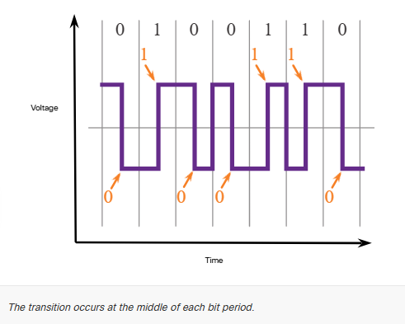

Signaling
The physical layer must generate the electrical, optical or wireless signals the represent the “1” and the “0” on the media. The way that bits are represented is called the signaling method. The physical layer standards must define what type of signal represents a “1” and what type of signal represents a “0”. This can be as simple as change in the level of the electrical or optical pulse. For example, a long pulse might represent a 1 whereas a short pulse might represent a 0.
This is similar to the signaling method used in Morse code, which may use a series of on-off tones, lights or clicks to send text over telephone wires or between ships at sea.

Encoding
Different physical media support the transfer of bits at different rates. Data transfer is usually discussed in terms of bandwidth. Bandwidth is the capacity at which a medium can carry data Digital bandwidth measures the amount of data that can flow from one place to another in a given amount of time. Bandwidth is typically measured in kilobits per second (kbps), megabits per second (Mbps) or gigabits per second (Gbps). Bandwidth is sometimes thought of as a speed that bits travel, however this is not accurate For example, in both 10Mbps and 100Mbps Ethernet, the bits are sent at the speed of electricity. The difference is the number of bits that are transmitted per second.
A combination of factors determines the practical bandwidth of a network:
- The properties of the physical media
- The technologies chosen for signaling and detecting network signals.
Physical media properties, current technologies and the laws of physics all play a tole in determining the available bandwidth.
The table shows the commonly used units of measure for bandwidth
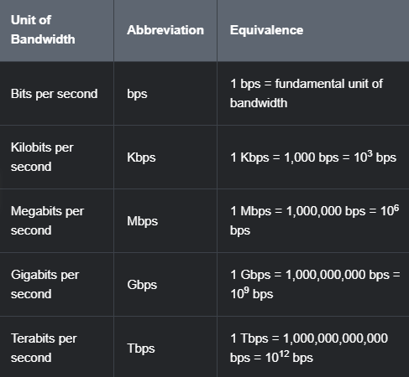

Bandwidth Terminology
Terms used to measure the quality of bandwidth include:
  - Latency
  - Throughput
  - Goodput
Latency refers to the amount of time, including delays, for data to travel from one given point to another.
In an internetwork, or a network with multiple segments, throughput cannot be faster than the slowest link in the path from source to destination. Even if all, or most, of the segments have high bandwidth, it will only take one segment in the path with a low throughput to create a bottleneck in the throughput of the entire network.
Throughput is the measure of the transfer of bits across the media over a given period of time.
Due to a number of factors, throughput usually does not match the specified bandwidth in physical layer implementations. Throughput is usually lower than the bandwidth There are many factors that influence throughput:
  - The amount of traffic
  - The type of traffic
  - The latency created by the number of network devices encountered between source and destination

There are many only speed tests that can reveal the throughput of an internet connection.
There is a third measurement to assess the transfer of usable data; it is known as goodput. Goodput is the measure of usable data transferred over a given period of time. Goodput is throughput minus traffic overhead for establishing sessions, acknowledgments, encapsulations and retransmitted bits. Goodput is always lower than throughput, which is generally lower than bandwidth

Copper Cabling

Characteristics of Copper Cabling
Copper cabling is the most common type of cabling used in networks today. In fact, copper cabling is not just one type of cable. There are three different types of copper cabling that are each used in specific situations.
Networks use copper media because it is inexpensive, easy to install, and has lower resistance to electrical current. However, copper media is limited by distance and signal interference.
Data is transmitted on copper cables as electrical pulses. A detector in the network interface of a destination device must receive a signal that can be successfully decoded to match the signal sent. However, the farther the signal travels, the more it deteriorates. This is referred to as signal attenuation. For this reason, all copper media mut follow strict distance limitations as specified by the guiding standards.
The timing and voltage values of the electrical pulses are also susceptible to interference from to sources:
- Electromagnetic Interference (EMI) or radio frequency interference (RFI) – EMI and RFI signals can distort and corrupt the fata signals being carried by copper media. Potential sources of EMI and RFI include radio wave and electromagnetic devices, such as fluorescent lights or electric motors
- Crosstalk – Crosstalk is disturbance caused by the electric or magnetic fields of a signal on one wire to the signal in an adjacent wire. In telephone circuits, crosstalk can result in hearing part of another voice conversation from an adjacent circuit. Specifically, when an electrical current flows through a wire, it creates a small, circular magnetic field around the wire, which can be picked up by an adjacent wire.
The figure shows how data transmission can be affected by interference.
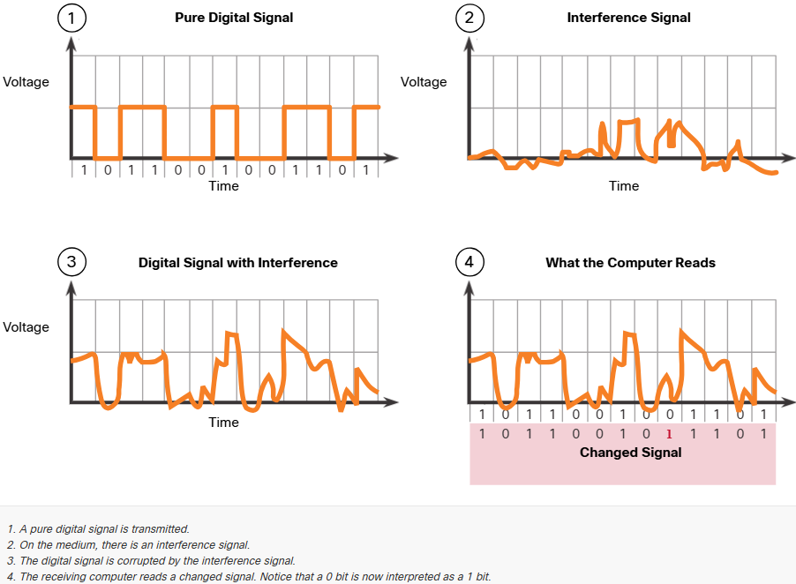
To counter the negative effect of EMI and RFI, some types of copper cables are wrapped in metallic shielding and require proper grounding connections.
To counter the negative effects of crosstalk, some types of copper cables have opposing circuit wire pairs twisted together, which effectively cancels the crosstalk.
The susceptibility of copper cables to electronic noise can also be limited using these recommendations:
- Selecting the cable type or category most suited to a given networking environment
- Designing a cable infrastructure to avoid known and potential sources of interference in the building structure
- Using cabling techniques that include the proper handling and termination of the cables.

Types of Copper Cabling
There are three main types of copper media used in networking
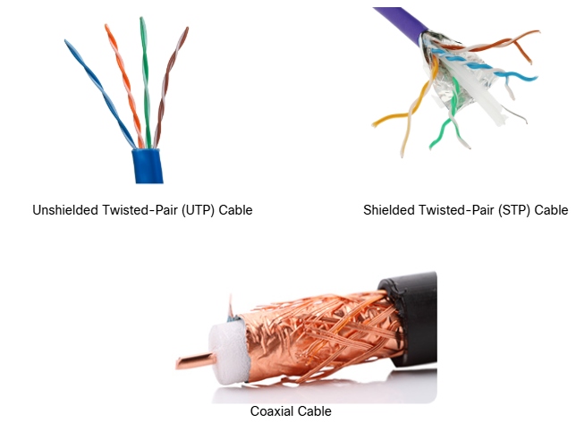

Unshielded Twisted-pair (UTP)
Unshielded twisted pair (UT) cabling is the most common networking media. UTP cabling, terminated with RJ-45 connectors, is used for interconnecting network hosts with intermediary networking devices, such as switches and routers.
In LANs, UTP cable consists of four pairs of color-coded wires that have been twisted together and then encased in a flexible plastic sheath that protects from minor physical damage. The twisting of wires helps protect against interference from other wires.
As seen in the figure, the color codes identify the individual pair and wires and aid in cable termination.
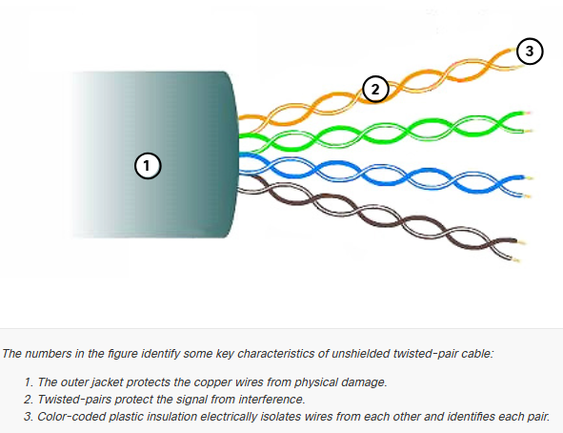

Shielded Twisted-pair (STP)
Shielded twisted-pair (STP) provides better noise protection than UTP cabling. However, compared to UTP cable STP cable is significantly more expensive and difficult to install. Like UTP cable, STP uses an RJ-45 connector.
STP cables combine the techniques of shielding to counter EMI and RFI, and wire twisting to counter crosstalk. To gain the full benefit of the shielding, STP cables are terminated with special shielded STP data connectors. If the cable is improperly grounded, the shield may act as an antenna and pick up unwanted signals.
The STP cable shown uses four main pairs of wires, each wrapped in a foil shield, which are then wrapped in an overall metallic braid or foil
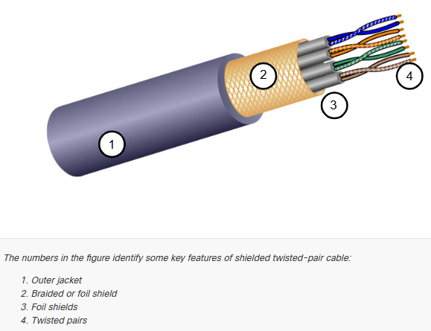

Coaxial Cable
Coaxial Cable, or “co-ax” for short, gets its name from the fact that there are two conductors that share the same axis. As shown in the figure, coaxial cable consists of the following:
  - A copper conductor is used to transmit the electronic signals.
  - A layer of flexible plastic insulation surrounds a copper conductor
  - The insulating material is surrounded in a woven copper braid, or metallic foil, that acts as the second wire on the circuit and as a shield for the inner conductor This second layer, or shield, also reduces the amount of outside electromagnetic interference.
  - The entire cable is covered with a cable jacket to prevent minor physical damage.
There are different types of connectors used with coax cable. The Bayonet Neill-Concelman (BNC), N type, and F type connectors are shown in the figure.
Although UTP cable has essentially replaced coaxial cable in modern Ethernet installations, the coaxial cable design is used in the following situations:
  - Wireless installations – Coaxial cables attach antennas to wireless devices. The coaxial cable carries radio frequency (RF) energy between the antennas and the radio equipment.
  - Cable internet installations – Cable service provide internet connectivity to their customers by replacing portions of the coaxial cable and supporting amplification elements with fiber-optic cable. However, the wiring inside the customer’s premises is still coax cable.
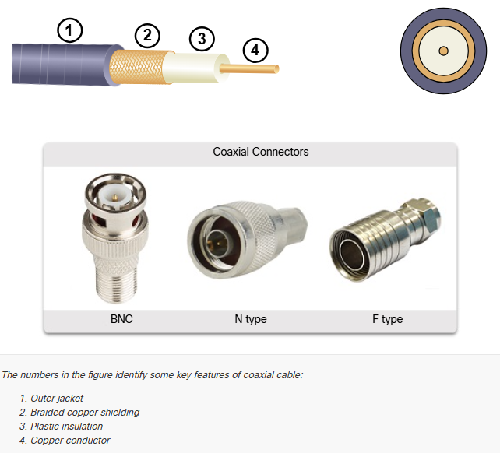

UTP Cabling

Properties of UTP Cabling
In the previous topic, you learned a bit about unshielded twisted-pair (UTP) copper cabling. Because UTP cabling is the standard for use in LANs, this topic goes into detail about its advantages and limitations, and what can be done to avoid problems.
When used as a networking medium, UTP cabling consists of four pairs of color-coded copper wires that have been twisted together and then encased in a flexible plastic sheath. Its small size can be advantageous during installation.
UTP cable does not use shielding to counter the effects of EMI and RFI. Instead, cable designers have discovered other ways that they can limit the negative effect of crosstalk:
  - Cancellation – Designers now pair wires in a circuit. When two wires in an electrical circuit are placed closed together, their magnetic fields are the exact opposite of each other. Therefore, the two magnetic fields cancel each other and also cancel out any outside EMI and RFI signals.
  - Varying the number of twists per wire pair – To further enhance the cancellation effect of paired circuit wires, designers vary the number of twists of each wire pair in a cable. UTP cable must follow precise specifications governing how many twists or braids are permitted per meter (3.28 feet) of cable. Notice in the figure that the orange/orange white pair is twisted less than the blue/blue white pair. Each coloured pair is twisted a different number of times.
UTP cable relies solely on the cancellation effect produced by the twisted wire pairs to limit signa degradation and effectively provide self-shielding for wire pairs within the network media.
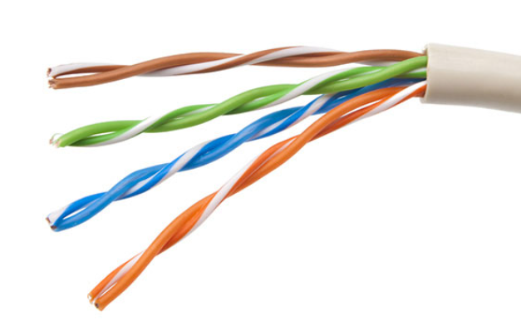

UTP Cabling Standards and Connectors
UTP cabling conforms to the standards established jointly by the TIA/EIA. Specifically, TIA/EIA-568 stipulates the commercial cabling standards for LAN installations and is the standard most commonly used in LAN cabling environments. Some of the elements defined are as follows:
  - Cable types
  - Cable lengths
  - Connectors
  - Cable termination
  - Methods of testing cable
The electrical characteristics of copper cabling are defined by the Institute of Electrical and Electronics Engineers (IEEE). IEEE rates UTP cabling according to its performance. Cables are placed into categories based on their ability to carry higher bandwidth rates. For example, Category 5 cable is used commonly in 100BASE-TX Fast Ethernet installations. Other categories included Enhanced Category 5 cable, Category 6 and Category 6a.
Cables in higher categories are designed and constructed to support higher data rates. As new gigabit speed Ethernet technologies are being developed and adopted, Category 5e is now the minimally acceptable cable type, with Category 6 being the recommended type for new building installations.
The figure shows three categories of UTP cable:
  - Category 3 was originally used for voice communications over voice lines but later use for data transmission.
  - Category 5 and 5e is used for data transmission. Category 5 supports 100Mbps and Category 5e supports 1000Mbps
  - Category 6 has an added separator between each wire pair to support higher speeds. Category 6 supports up to 10Gbps
  - Category 7 also supports 10Gbps
  - Category 8 supports 40Gbps
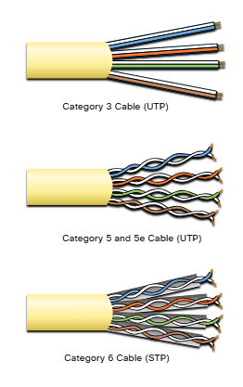

UTP cable is usually terminated with an RJ-45 connector. The TIA/EIA-568 standard describes the wire color codes to pin assignments (pinouts) for Ethernet cables.
As shown in the figure, the RJ-45 connector is the male component, crimped at the end of the cable.
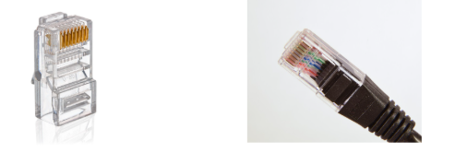

The socket, shown in the figure, is the female component of a network device, wall, cubicle partition outlet, or patch panel. When terminated improperly, each cable is a potential source of physical layer performance degradation.
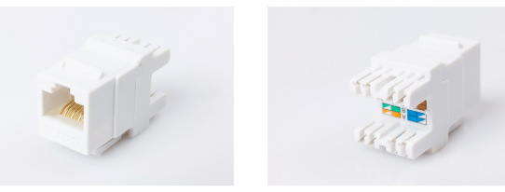
This figure shows an example of a badly terminated UTP cable. This bad connector has wires that are exposed, untwisted and not entirely covered by the sheath.
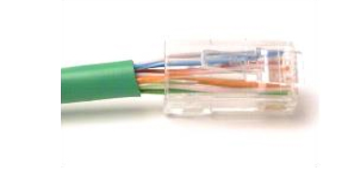
The next figure shows a properly terminated UTP cable. It is a good connector with wires that are untwisted only to the extent necessary to attach the connector
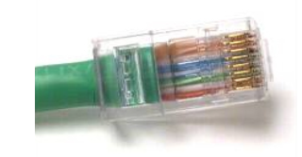

Straight-through and Crossover UTP
Different situations may require UTP cables to be wired according to different wiring conventions. This means that the individual wires in he cable have to be connected in different orders to different set of pins in the RJ-45 connectors.
The following are the main cable types that are obtained by using specific wiring conventions:
  - Ethernet Straight-through – The most common type of networking cable. It is commonly used to interconnect a host to a witch and a switch to a router.
  - Ethernet Crossover – A cable used to interconnect similar devices. For example, to connect a switch to a switch, a host to a host, or a router to a router. However, crossover cables are now considered legacy as NICs use medium-dependent interface crossover (auto-MDIX) to automatically detect the cable type and make the internal connection.
Note: Another type of cable is a rollover cable, which is Cisco proprietary. It is used to connect a workstation to a router or switch console port.

Using a crossover or straight-through cable incorrectly between devices may not damage the device, but connectivity and communication between the devices will not take place. This is a common error and checking that the device connections are correct should be the first troubleshooting action if connectivity is not achieved.
The figure identifies the individual wire pairs for the T658A and T568B standards.
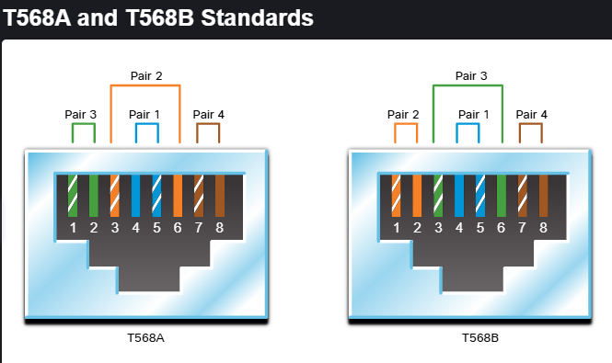

The table shows the UTP cable type, relate standards and the typical application of these cables.
Ethernet Straight-through | Both ends T568A or both ends T568B | Connects a network host to a network device such as a switch or hub
Ethernet Crossover | One end T568A, other end T568B | Connects two network hosts. Connects two network intermediary devices (switch to switch or router to router)
Rollover | Cisco proprietary | Connects a workstation serial port to a router console port, using an adapter

Fiber-Optic Cabling

Properties of Fiber-Optic Cabling
As you have learned, fiber-optic cabling is the other type o cabling used in networks. Because it is expensive, it is not as commonly used at the various types of copper cabling. But fiber-optic cabling has certain properties that make it the best option in certain situations, which you will discover in this topic.
Optical fiber cable transmits data over longer distances and at higher bandwidths than any other networking media. Unlike copper wires, fiber-optic cable can transmit signals with less attenuation and is complete immune to EMI and RFI. Optical fiber is commonly used to interconnect network devices.
Optical fiber is a flexible, but extremely thin, transparent strand of very pure glass, not much bigger than a human hair. Bits are encoded on the fiber as light impulses. The fiber-optic cable acts as a waveguide or “light-pipe” to transmit light between the two ends with minimal loss of signal.
As an analogy, consider an empty paper towel roll with the inside coated like a mirror. It is a thousand meters in length, and a small laser pointer is used to send Morse code signals at the speed o light. Essentially, that is how a fiber-optic cable operates, except that it is smaller in diameter and uses sophisticated light technologies.

Types of Fiber Media
Fiber-optic cables are broadly classified into two types:
  - Single-mode fiber (SMF)
  - Multimode fiber (MMF)
Single-Mode Fiber
SMF consists of a very small core and uses expensive laser technology to send a single ray of light, as shown in the figure. SMF is popular in long-distance situations spanning hundreds of kilometers, such as those required in long haul telephony and cable TV applications.
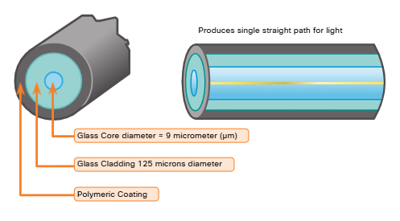
Multimode Fiber
MMF consists of a larger core and uses LED emitters to send light pulses. Specifically, light from an LED enters the multimode fiber at different angles, as shown in the figure. MMFs are popular in LANs because they can be powered by low-cost LEDs. It provides bandwidth up to 10Gbps over link lengths o up to 550 meters.
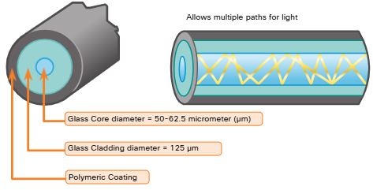

One of the highlighted differences between MMF and SMF is the amount of dispersion. Dispersion refers to the spreading out of a light pulse over time. Increased dispersion means increased loss of signal strength. MMF has a greater dispersion than SMF. That is why MMF can only travel up to 500 meters before signal loss

Fiber-Optic Cabling Usage
Fiber-optic cabling is now being used in four types of industry:
  - Enterprise Networks – Used for backbone cabling applications and interconnecting infrastructure devices
  - Fiber-to-the-home (FTTH) – Used to provide always-on broadband services to homes and small businesses
  - Long-Haul Networks – Used by service providers to connect countries and cities
  - Submarine Cable Networks – Used to provide reliable high speed, high-capacity solutions capable of surviving in harsh undersea environments at up to transoceanic distances. Search the internet for “submarine cables telegeography map” to view various maps online.
Our focus in this course is the use of fiber within the enterprise.

Fiber-Optic Connectors
An optical-fiber connector terminates the end of an optical fiber. A variety of optical-fiber connectors are available. The main differences among the types of connectors are dimensions and methods of coupling. Businesses decide on the type of connectors that will be used, based on their equipment.
Note: Some switches and routers have ports that support fiber-optic connectors through a small form-factor pluggable (SFP) transceiver. Search the internet for various types of SFPs

Straight Tip (ST) Connectors were one of the first connector types used. The connector locks securely with a “twist-on/twist-off” bayonet-style mechanism.
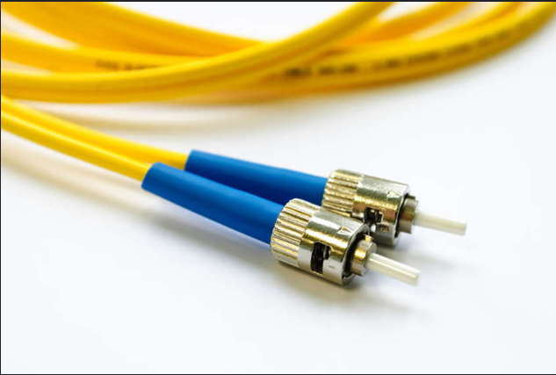

Subscriber Connector (SC) connectors are sometimes referred to as “square connectors” or “standard connectors.” They are widely adopted LAN and WAN connector that uses a push-pull mechanism to ensure positive insertion. This connector type is used with multimode and single-mode fiber.
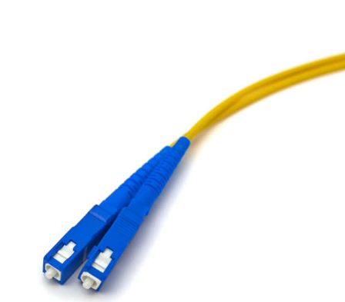

Lucent Connector (LC) Simplex Connectors are a smaller version of the SC connector. These are sometimes called little or local connector and are quickly growing in popularity due to their smaller size.
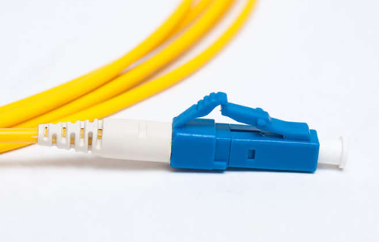
Duplex Multimode LC Connectors are similar to an LC simplex connector but uses a duplex connector.
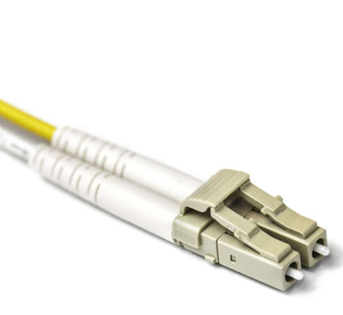
Until recently, light could only travel in one direction over optical fiber. Two different fibers were required to support the full duplex operation. Therefore, fiber-optic patch cables bundle together two optical fiber cables and terminate them with a pair of standard, single-fiber connectors. Some fiber connectors accept both the transmitting and receiving fibers in a single connector known as a duplex connector, as shown in the Duplex Multimode LC Connector figure. BX standards such as 100BASE-BX use different wavelengths for sending and receiving over a single fiber.

Fiber Patch Cords
Fiber patch cords are required for interconnecting infrastructure devices. The use of color distinguishes between single-mode and multimode cords. A yellow jacket is for single-mode fiber cables and orange (or aqua) for multimode fiber cables.

Fiber versus Copper
There are many advantages to using fiber-optic cable compared to copper cables. The table highlights some of these differences.
At present, in most enterprise environments, optical fiber is primarily used as backbone cabling for high-traffic, point-to-point connections between data distribution facilities. It is also use for the interconnection of buildings in multi-building campuses. Because fiber-optic cables do not conduct electricity and have a low signal loss, they are will suited for those uses.
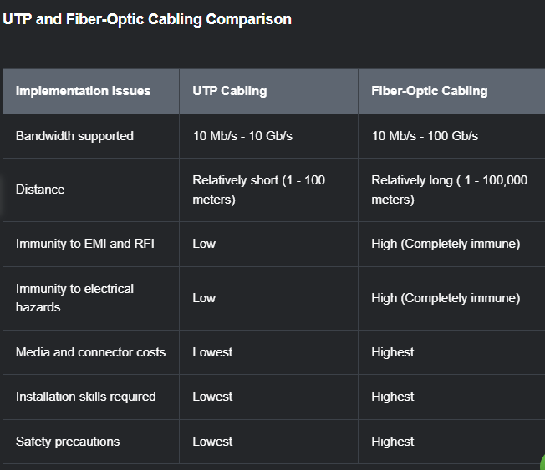

Wireless Media

Properties of Wireless Media
You may be taking this course using a tablet or a smart phone. This is only possible due to wireless media, which is the third way to connect to the physical layer of a network.
Wireless media carry electromagnetic signals that represent the binary digits of data communications using radio or microwave frequencies.
Wireless media provide the greatest mobility options of all media, and the number of wireless-enabled devices continues to increase. Wireless is now the primary way users connect to home and enterprise networks.
These are some of the imitations of wireless:
  - Coverage Area – Wireless data communication technologies work well in open environments. However, certain construction materials used in buildings and structures, and the local terrain, will limit effective coverage.
  - Interference – Wireless is susceptible to interference and can be disrupted by such common devices as household cordless phones, some types of fluorescent lights, microwave ovens and other wireless communications.
  - Security – Wireless communications coverage requires no access to a physical strand of media. Therefore, devices and users, not authorized for access to the network, con gain access to the transmission. Network security is a major component of wireless network administration.
  - Shared Medium – WLANs operate in half-duplex, which means only one device can send or receive at a time. The wireless medium is shared amongst all wireless users. Many users accessing the WLAN simultaneously results in reduced bandwidth for each user

Although wireless is increasing in popularity for desktop connectivity, copper and fiber are the most popular physical layer media for deployment of intermediary network devices such as routers and switches.

Types of Wireless Media
The IEEE and telecommunications industry standards for wireless data communications cover both the data link and physical layers. In each of these standards, physical layer specifications are applied to area that include the following:
  - Data to radio signal encoding
  - Frequency and power of transmission
  - Signal reception and decoding requirements
  - Antenna design and construction
These are the wireless standards:
  - Wi-Fi (IEEE 802.11) – Wireless LAN (WLAN) technology, commonly referred to as Wi-Fi. WLAN uses a contention-base protocol known as carrier sense multiple access/collision avoidance (CSMA/CA). The wireless NIC must first listen before transmitting to determine if the radio channel is clear. If another wireless device is transmitting, then the NIC must wait until the channel is clear. Wi-Fi is a trademark of the Wi-Fi Alliance. Wi-Fi is used with certified WLAN devices based on the IEEE 802.11 standards.
  - Bluetooth (IEEE 802.15) – This is a wireless personal area network (WPAN) standard, commonly known as “Bluetooth.” It uses a device pairing process to communicate over distances from 1 – 100 meters.
  - WiMAX (IEEE 802.16) – Commonly known as Worldwide Interoperability for Microwave Access (WiMAX), this wireless standard uses a point-to-multipoint topology to provide wireless broadband access.
  - Zigbee (IEEE 802.15.14) – Zigbee is a specification used for low-data rate, low-power communications. It is intended for application that require short-range, low data-rates and long battery life. Zigbee is typically use for industrial and Internet of Things (IoT) environments such as wireless light switches and medical device data collection

Note: Other wireless technologies such as cellular satellite communications can also provide data network connectivity. However, these wireless technologies are out of scope for this module.

Wireless LAN
A common wireless data implementation is enabling devices to connect wirelessly via a LAN. In general, a WLAN requires the following network devices:
  - Wireless Access Point (AP) – These concentrate the wireless signals from users and connect to the existing copper-based network infrastructure, such as Ethernet. Home and small business wireless routers integrate the functions of a router, switch and access point into one device, as shown in the figure.
  - Wireless NIC adaptors – These provide wireless communication capability to network hosts
As the technology has developed, a number of WLAN Ethernet-based standards have emerged. When purchasing wireless devices, ensure compatibility and interoperability.
The benefits of a wireless data communications technologies are evident, especially the saving on costly premises wiring and the convenience of host mobility. Network administrators must develop and apply stringent security policies and processes to protect WLANs from unauthorized access and damage.

Networking Summary 4.0
- Before any network communications can occur, a physical connection to a local network, either wired or wireless, must be established.
- The Physical Layer consists of electronic circuitry, media and connectors developed by engineers.
- The Physical Layer standards address three function areas: physical components, encoding, and signaling.
- Three types of copper cabling are: UTP, STP, and coaxial cable (coax)
- UTP cabling conforms to the standards established jointly by the TIA/EIA. The electrical characteristics of copper cabling are defined by the Institute of Electrical and Electronics Engineers (IEEE)
- The main cable types that are obtained by using specific wiring conventions are Ethernet Straight-through and Ethernet Crossover
- Optical fiber cable transmits data over longer distances and at higher bandwidths than any other networking media.
- There are four topes of fiber-optic connectors: ST, SC, LC and Duplex Multimode LC.
- Fiber-optic patch cords include SC-SC multimode, LC-LC single-mode, ST-LC multimode, and SC-ST single-mode
- Wireless media carry electromagnetic signals that represent the binary digits of data communications using radio or microwave frequencies. Wireless does have some limitations, including coverage area, interference, security, and the problems that occur with any shared media.
- Wireless stands include the following: Wi-Fi (IEEE 802.11), Bluetooth (IEEE 802.15), WiMax (IEEE 802.16) and Zigbee (IEEE 802.15.4)
- Wireless LAN (WLAN)b requires a wireless AP and wireless NIC adapters.

Binary Number Systems

Binary and IPv4 Addresses
IPv4 addresses begin as binary, a series of only 1s and 0s. These are difficult to manage, so network administrators must convert them to decimal. This topic shows you a few ways to do this.
Binary is a numbering system that consists of the digits 0 and 1 called bits. In contrast, the decimal numbering system consists of 10 digits consisting of the digits 0 -9.
Binary is important for us to understand because hosts, servers and network devices use binary addressing. Specifically, they use binary IPv4 addresses as shown in the figure, to identify each other.
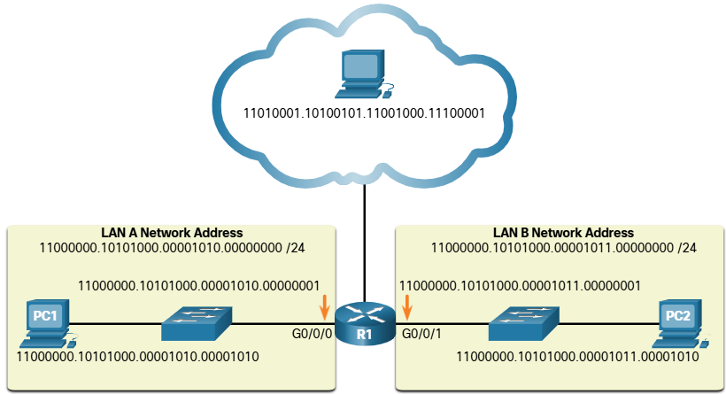

Each address consists of a string of 32 bits, divided into four sections called octets. Each octet contains 8 bits ( or 1 byte) separated with a dot. For example, PC1 in the figured is assigned IPv4 address 11000000.10101000.00001010.00000001. Its default gateway address would be that of R! Gigabit Ethernet interface 11000000.10101000.00001010.00000001.
Binary works well with hosts and network devices. However, it is very challenging for humans to work with.
For each of use by people, IPv4 addresses are commonly expressed in dotted decimal notation. PC1 is assigned the IPv4 address 192.168.10.10 and its default gateway address is 192.168.10.1, a shown in the figure.
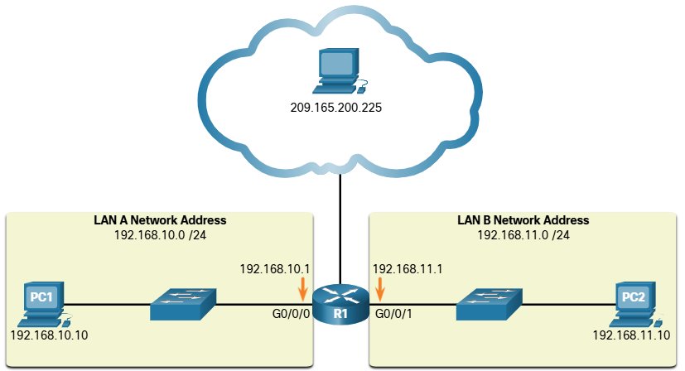
For a solid understanding of networking addressing, it is necessary to know binary addressing and gain practical skills converting between binary and dotted decimal IPv4 addresses. This section will cover how to convert between base two (binary) and base 10 (decimal) numbering systems.

Binary Positional Notation
Learning to convert binary to decimal requires an understanding of positional notation. Positional notation means that a digit represents different values depending on the “position” the digit occupies in the sequence of numbers. You already know the most common numbering system; the decimal (base 10) notation system.
The decimal positional notation system operates as described in the table.
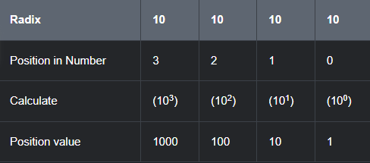
The following bullets describe each row on the table
  - Row 1 – Radix is the number base. Decimal notation is based on 10, therefore the radix is 10
  - Row 2 – Position in number considers the position of the decimal number starting with, from right to let, 0 (1st position), 1 (2nd position), 2 (3rd position), 3 (4th position). These numbers also represent the exponential value used to calculate the positional value in the 4th row.
  - Row 3 – Calculates the positional value y taking the radix and raising it by the exponential value of its position in Row 2
  - Row 4 – Positional value represents units of thousands, hundreds, tens and ones.

The use the positional system, match a given number to its positional value. The example in the table illustrates how positional notation is used with the decimal number 1234.
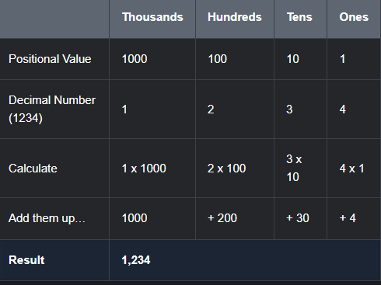
In contrast, the binary positional notation operates as described in the table:
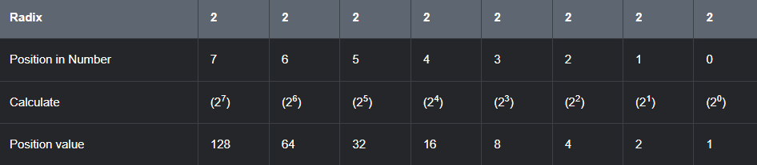
The following bullets describe each row of the table
  - Row 1 = Radix is the number base Binary notation is based on 2, therefore the radix is 2.
  - Row 2 – Position in number considers the position of the binary number starting with, from right to left, 0 (1st position), 1 (2nd position), 2 (3rd position), 3 (4th position). These numbers also represent the exponential value used to calculate the positional value in the 4th row.
  - Row 3 – Calculates the positional value by taking the radix and raising it by the exponential value of it’s position in Row 2
  - Row 4 – Positional value represents units of ones, twos, fours, eights, etc.

The example in the table illustrates how a binary number 11000000 corresponds to the number 192. If the binary number had been 10101000, then the corresponding decimal number would be 168.
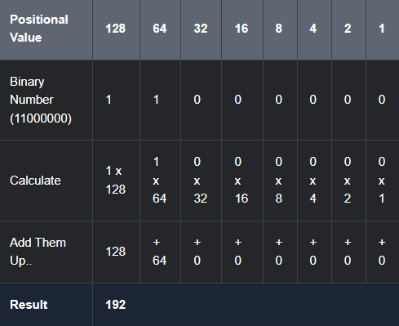

Convert Binary to Decimal
To convert a binary IPv4 address to its dotted decimal equivalent, divide the IPv4 address into four 8-bit octets. Next apply the binary positional value to the first octet binary number are calculate accordingly.
For example, consider that 11000000.10101000.00001011.00001010 is the binary IPv4 address of a host. To convert the binary address to decimal, start with the first octet, as shown in the table. Enter the 8bit binary number under the positional value of row 1 and then calculate to produce the decimal umber 192. This number goes into the first octet of the dotted decimal notation.
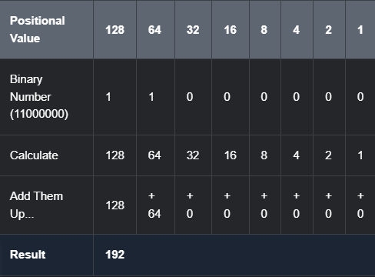
Next, convert the second octet of 10101000 as shown in the table. The resulting decimal value is 168, and it goes into the second octet.
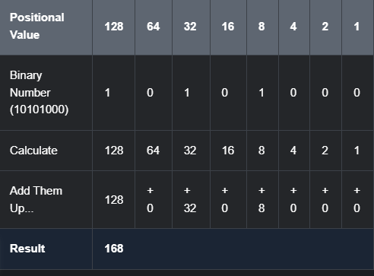
Convert the third octet of 00001011 as shown in the table.
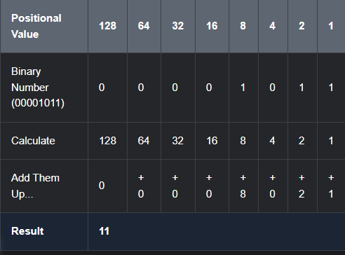
Convert the fourth octet of 00001010 as shown in the table. This completes the IP address and produces 192.168.11.10
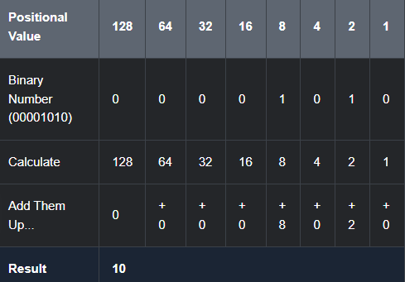

Decimal to Binary Conversion
It is also necessary to understand how to convert dotted decimal IPv4 address to binary. A useful tool in the binary positional value table.
Imagine our IPv4 address is 192.168.10.11
Break 192 down into an octet:
128 | 64 | 32 | 16 | 8 | 4 | 2 | 1

Check each position starting at 128 and work left to right, to the 1 position.
Starting from 128, is the decimal number of the octet is <= or > than 128?
If it is > (greater than) , then enter a 0 in the 128 positional value.
If is <= (Less than or equal to), then enter a 1 in the 128 positional value and then subtract 128 from the decimal value.
Since 128 is less than 192, we can place a 1 in the 128 positional value, like so
128 | 64 | 32 | 16 | 8 | 4 | 2 | 1
1

We then subtract 128 from 192 to get us 64.
Then we check if the new decimal number of 64 (192 – 128 ) is <= or > than 64.
Since it is, we will place a “1” under the 64 positional value. Like so:
128 | 64 | 32 | 16 | 8 | 4 | 2 | 1
1 | 1

Then we repeat the steps of subtracting 64 from our decimal number. 64 – 64. This leaves us with 0. AS we have no longer anything left in our decimal, we will place 0s in the remaining positional values. Like so
128 | 64 | 32 | 16 | 8 | 4 | 2 | 1
1 | 1 | 0 | 0 | 0 | 0 | 0 | 0

This means the binary value of our first octet, 192 is 11000000.
We repeat the above until we have converted all 4 octets.

IPv4 Addresses
As mentioned in the beginning of this topic, routers and computers only understand binary, while humans work in decimal. It is important for you to gain a thorough understanding of these two numbering systems and how they are used in networking.
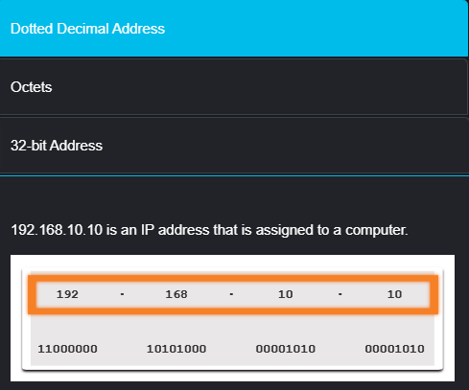
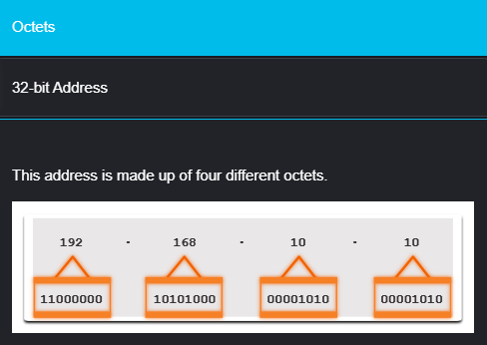
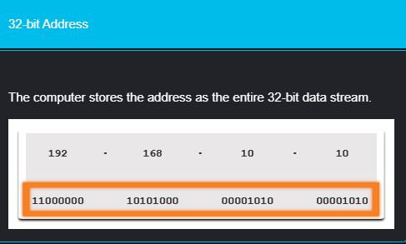

Hexadecimal Number Systems

Hexadecimal and IPv6 Addresses
Now you know how to convert binary to decimal and decimal to binary. You need that skill to understand IPv4 addressing in your network. But you are just as likely to be using IPv6 addresses in your network. To understand IPv6 addresses, you must be able to convert hexadecimal to decimal and vice versa
Just as decimal is a base ten number system, hexadecimal is a base sixteen system. The base sixteen number system uses the digits 0 – 9 and the letters A to F. The figure shows the equivalent decimal and hexadecimal values for binary 0000 to 1111
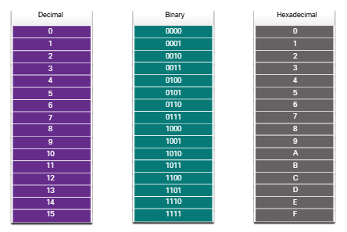

Binary and hexadecimal work well together because it is easier to express a value as a single hexadecimal digit that as four binary bits.
The hexadecimal numbering system is used in networking to represent IP Version 6 addresses and Ethernet MAC addresses.
IPv6 addresses are 128 bits in length and every 4 bits is represented by a single hexadecimal digit, for a total of 32 hexadecimal values. IPv6 addresses are not case-sensitive and can be written either in lowercase or uppercase.
As shown in the figure, the preferred format for writing IPv6 address is x:x:x:x:x:x:x:x, with each “x” consisting of four hexadecimal values. When referring to 8 bits of an IPv4 address we use the term octet. In IPv6, a hextet is the unofficial term used to refer to a segment o 16 bits or our hexadecimal value. Each “x” is a single hextet, 16 its or four hexadecimal digits.
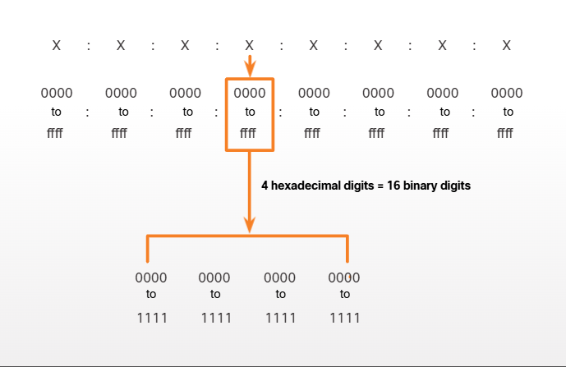The sample topology in the figure displays IPv6 hexadecimal addresses
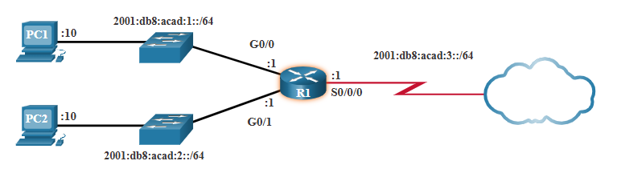

Decimal to Hexadecimal Conversions
Converting decimal numbers to hexadecimal values is straightforward. Follow the steps listed:
- Convert the decimal number to 8-bit binary strings
- Divide the binary strings in groups of four, starting from the rightmost position
- Convert each binary number into the equivalent hexadecimal digit.
The example provides the steps for converting 168 to a hexadecimal.
- 168 is binary 10101000
- 10101000 in two groups of 4 binary digits is 1010 and 1000
- 1010 is hex A and 1000 is hex B
Answer: 168 is AB in hexadecimal.

Hexadecimal to Decimal Conversions
Converting hexadecimal numbers to decimal values is also straightforward. Follow the steps listed:
- Convert the hexadecimal number to 4-bit binary strings
- Create 80bit binary grouping starting from the rightmost position
- Convert each 80bit binary grouping into the equivalent decimal digit.
This example provides the steps for converting D2 to decimal
- D2 in 4-bit binary strings is 1101 and 0010
- 1101 and 0010 is 11010010 in an 8-bit grouping.
- 11010010 in binary is equivalent to 210 in decimal
Answer: D2 in hexadecimal is 210 in decimal.

Number System Summary
- Binary is a base two numbering system that consists of the numbers 0 and 1, called bits.
- Decimal is a base ten numbering system that consists of the numbers 0 through 9
- Binary is what hosts, servers and networking equipment use to identify each other
- Hexadecimal is a base sixteen (16) numbering system that consists of the numbers 0 through 9 and the letters A to
- Hexadecimal is used to represent IPv6 address and MAC addresses.
- IPv6 addresses are 128 bits long and every 4 bits is represented by a hexadecimal digit or a total of 32 hexadecimal digits.
- To convert hexadecimal to decimal, you must first convert the hexadecimal to binary, then convert the binary to decimal.
- To convert decimal to hexadecimal, you must first convert the decimal to binary and then the binary to hexadecimal.

Data Link Layer

Purpose of the Data Link Layer
The Data Link Layer is responsible for communications between end-device network interface cards (NICs). It allows upper layer protocols to access the physical layer media and encapsulates Layer 3 packets (Iv4 and IPv6) into Layer 2 Frames. It also performs error detection and rejects corrupted frames.
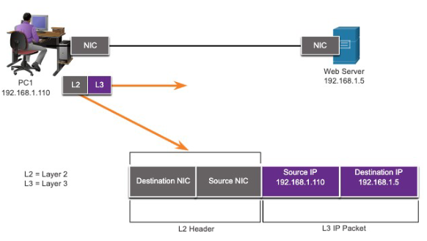
IEEE 802 LAN/MAN standards are specific to the type of network (Ethernet, WLAN, WPAN, etc.)
The Data Link Layer consists of two sublayers; the Logical Control (LLC) and the Media Access Control (MAC).
  - The LLC sublayer communicates between the networking software at the upper layers and the device hardware at the lower layers.
  - The MAC sublayer is responsible for data encapsulation and media access control.
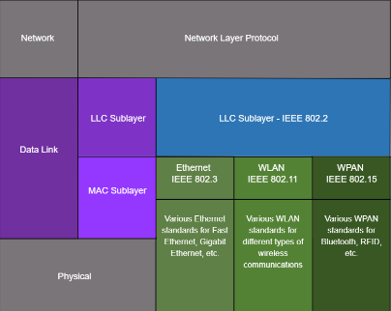

Packets exchanged between nodes may experience numerous data link layers and media transitions. At each “hop along he path,” a router performs our basic Layer 2 functions:
  - Accepts a frame from the network medium
  - De-encapsulates the frame to expose encapsulated packet.
  - Re-encapsulates the packet into a new frame.
  - Forwards the new frame on the medium of the net network segment.

Topologies
The topology of a network is the arrangement and relationship of the network devices and the interconnections between them. There are two types of topologies when describing networks:
  - Physical topology – Shows physical connections and how devices are interconnected.
  - Logical topology – Identifies the virtual connections between devices using device interfaces and IP addressing schemes.
There are three types of common physical WAN topologies:
  - Point-to-point – The simplest and most common WAN topology. Consists of a permanent link between two endpoints.
    - Physical point-to-point topologies directly connect two nodes.
    - The nodes may not share the media with other hosts.
    - Because all frames on the media can only travel to or from the two nodes, point-to-point WAN protocols can be very simple.
  - Hub and spoke – Similar to a “star” topology, where a central site interconnects branch sites through point-to-point links.
  - Mesh – Provides high availability but requires every end system to be connected to every other end system.
End devices on LANs are typically interconnected using a “star” or “extended star” topology. Star and extended star topologies are easy to install, very scalable and easy to troubleshoot.
Early Ethernet and Legacy Token Ring technologies provide two additional topologies:
  - Bus – All end systems chained together and terminated at each end.
  - Ring – Each end system s connection to its respective neighbors to form a ring.

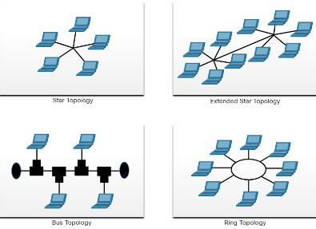

Half-duplex Communications
- Only allows one device to send or receive at a time on a shared medium.
- Used on WLAN and legacy bus topologies with Ethernet hubs
  - Contention-based Access – All nodes operating in half-duplex, competing for use of the medium.
    - Carrier sense multiple access with collision detection (CSMA/CD) as used on legacy bus-topology Ethernet
    - CSMA/CD
      - Used by legacy Ethernet LANs
      - Operates in half-duplex mode where only one device sends or receives at a time.
      - Uses a collision detection process to govern when a device can send and what happens if multiple devices send at the same time.
      - CSMA/CD collision detection process
        - Devices transmitting simultaneously will result in a signal collision on the shared media.
        - Devices detect the collision.
        - Devices wait a random period of time and retransmits data
    - Carrier sense multiple access with collision avoidance (CSMA/CA) as used on Wireless LANs.
    - CSMA/CA
      - Used by IEEE 802.11 WLANs
      - Operates in half-duplex mode where only one device sends or receives at a time.
      - Uses a collision avoidance process to govern when a device can send and what happens if multiple devices send at the same time.
      - CSMA/CA collision avoidance process:
        - When transmitting, devices also include the time duration needed for the transmission.
        - Other devices on the shared medium receive the time duration information and know how long the medium will be unavailable.

Full-duplex Communications
- Allows both devices to simultaneously transmit and receive on a shared medium.
- Ethernet switches operate in full-duplex mode.

Controlled access
- Deterministic access where each node has its own time on the medium.
- Used in legacy networks such as Token Ring and ARCNET.

Data Link Frame
Data is encapsulated by the data link layer with a header and a trailer to form a frame. A data link frame has three parts:
    - Header
    - Data
    - Trailer
The fields of the header and trailer vary according to data link layer protocol.
The amount of control information carried with in the frame varies according to access control information and logical topology.

Frame Field
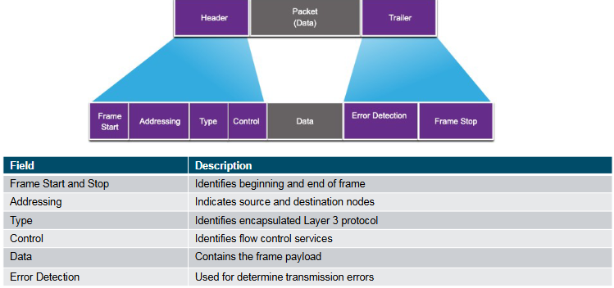

Layer 2 Addresses
The Layer 2 Address is also referred to as a physical address. It is contained in the frame header and is used only for local delivery of a frame on the link. It is updated by each device that forwards the frame.

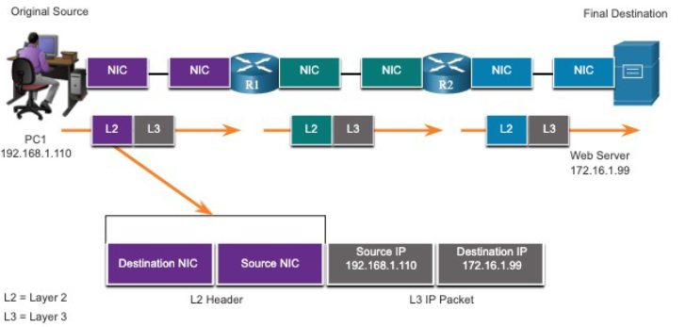

The logical topology and physical media determine the data link protocol used:
- Ethernet
- 802.11 Wireless
- Point-to-Point (PPP)
- High0Level Data Link Control (HDLC)
- Frame-Relay

Each protocol performs media access control for specified logical topologies.

Data Link Layer Summary
- The data link layer of the OSI Model (Layer 2) prepares network data for the physical network
- The data link layer is responsible for network interface card (NIC) to network interface card (NIC) communications.
- The IEEE 802 LAN/MAN data link layer consists of the following two sublayers: LLC and MAC.
- The two types topologies used in LAN and WAN networks are physical and logical.
- Three common types of physical WAN topologies are: Point-To-Point, hub and spoke and mesh.
- Half-duplex communications exchange data in one direction at a time. Full-duplex sends and receives data simultaneously.
- In contention-based multi-access networks, all nodes are operating in half-duplex.
- The examples of contention-based access methods include: CSMA/CD for buss-topology Ethernet LANs and CSMA/CA for WLANS.
- The data link frame has three basic parts: header, data and trailer.
- The frame fields include: frame start and stop indicator flags, addressing, type, control, data, and error detection.
- Data link addresses are also know as physical addresses
- Data link address are only used for link local delivery frames.

Ethernet Switching

Ethernet Frames

Ethernet Encapsulation
Ethernet is one of two LAN technologies used today, with the other being wireless LANs (WLANs). Ethernet uses wired communications, including twisted pair, fiber-optic links and coaxial cables.
Ethernet operates in the data link layer and the physical layer. It is a family of networking technologies defined in the IEEE 802.2 and 802.3 standards. Ethernet supports data bandwidth of the following:
- 10 Mbps
- 100 Mbps
- 1000 Mbps (1 Gbps)
- 10 000 Mbps (10 Gbps)
- 40 000 Mbps (40 Gbps)
- 100 000 Mbps (100 Gbps)

As shown in the figure, Ethernet standards define both the Layer 2 protocols and the layer 1 technologies.
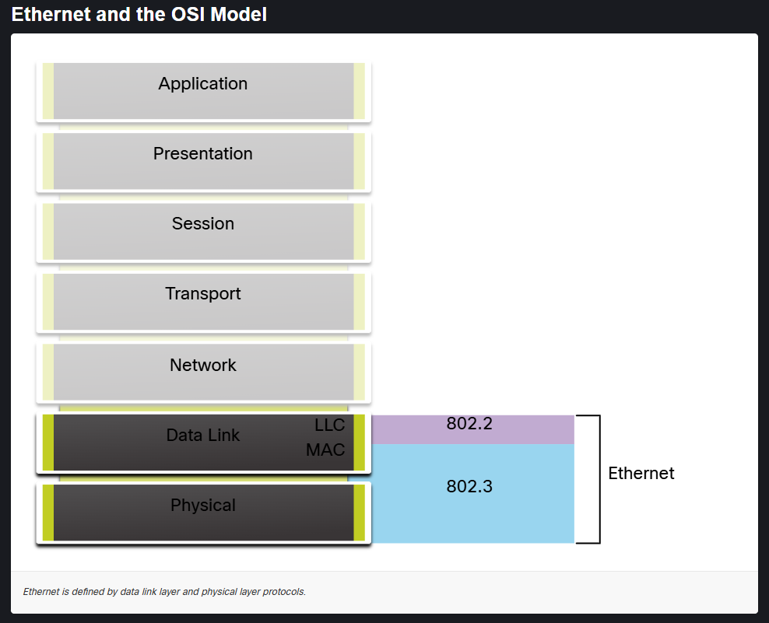

Data Link Sublayers
IEEE 802 LAN/MAN protocols, including Ethernet, use the following two separate sublayers of the data link layer to operate. They are the Logical Link Control (LLC) and the Media Access Control (MAC), as shown in the figure below.
Recall that LLC and MAC have the following roles in the Data Link Layer:
  - LLC Sublayer – This IEEE 802.2 sublayer communicates between the networking software at the upper layers and the device hardware at the lower layers. It places information in the frame that identifies which network layer protocol is being used for the frame. This information allows multiple Layer 3 protocols, such as IPv4 and IPv6 to use the same network interface and media.
  - MAC Sublayer – This sublayer (IEEE 802.3, 802.11, or 802.15, for example) is implemented in hardware and is responsible for data encapsulation and media access control. It provides data link layer addressing and is integrated with various physical layer technologies.

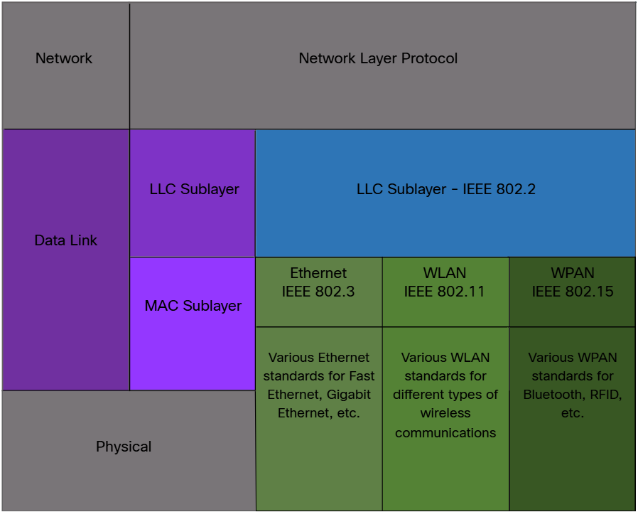

MAC Sublayer
The MAC sublayer is responsible for data encapsulation and access the media.
IEEE 802.3 data encapsulation includes the following:
  - Ethernet frame - This is the internal structure of the Ethernet frame
  - Ethernet Addressing – The Ethernet frame includes both a source and destination MAC address to deliver the Ethernet frame from Ethernet NIC to Ethernet NIC on the same LAN
  - Ethernet Error detection – The Ethernet frame includes a frame check sequence (FCS) trailer used for error detection.

As shown in the figure, the IEEE 802.3 MAC sublayer includes the specifications for different Ethernet communications standards over various types of media including copper and fiber.

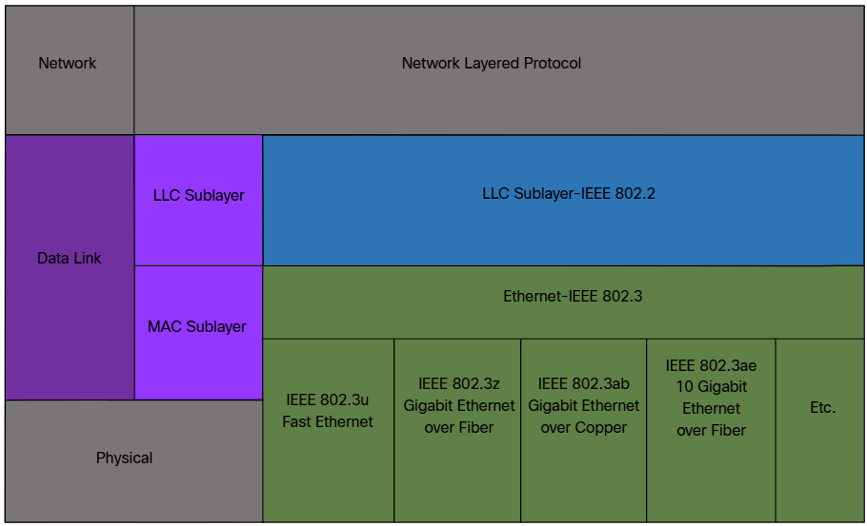

Recall that legacy Ethernet using a bus topology or hubs, is a shared, half-duplex medium. Ethernet over a half-duplex medium uses a contention-based access method, carrier sense multiple access/collision detection (CSMA/CS). This ensures that only one device is transmitting at a time. CSMA/CD allows multiple devices to share the same half-duplex medium, detecting a collision when more than one device attempts to transmit simultaneously. It also provides a back-off algorithm for retransmission.
Ethernet LANs of today use switches that operate in full-duplex. Full-duplex communications with Ethernet switches do not require access control through CSMA/CD

OSYS1200 Introduction to Windows Administration

The Evolving Role of System Administrators in the Future of Computing

Introduction
System administrators have historically been the gatekeepers of IT infrastructure. Their role has been pivotal in ensuring the smooth operation and security of computer systems. However, with the rapid advancements in technology, the responsibilities of system administrators are evolving. This essay will explore how the role of system administrators is changing and what the future holds for this critical professions

The Impact of Cloud Computing
Cloud computing has revolutionized the way businesses and organizations utilize IT resources. The shit towards cloud based infrastructure has significantly altered the traditional responsibilities of system administrators. Instead of managing physical servers and data centers, system administrators now often oversee cloud environments, ensuring optimal performance, security, and cost-efficiency. This transition requires new skills and expertise, such as cloud platform knowledge and automation techniques.

Automation and DevOps
Automation is another major trend reshaping the role of system administrators. DevOps practices, which emphasize collaboration between development and operations teams, have gained widespread adoption. Automation tools and scripting languages are being used to automate routine tasks, allowing system administrators to focus on more strategic and complex challenges. This shift towards automation can improve efficiency, reduce errors and accelerate innovation.

Security and Risk Management
As cyber threats continue to evolve, the responsibility of system administrators to protect sensitive data has become paramount. They must stay informed about emerging security threats and implement appropriate measures to safeguard systems and networks. This includes tasks such as vulnerability assessment, intrusion detection, and incident response. Additionally, system administrators play a crucial role in managing risks associate with data privacy and compliance regulations.

Emerging Technologies and Skill Requirements
The future of computing is marked by the emergence of new technologies, such as artificial intelligence, machine learning and the internet of things (IoT). These technologies present both opportunities and challenges for system administrators. They must adapt their skill sets to understand and manage these emerging technologies effectively. This may involve learning about AI frameworks, data analytics and IoT security protocols.

Conclusion
The role of system administrators is undergoing a significant transformation in response to technological advancements. The shift towards cloud computing, automation and emerging technologies require system administrators to develop new skills and adopt new approaches. By embracing these changes and staying ahead of the curve, system administrators can continue to play a vital role in shaping the future of computing and ensuring the successful operation of IT infrastructure.

Windows: Using System and Utilities

Settings Overview
Most configuration options for Windows 11 can be accessed through “Settings”.
To access “Settings”: Click the Start Button > Click Settings
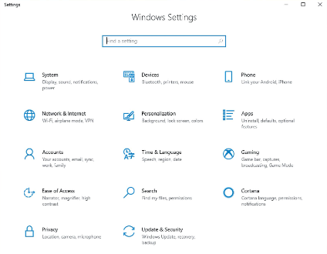

Administrative Tools
Administrative tools are a collection of system configuration utilities found in System and Security in Control Panel.
Most tools in this category use the Microsoft Management Console (MMC). Microsoft Management Console is a framework that simplifies the development of administrative tools.
The tools include:
Component Services | Performance Monitor
Defragment and Optimize Drives | Print Management
Disk Cleanup | Resource Monitor
Event Viewer | Service
iSCSI Initiator | System Configuration
Local Security Policy | Task Scheduler
Open Database Connectivity (ODBC) | Windows Firewall with Advanced Security
Windows Memory Diagnostics

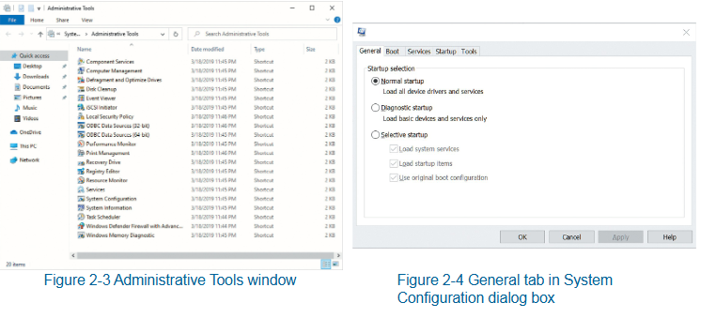

Microsoft Management Console
Microsoft Management Console (MMC) is a graphical interface shell that provides a structured environment to build management utilities. Network administrators use MMC consoles with snap-ins to perform management tasks. Each console can host one or more snap-ins.
A snap-in is a component that adds control mechanisms to the MMC console for a specific service or object.
You can create a customized MMC console. You can do this by adding the snap-ins you want to a single console and then saving the console as a .msc file.
You can share .msc files between other users and computers.
The MMC console is divided into three sections:
System Tools | Storage | Services and Applications
Task Scheduler | Disk Management | Services
Event Viewer |  | WMI Control
Shared Folders
Local Users and Groups
Performance
Device Manager

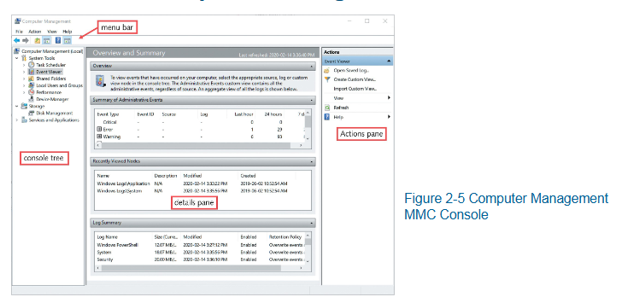

Services
Services is a type of Windows application that runs in the background without user interactions. Typically performs tasks for other software applications.
Services Administration Tool is used to manage Windows 11 services.
Service information:
    - Name
    - Description
    - Status
    - Start-up type
    - Log On As
Properties of a service:
    - General
    - Log On
    - Recovery
    - Dependencies
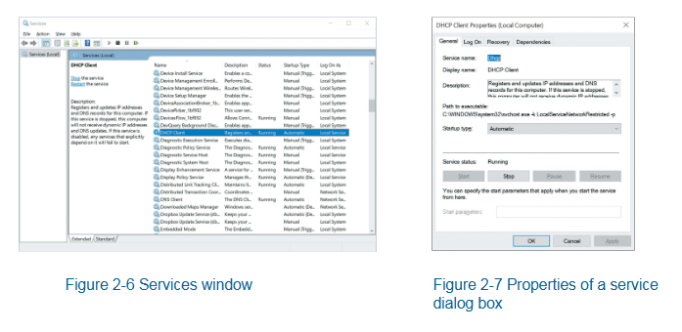

Command-Line Administration Tools
Command-Line Administration tools include Command Prompt and Windows PowerShell. These are “text-based” interfaces that require you to type in all commands.

Command Prompt:
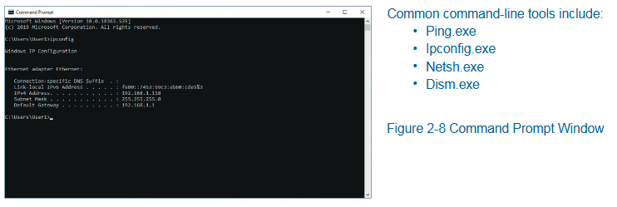
Windows PowerShell:
A command-line interface (CLI) for performing system configuration in Windows 11.
It is an effective replacement for batch scripts and Visual Basic scripts.
Some things you can do with Windows PowerShell include:
      - Manage services
      - Manage processes
      - Manage networking
      - Edit the registry
      - Manipulate files and folders
      - Retrieve event log events

Managing Disks and File System

Disk Technology
Can be categorized by
  - How it is connected to the computer
  - How it is presented in Windows 11
When reviewing disk technology for use with Windows 11, consider these technologies:
  - Internal Disk
    - Electromechanical drives
    - Solid-state drives (SSD)
    - Custom embedded chip memory (flash memory)
  - External Disk
    - Used to connect removable disk storage. Avoid using ext. disks as a location for operating systems
  - Virtual Hard Disk (VHD)
    - All versions of Windows 11 support VHD operations. Files can be stored in a VHD storage location just like any other disk technology.
  - Multiple disks as one logical disk.
    - Logical disks appear to the Windows 11 operating system as if it is one disk drive
    - Can combine multiple disks as one logical disk.

Disk Partition Styles
Windows 11 can organize data on disk drives using a partition style. When a blank disk is first configured for use by Windows, you can select one of these styles:
- GUID Partition Table (GPT)
- Master Boot Record (MBR)
In Windows Recovery, use the command-line tool MBR2GPT to upgrade from BIOS.MBR to UEFI/GPT

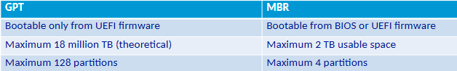

Disk Types
Empty space on the drive can be organized using three different methods in Windows 11
- Basic disks
  - This is hard disks initialized to use basic storage technology. Basic disks can have their space organized into one or more defined areas of storage call partitions. These are defined by the size and type of data it holds. The partition’s attributes are stored in a data table on the disk that is part of the MBR or GPT specifications. This is called the Partition Table.
- Dynamic disks
  - Dynamic disks provide flexibility to logically organize disk space across one or more disk drives. Blocks of space are call volumes.
- Storage spaces
  - Storage Spaces are an inexpensive way to combine, or pool, storage of multiple physical disk drives. These can also provide fault tolerance with data redundancy across multiple disks. Software-based storage technology that doesn’t need specialized storage hardware.

Disk Management Tools
Windows 11 tools for Disk Management
- Disk Management Console
  - MMC Console Snap-in (diskmgmt.msc)
  - Part of the Computer Management utility
  - Allows a member of the Administrators group to observe and make changes to the computer’s disk configuration.
  - Allows changes to be made interactively
    - Usually takes effect immediately without restart
- DiskPart
  - Command-line tool
    - Allows disk, partition, volume and virtual hard disk management operations to be performed
      - From a text-based screen interactively
      - From a scripted file
  - Operations are driven by a sequence of commands
    - As part of a scheduled task
    - As an automated response on the local computer or remotely on another computer
- Storage Cmdlets in Windows PowerShell

Adding a New Drive
New drives are typically connected via SATA or via USD
A brand-new drive is typically not initialized by Windows.

Configuring Storage Spaces Fault Tolerance
A storage space volume can be configured for fault tolerance when it is initially created if the proper starting conditions are met. Different levels of tolerance are available.
Resiliency Type | Description
Simple (no resilience) | - Needs one drive minimum in the pool  - Good for temporary data and where performance is more important than resilience.  - If a drive in the pool fails and contains part of the this volume, the volume is not available to the end user
Two-way Mirror | - Needs two drives minimum  - A volume’s data is copied to at least two separate disks in the pool; each disk holds a synchronized copy of the volume’s data  - Good performance with disk read and write operations  - Can handle single drive failure and still be operational.  - Supported volume size is limited to the size of the smallest drive member
Three-way Mirror | - Needs five drives minimum  - Three copies of a volume’s data are spread across all five drives  - Good performance with disk read and write operations.  - Can handle multiple drive failures and still be operational.
Parity | - Similar to RAID 5 in that parity information is calculated and can determine data that is lost from a drive failure.  - Needs three drives minimum to handle a single drive failure.  - Needs seven drives minimum to handle a double drive failure  - Slow performance during a disk failure while the system calculates missing data; best used for low data that needs fault tolerance but not high performance, such as archive data.

DBAS1007 Data Fundamentals
Data is raw. It is pure fact. We require context to turn data into something.
Data = pure fact. Information = interpretation of fact. Knowledge = network of information. Insight = novel crosslinking point between information. Wisdom = connection of information.

Databases
A Database Management System (DBMS) is a software application that interacts with end-users, application, and the database itself to capture and analyze data. The primary role of a DBMS is to provide a systematic and efficient way to store, retrieve, and manage data in databases. It ensures data integrity, security and consistency while supporting multiple users and applications simultaneously. In IT infrastructure, a DBMS is crucial as it underpin the data architecture, enabling organizations to handle large volumes of data, perform complex queries, and generate insights that drive decision-making and operational efficiency. By centralizing data management, a DBMS enhances data accessibility and reliability, which are essential for modern business operations and digital services.
SQL (sequel) is a Database Management System (DBMS) that is often used for banking and military purposes for its rigidity.
A database is a place where information is stored. This allows the information to be easily found, used and updated. They are used in websites, apps, and businesses to manage everything from customer details to class schedules.
Databases come in various types, each suited to different applications.
Relational databases (MySQL, PostgreSQL) use structured tables and are ideal for transactional systems like banking and e-commerce.
NoSQL databases (MongoDB, Cassandra) handle unstructured data and are perfect for big data application and real-time analytics.
In-memory databases (Redis) store data in RAM (Random Access Memory) for fast access, making them suitable for caching and real-time applications.
Object-oriented databases (db40) store data as object, which is useful for applications requiring complex data representations.
Graph databases (Neo4) excel in managing interconnected data, making them ideal for social networks and recommendation systems.
Each type of database is designed to meet specific needs, ensuring efficient data management and retrieval for various use cases.

Database diagrams are visual representations of a database’s structure, showcasing tables, columns, relationships and constraints. They help in understanding how data is organized and interconnected within the database.
Database objects include tables, views, indexes, stored procedures, and triggers, each serving a specific function in data management. Tables store data in rows and columns, views provide virtual tables for querying, indexes enhance search performance, stored procedures encapsulate business logic, and trigger automate actions based on events.
Together, database diagrams and objects facilitate efficient design, implementation and maintenance of databases, ensuring data integrity and accessibility.

ACID Properties
Atomicity - All parts of a transaction must succeed or none-at-all. If something fails, the database goes back to its original state.
Consistency - A transaction must bring the database from one valid state to another, following all rules and constraints.
Isolation - Transaction happen independently. One transaction doesn’t affect another while it’s running.
Durability - Once a transaction is complete, the changes are saved permanently, even if the system crashes.

Best Practices
Best practices in structuring data components involve organizing data to ensure efficiency, scalability, and maintainability. This includes normalizing data to eliminate redundancy defining clear primary and foreign keys (Keys are used to uniquely identify data) to establish relationships and using indexes to speed up query performance.
It’s essential to design consistent naming conventions for tables and columns, implement data integrity constraints to maintain accuracy and regularly backup and secure data to prevent loss and unauthorized access.
Additionally, documenting the database schema and changes helps in maintaining clarity and facilitating collaboration among developers and database administrators. These practices collectively enhance reliability and performance of the database system.

Normalization
Normalization is a process in database design aimed at organizing data to reduce redundancy and improve data integrity. It involves dividing a database into smaller, well-structured tables and defining relationships between them.
The primary goal I to ensure that each piece of data is stored only once, minimizing duplication and potential inconsistencies. Normalization typically follows a series of steps, known as normal forms, each addressing specific types of redundancy and dependency.
By adhering to normalization principles, databases become more efficient, easier to maintain, and capable of supporting complex queries and updates without compromising data accuracy.

Normal Forms
Normal forms are a series of guidelines used in database normalization to reduce redundancy to dependency by organizing fields and table relationships.
Each normal form addresses specific types of anomalies and inefficiencies.
The most commonly used normal forms are the First Normal Form (1NF), which ensures that all columns contain atomic, indivisible values; the Second Normal Form (2NF), which removes partial dependencies on a composite primary key; and the Third Normal Form (3NF), which eliminates transitive dependencies.
Higher normal forms, like Boyce-Codd Normal Form (BCNF), further refine these principles. Adhering to normal forms is crucial for maintaining data integrity, optimizing query performance and simplifying database maintenance.

Normalization Steps
To go from First Normal Form (1NF) to Third Normal Form (3NF) in normalization, follow these steps:
- First Normal Form (1NF)
  - Ensure that all columns contain atomic, indivisible values
  - Remove any repeating groups of arrays, so each columns contain only one value per row.
- Second Normal Form (2NF)
  - Ensure the table is already in 1NF
  - Remove partial dependencies, where non-key attributes are dependent on pat of a composite primary key. This involves creating separate tables for sets of values that apply to multiple records.
- Third Normal Form (3NF)
  - Ensure the table is already in 2NF
  - Remove transitive dependencies, where non-key attributes depend on other non-key attributes. This involves creating separate tables to ensure that non-key attributes depend only on the primary key.

By following these steps, you can systematically reduce redundancy and improve data integrity in your database.
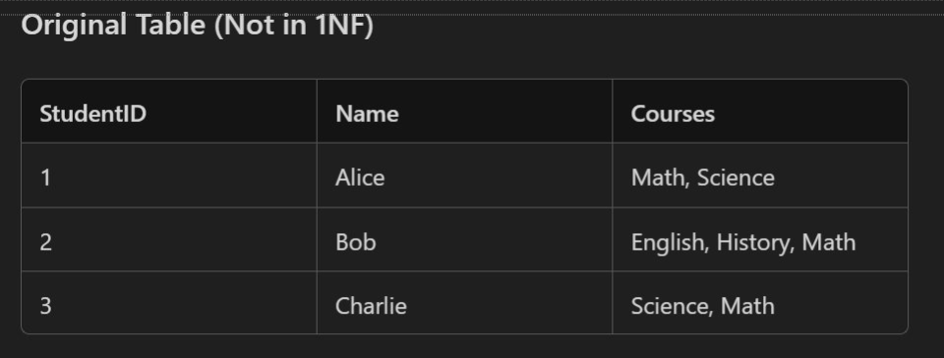
The above is an example of an unnormalized table.
The hallmark of an unnormalized table is that there is repeating information as well as multiple data points in a row. Take “Courses” for example; for Alice, it has “Math, Science” and for Bob it has “English, History, Math.” Through Normalization we will get this broken down to be more concise,”
The first step to this is to re-write this as First Normal Form (1NF).
To do this, we need to identify the Primary Key. This is the central data point that we are going to base our tables off. For this example, we will be using “StudentID.”
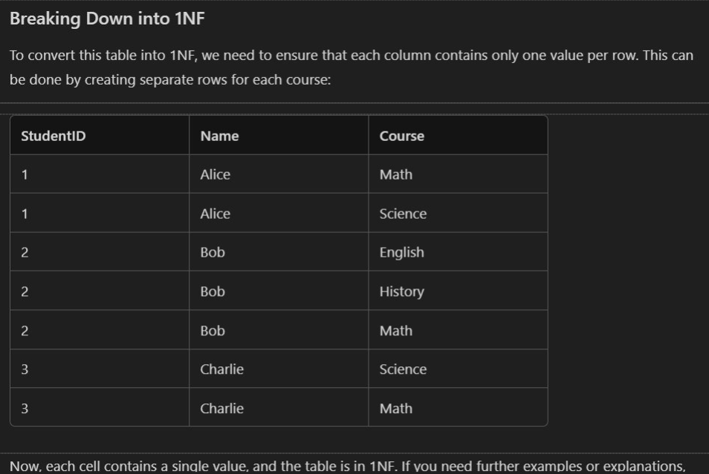
Now that we have broken the original table down to First Normal Form (1NF) we can see that there is still some repeating information, however, “Courses” has been re-named to “Course” and no longer has multiple entries per row.
However, we can still break this down further, into Second Normal Form (2NF).
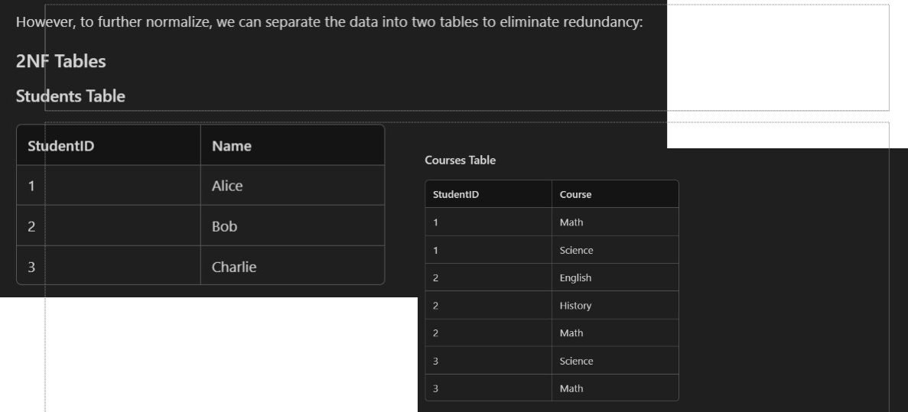

To go to Second Normal Form (2NF) we have split the table into two different tables, to reduce redundancy. Note that the “Students Table” contains unique information and the “Courses Table” lists the courses each student is enrolled in. This structure ensures that each non-key attribute is fully dependent on the Primary Key, satisfying the 2NF.
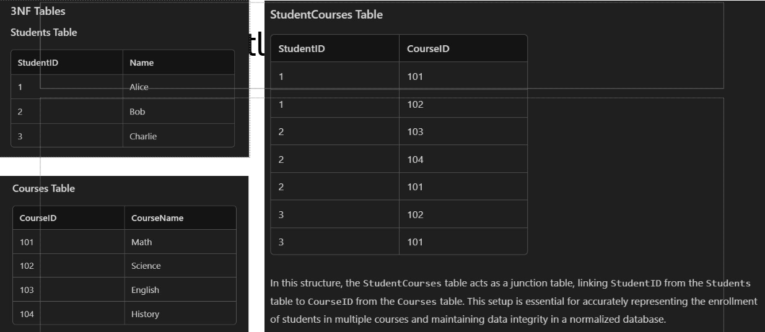
Now we have entered Third Normal Form (3NF). In this structure, the “StudentCourses Table” acts as a junction table, linking “Student ID” from “Students Table” to “CourseID” from the “Courses Table.” This setup is essential for accurately representing the enrollment of students in multiple courses and maintaining data integrity in a normalized database.

This structure is in Third Normal Form (3NF) because:
- Students Table
  - Contains only atomic values
  - Each non-key attribute (Name) I fully dependent on the Primary Key (StudentID)
- Course Table
  - Contains only atomic values.
  - Each non-key attribute (CourseName) is fully dependent on the Primary Key (CourseID)
- StudentCourses Table
  - Contains only atomic values
  - The composite Primary Key (StudentID, CourseID) ensures that each non-key attribute is fully dependent on the entire Primary Key.
  - There are no transitive dependencies, as the table only links StudentID to CourseID.

ERDs and ERMs
In the database world, Entity Relationship Modeling (ERM) and Entity Relationship Diagrams (ERD) are closely related but serve different purposes.

Entity Relationship Modeling (ERM)
In the context of Relational Database Management System (RDBMS), ERM stans for Entity Relationship Model. This model is a fundamental concept used in database design to visually represent the structure of data and the relationships between different data entities.
- Conceptual Framework: ERM is a high-level conceptual framework used to outline the entities relevant to a system and their interrelationships.
- Purpose: It focuses on the overall structure and organization of data, ensuring that all necessary components are identified before diving into specifics.
- Usage: ERM is typically utilize in the initial stages of database design to conceptualize the data structure.
Using an Entity Relationship Model (ERM) in database design offers several advantages.
- Clear Structure
  - ERM provides a clear and organized way to represent data and its relationship, making it easier to understand the database structure
- Improved Communication
  - ER diagrams server as a visual tool that helps stakeholders, including developers and business analysts, communicate effectively about the database design.
- Simplified Maintenance
  - A well-designed ERM makes it easier to maintain and update the database as changes in requirements or data structures occur.
- Enhanced Query Performance
  - Properly structure databases based on ERM can lead to optimized query performance, as relationships and data dependencies are clearly defined.
- Scalability
  - ERM facilitates the design of scalable databases that can grow and adapt to changing business needs without significant restructuring.
An ER model usually results from systematic analysis to define and describe the data created and needed by processes in a business area. Typically, it represents records of entities and events monitored and directed by business processes, rather than processes themselves. It is usually drawn in a graphical form as boxes (entities) that are connected by lined (relationships) which express the associations and dependencies between entities. It can also be expressed I a verbal form, for example: one building may be divided into zero or more apartments, but one apartment can only be located in one building.
Entities may be defined not only by relationships, but also by additional properties (attributes), which include identifiers called “primary keys”. Diagrams created to represent attributes as well as entities and relationships may be called entity-attribute-relationship diagrams, rather than entity-relationship models.
An ER model is typically implemented as a database. In a simple relational database implementation, each row of a table requests one instance of an entity type, and each field in a table represents an attribute type. In a relational database, a relationship between entities is implemented by storing the primary key of one entity as a point or “foreign key” in the table of another entity.
There is a tradition for ER/data models to be built at two or three levels of abstraction. The conceptual-logical-physical hierarchy below is used in other kinds of specification and is different from the three scheme approach to software engineering.

Entity Relationship Diagrams (ERD)
- Visual Representation: ERD is a graphical depiction of the ERM, illustrating how entities interact with one another through relationships.
- Detail Level: ERDs include specific attribute and cardinalities, providing a detailed view of the data structure
- Usage: ERDs are employed for communication and documentation purposes, helping stakeholders understand the relationship between entities.

Key Differences
- Purpose: ERM is used for conceptualizing the data structure, while ERD provides a graphical depiction of that structure.
- Detail Level: ERM outlines entities and relationships broadly, whereas ERD includes specific attributes and cardinalities.
- Usage ERM is often utilized in the initial stages of database design, while ERD is employed for communication and documentation

Components
- Entities: Primary objects or concepts within the system, such as “Customer”, “Order”, or “Product.
- Relationships: Define how entities interact with one another, classified as one-to-one, one-to-many, or many-to-many.\
- Attributes: Properties or details that describe an entity, like “Name”, “Email”, and “Pone Number” for a “Customer” entity.

Chen Notation
- Chen Notation is a way to visually represent entities and their relationships in an Entity Relationship Diagram (ERD). Named after Peter Chen, who introduced it in 1976, this notation uses specific symbols to illustrate the structures of a database.
- Key Elements of Chen Notation
  - Entities: Represented by rectangles, entities are objects or concepts that store data.
  - Attributes: Represented by ovals, attributes are properties or details about entities.
  - Relationships: Represented by diamonds, relationships show how entities are connected.
  - Primary Keys: Underlined attributes within an entity rectangle indicate primary keys.
- Chen Notation is particularly useful for conceptual database design, helping to clearly define the data structure and relationships before implementation.
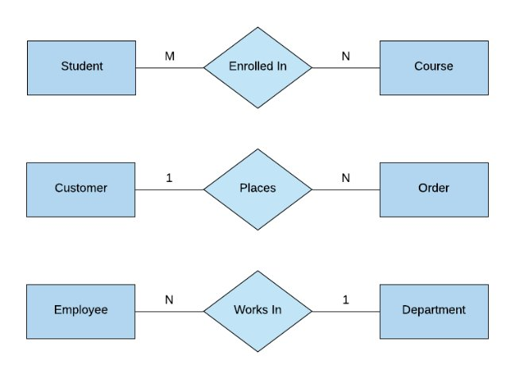

Three Types of Data Models

Conceptual Data Model
- Purpose: Provides a high-level overview of the system, focusing on the entities and their relationships without detailing attributes or keys.
- Components: Entities and relationships
- Audience: Business stakeholders and analysts
- Example: An ER diagram showing entities like Customer, Order and Product with relationships between them.

Logical Data Model
- Purpose: Adds more detail so the conceptual model by specifying attributes, primary keys, and foreign keys, but still independent of physical implementation
- Components: Entities, attributes, primary keys, foreign keys and relationships.
- Audience: Database designers and developers
- Example: An ER diagram showing Customer with attributes like CustomerID, Name and Address, Order with attributes like OrderID, OrderDate ad CustomerID

Physical Data Model
- Purpose: Translates the logical model into a physical structure, detailing how data will be stored in the database, including tables, columns, data types, indexes, and constraints.
- Components: Tables, columns, data types, indexes, constraints and relationships.
- Audience: Database administrator and developers.
- Example: A database scheme showing the Customer table with columns CustomerID (INT), Name (VARCHAR), and Address (VARCHAR) and the Order table with columns OrderID (INT) OrderDate(DATE) and CustomerID (INT)
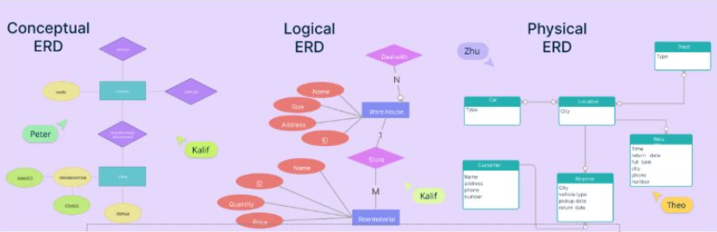

SQL
SQL or Structured Query Language, was developed in the early 1970s by IBM researches Raymond Boyce and Donald Chamberlin.
It was initially called SEQUEL (Structured English Query Language) and was designed to manage and retrieve data stored in IBM’s original relational database management system, System R.
Over time, SQL evolved and became the standard language for relational database management systems, with its first commercial implementation appearing in the late 1970s. The American Standards Institute (ANSI) adopted SQL as the standard in 1986, solidifying its role as a fundamental tool in database management and manipulation.
Today, SQL remains a critical skill for data professionals and is widely used across various industries.

SQL Statements & Execution
A SQL statement is a command used to interact with a database, performing tasks like querying, updating, and managing data.
In MySQL Workbench, you can execute these statements individually by writing them in the query editor, highlighting the specific statement you want to run, and then clicking the “Execute” button or pressing Ctrl + Enter
This method allows for precise control and testing of each command, ensuring accurate database operations.

SQL DDL
SQL DDL, or Data Definition Language, is a subset of SQL used to define and manage database structures.
It includes commands such as CREATE, ALTER, DROP and TRUNCATE, which are used to create, modify, delete and truncate database objects like tables, indexes and views.
Essentially, DDL commands help in setting up and organizing the schema of a database, ensuring that the data is stored in a structured and efficient manner.

Logical Data Model
Data Types in a logical data model:
    - VARCHAR(n) – Variable-length string
    - INT / BIGINT – Whole numbers
    - DECIMAL(p, s) – Precise decimal values
    - DATE, TIME, DATETIME
    - BOOLEAN
    - TEXT, BLOB - Large text or binary data

WEBD1000 Website Development

Web Development History

Introduction to Web Development
- What is web development?
  - The process of creating websites and web applications for the internet
  - Involves coding, designing and maintaining websites.
- Importance of Understanding History
  - Knowing the evolution of web technologies helps in appreciating current standards and trends.

The Birth of the Web (1989 – 1991)
- Tim Berners-Lee’s Vision
  - 1989: Proposed a project at CERN for a system of linked information.
  - 1990: Developed the first web browser (WorldWideWeb) and the first website (info.cern.ch
  - 1991: Public release of the World Wide Web, allowing people to create and share documents globally.

The Rise of Web Browsers (1993 – 1995)
- Mosaic (1993)
  - The first widely used web browser with a graphical interface, making the web accessible to non-technical users.
- Netscape Navigator (1994)
  - Improved user experience with faster loading times and features like cookies.
  - Become the dominant browser, sparking the “Browser Wars.”

The Browser Wars and Standards (1995 – 1998)
- Internet Explorer Vs. Netscape
  - Microsoft launched Internet Explorer in 1995, integrating it with Windows.
  - The competition le to rapid advancement but also inconsistencies in web standards.
- Formation of W3C (1994)
  - World Wide Web Consortium (W3C) established by Tim Berners-Lee to develop standardized protocols and guidelines.

The Dot-Com Boom and Bust (1997 – 2001)
- Rapid Growth
  - Late 1990s. Explosion of web Startups, e-commerce and online services.
  - Introduction of CSS (1996) for better design control and JavaScript (1995) for interactivity.
- The Dot-Com Bust (2000)
  - Overinvestment in internet companies led to a market crash, reshaping the industry towards sustainable business models.

The Modern Web (2002 – Present)
- Web 2.0 and Beyond
  - Early 2000s: Rise of dynamic content, user-generated content and social media platforms.
  - HTMLS (2014) and CSS3 (2012): Introduced new features for multimedia, responsive design and more
- Mobile Revolution
  - 2010s: Shift towards mobile-first design as smartphones and tablets become prevalent.
  - Emphasis on responsive web design, accessibility and performance optimization.

Introduction to Usability
- What is Usability?
  - Usability refers to how easy and efficient it is for users to navigate and interact with a website or application
- Importance of Usability
  - Enhances user experience, satisfaction, and accessibility.
  - Reduces errors and increases the effectiveness of the website.
- Core Components
  - Learnability, efficiency, memorability, errors and satisfaction.

Principles of Good Usability
- Understand your Users
  - Identify target audience needs and preferences.
  - Conduct user research and testing.
- Consistency
  - Maintain consistency in design, navigation and interaction across the website.
- Feedback
  - Provide users with immediate and clear feedback on their actions. (Button clicks, form submissions, etc)

Principle of Contrast
- What is Contrast?
  - Contrast is the difference in visual properties (color, brighten) that makes an object distinguishable from other objects and the background.
- Importance in Design
  - Helps draw attention to key elements.
  - Improves readability and accessibility.
- Examples
  - Text colour vs background colour (black text on white background)
  - Button colours that stand out from the page (A red “Submit” button on a white form)

Applying Contrast Effectively
- Best Practices:
  - Use sufficient contrast between test and background to ensure readability.
  - Use contrast to highlight important elements (call-to-action buttons)
  - Avoid too many contrasting elements that can lead to visual clutter
- Tools
  - Contrast check tools (WebAIM Contrast Checker) to ensure compliance with accessibility standards.

Principle of Repetition
- What is Repetition
  - Repetition involves reusing the same or similar elements throughout the design to create a sense of unity and consistency.
- Importance in Design
  - Reinforces brand identity and improves use recognition.
  - Enhances visual organization and flow
- Examples
  - Consistent use of fonts, colours and button styles across all pages.
  - Repeating logos or icons to maintain brand consistency.

Applying Repetition Effectively
- Best Practices
  - Repeat navigation menus, headers and footers on every page for a cohesive look
  - Use consistent typography and colour schemes.
  - Ensure that repeated elements maintain the same meaning and function throughout the site.

Principle of Alignment
- What is Alignment
  - Alignment refers to the placement of elements on a page in relation to each other, creating a visual connection between them
- Importance in Design
  - Creates a structured and organized layout
  - Guides the user’s eye and improves readability
- Examples
  - Text aligned to the let, center or right for clear reading paths.
  - Images and buttons aligned with text to create harmony.

Applying Alignment Effectively
- Best Practices
  - Align elements to a grid the ensure consistency across the layout
  - Use alignment to create a clear hierarchy and flow of information.
  - Avoid arbitrary or mixed alignment, which can lead to a disorganized appearance.

Principle of Proximity
- What is Proximity?
  - Proximity involves placing related elements close together to signify their connection and make the layout easier to scan.
- Importance in Design
  - Helps user quickly identify relationships between elements.
  - Reduces cognitive load by grouping similar information.
- Examples
  - Grouping form labels and input fields together
  - Placing related links or buttons near each other.

Applying Proximity Effectively
- Best Practices
  - Group related items together (Contact information, navigation links)
  - Use white space strategically to separate unrelate elements)
  - Ensure that proximity reflects the logical relationships between elements

What is Web Accessibility?
Consider out website visitors. They may have different visual, auditory, physical, speech, cognitive and/or neurological abilities.

Definition
  - Web accessibility ensures that websites, tools and technologies are designed and developed so that people with disabilities can use them.
Scope
  - Includes visual, auditory, physical, speech, cognitive and neurological disabilities.
Core Principles
  - Making the web usable for everyone, regardless of ability.

Importance of Accessibility
- Legal compliance
  - Adhering to laws such as Americans with Disabilities Act (ADA) and Web Content Accessibility Guideline (WCAG)b
- Ethical Responsibility
  - Ensuring equal access to information and services.
- Business Benefits
  - Reaching a broader audience and improving user experience for all users.
- SEO Benefits
  - Accessible websites often rank better in search engines due to clean, well-structured content.

Understanding WCAG (Web Content Accessibility Guidelines)
- Introduction to WCAG
  - WCAG provides a set of guidelines to make web content more accessible
- WCAG Principles
  - Perceivable: Information must be presented in ways that all users can perceive.
  - Operable: Interface components and navigation must be operable.
  - Understandable: Information and the operation of the interface must be understandable.
  - Robust: Content must be robust enough to be interpreted by a wide variety of user agents, including assistive technologies.

Accessible Design Components: Perceivable Content
- Text Alternatives
  - Provide text alternatives (ALT attributes) for non-text content such as images.
- Captions and Transcripts
  - Include captions for videos and transcripts for audio content.
- Colour Contrast
  - Ensure sufficient colour contrast between text and background for readability.
- Text Resizing
  - Allowing users to resize text without losing content of functionality.

Accessible Design Components: Operable Interface
- Keyboard Accessibility
  - Ensure all functionalities are accessible via keyboards (navigation, forms)
- Focus Indicators
  - Provide visible focus indicators to guide users through interactive elements.
- Navigable Content
  - Use logical and clear navigation structures, such as heading and landmark.
- Time-based Media Controls
  - Provide users with control to pause, stop or adjust time-based media.

Accessible Design Components: Understandable Content
- Clear and Simple Language
  - Write content in a clear, simple and concise manner.
- Consistent Navigation
  - Ensure navigation is consistent across pages to avoid confusion.
- Error Identification and Suggestion
  - Provide helpful error messages and suggestions for fixing errors in forms or other interactive elements.
- Readable Fonts
  - Use fonts that are easy to read and avoid overly decorative typefaces

Accessible Design Components: Robust Content
- Semantic HTML
  - Use HTML elements according to their intended purpose (<header>, <nav>, <main>
- ARIA Landmarks
  - Implement ARIA (Accessible Rich Internet Applications) roles to enhance accessibility for assistive technologies.
- Cross-Browser and Cross-Device Compatibility
  - Ensure your website functions correctly across various browsers and devices.
- Support for Assistive Technologies
  - Ensure compatibility with screen readers, magnifiers and other assistive technologies.

Tools and Resources for Testing Accessibility
- Automated Tools
  - Wave: Web Accessibility Evaluation Tool for checking accessibility issues.
  - AXE: Accessibility testing tool that integrates with browsers
  - Lighthouse: Built-in Chrome tool for auditing accessibility
- Manual Testing:
  - Keyboard navigation testing.
  - Screen reader testing using tools like NVDA or VoiceOver
- Online Resources
  - WCAD 2.1 Guidelines and tutorial available on W3C website.
  - Accessible design examples and case studies.

Planning and Designing Websites

Understanding Project Requirements
What are Project Requirements?
  - Specific goals, tasks and functionalities that a website must achieve.
Types of Requirements
  - Functional requirements: What the website should do (e.g., user login, search functionality.
  - Non-functional Requirements: How the website should perform (e.g., speed, scalability, security.)
Importance
  - Clear requirements ensure that the project meets the client’s or stakeholder’s needs and expectations

Gathering Project Requirements
Stakeholder Interviews
  - Conduct interviews with clients, users and other stakeholders to understand their needs.
User stories
  - Develop user stories to capture what different types of users need from the website
  - Example: “As a [user type], I want to [action] so that [goal]
Surveys and Research
  - Use surveys and research to gather data on user needs and market trends.

Analyzing Content Requirements
What is contact analysis?
    - The process of identifying and organizing the content that needs to be included on the website
Types of Content
    - Text: Articles, blog posts, product descriptions
    - Media: Images, videos, infographics
    - Interactive Elements: Forms, calculators, maps
Content Strategy
    - Develop a strategy for organizing and delivering content that aligns with user needs and business goals.

Designing Based on Criteria
Design Criteria
  - User Experience (UX): How easy and enjoyable it is for users to interact with the site
  - Visual Design: Aesthetic aspects like color schemes, typography and layout
  - Technical Criteria: Performance, compatibility and accessibility

Setting Priorities
  - Rank design criteria based on product goals, user needs and technical constraints.

Translating Requirements into Design
Wireframes and Mockups
    - Create wireframes to visual the structure of the website
    - Develop mockups to show the visual design and layout
Information Architecture (IA)
    - Organize content into a logical structure that’s easy for users to navigate
Navigation Design
    - Plan the navigation to ensure that users can find what they’re looking for quickly and easily

Designing for Content First
Content-First Design Approach
    - Start by understanding and organizing content before focusing on design elements
Benefits
    - Ensures that design supports content, rather than content being forced to fit the design
Practical Steps
    - Identify core content elements
    - Design layouts that prioritize and highlight important content.

Balancing Aesthetics and Functionality
Aesthetic Design
    - Focus on creating visually appealing website that align with the brand’s identity
Functional Design
    - Ensure that the website is usable, accessible and provides a seamless experience across all devices.
Achieving Balance
    - Use visual design to enhance, not overpower, functionality.
    - Test design to ensure they meet both aesthetics and functional criteria

Importance of Wireframes in Web Design
Planning and Communications
    - Provides a visual representation of the website’s structure, helping communicate ideas clearly to stakeholders.
User Experience (UX)
    - Ensures that the user journey is intuitive and efficient before moving on to a detailed design.
Cost and Time Efficiency
    - Identifies potential design issues early in the process, saving time and resources.

Wireframing Process
Step 1 – Understanding Requirements
    - Review project requirements and user needs
Step 2 – Sketching Basic Layouts
    - Start with low-fidelity sketches to outline the general layout and structure
Step 3 – Refining the Wireframe
    - Transition to high-fidelity wireframes, adding more detail and refining the layout
Step 4 – Feedback and Iterations
    - Share wireframes with stakeholders for feedback and make necessary adjustments

Key Components of a Wireframe
Navigation
    - Placement of menus, links and buttons for easy site navigation
Content Areas
    - Designated spaces for text, images, videos and other content types
Call-to-Action (CTA)
    - Highlighted buttons or links that guide users to take specific actions
Footer
    - Contains secondary navigation, contact information and other utilities.

Tools for Wireframing
Popular Wireframing Tools
    - Balsamiq: Known for its simplicity and low-fidelity wireframes
    - Figma: Offers both wireframing and design capabilities with collaborative features
    - Adobe XD: Provides high-fidelity wireframing and prototyping
    - Sketch: Favored for high-fidelity designs and a wide range of plugins
Choosing the Right Tool
    - Consider the complexity of the project, team collaboration needs, and integration with other design tools

Creating Web Structure Diagram
What are Web Structure Diagrams
    - Visual representations of the website’s information architecture, showing how pages and organized and linked together
Purpose
    - Helps in planning the overall structure of the website, ensuring logical flow and easy navigation
Types of Diagrams
    - Site Map: High-level overview showing the main pages and their relationships
    - Flowchart: Detailed diagram showing the user’s journey through different pages

Steps to Create a Web Structure Diagram
Step 1: Identify Key Pages
    - Determine the main pages of the website, such as Home, About, Services and Contact
Step 2: Define Page Hierarchy
    - Organize pages into a hierarchical structure, showing parent-child relationships
Step 3: Map Out Navigation Paths
    - Illustrate how users will navigate between pages, ensuring logical and intuitive flow
Step 4: Review and Refine
    - Collaborate with stakeholder to review the structure and make necessary adjustments.

Best Practices or Wireframing and Structure Diagrams
Keep it Simple
    - Focus on layout and functionality, avoiding distractions from design details
User-Centered Design
    - Always consider the user’s needs and how they will interact with the site
Iterate Based on Feedback
    - Regularly review and update wireframes and diagrams based on user testing and stakeholder feedback
Consistency
    - Maintain consistency in layout, navigation, and interaction patterns across the site.

HTML

Understanding HTML Tags an Attributes
  - HTML Tags
    - Tags define the structure and content of the web page.
    - Common tags: <h1> to <h6> for headings. <p> for paragraphs. <div> for divisions, and <span> for inline elements
  - Attributes
    - Provide additional information about an element (e.g, class, id, style)
    - Example: <img src=”image.jpg” alt=”A description of the image”>
  - Self-closing Tags
    - Tags that don’t have a closing part (e.g., <img/>, >br />

Introduction to Semantic HTML Tags
  - What are semantic Tags?
    - Semantic tags clearly describe their meaning both to the browser and the developer
  - Importance
    - Improves code readability and accessibility
    - Helps search engines and assistive technologies understand the content structure
  - Common Semantic Tags
    - <header>: Represents the header of a document or section
    - <nav>: Defines navigation block
    - <main>: Represents the main content of the document
    - <article>: Defines an independent, self-contained content
    - <footer>: Represents the footer of a document or section

Understanding URLS
- What is a URL?
  - URL stands for Uniform Resource Locator, which is the address used to access resources on the web
- Components of a URL
  - Scheme – The protocol (e.g. http, https)
  - Host – The domain name (e.g, www.example.com)
  - Path - The specific resource on the server (e.g., /about.html)
  - Query String – Optional parameters for data (e.g., ?id=123).
- Example
  - https://www.example.com/about.html?id-123

Creating Hyperlinks with HTML
- What is a Hyperlink?
  - A hyperlink is an element in HTML that allows users to click and navigate to another page or resource.
- Basic Syntax
  - Use the <a> (anchor) tag to create hyperlinks.
  - Example
    - <a href=”https://www.example.com”> Visit Example </a?
- Attributes
  - href: Specifies the destination URL
  - target: Defines where to open the linked document (e.g., _blank opens a new tab).

Absolute Vs. Relative URLS
- Absolute URLS
  - Includes the full path to the resource, starting from the protocol (e.g., https://www.example.com/page.html)
  - Use case: Linking to externa sites or resources
- Relative URLS
  - Path relative to the current document (e.g., about.html, ../images/photo.jpg)
  - Use case: Linking to internal pages within the same website.
- Example Comparisons
  - Absolute:
    - <a href=”https://www.example.com/contact.html”>Contact us</a
  - Relative:
    - <a href=”contact.html”>contact us</a?

Adding Images to Web Pages
- Basic Syntax
  - Use the <img> tag to include images to HTML
  - Example
    - <img src=”images/logo.png” alt=”Company logo”>
- Attributes
  - src: Specifies the path to the image file
  - alt: Provides alternative text for accessibility and SEO
  - width and height: Specify the dimensions of the image.
- Best Practices
  - Always include the alt attribute for better accessibility.
  - Optimize images for web to reduce load times.

Using Special Characters in HTML
- What are Special Characters?
  - Special characters are symbols that have specific meaning sin HTML (e.g., <, >, &) and must be encoded to be displayed correctly.
- Common Special Characters
  - &lt – For < (less than sign)
  - &gt – For > (greater than sign)
  - &amp – For & (ampersand)
  - &copy – For copyright symbol
- Example Usage
  - Displaying code:
    - &lt; div&t Hello Worldd&lt;/div&gt
  - Special symbols
    - &copy; 2024 My Website

Introduction to CSS (Cascading Style Sheets)
- What is CSS?
  - CSS is used to style and layout webpages including changing colours, fonts and spacing.
- CSS Syntax
  - Selector: Defines which HTML elements the styles apply to.
  - Property: The style attribute you want to change
  - Value: The specific setting for the property

